Filed pursuant to Rule 425 under the
Securities Act of 1933, as amended, and
deemed filed under Rule 14a-12 under the
Securities Exchange Act of 1934, as amended

Filer: ON Semiconductor Corporation
Commission File No.: 000-49602
Registration Statement File No.: 333-298477

Subject Company: Synaptics Incorporated

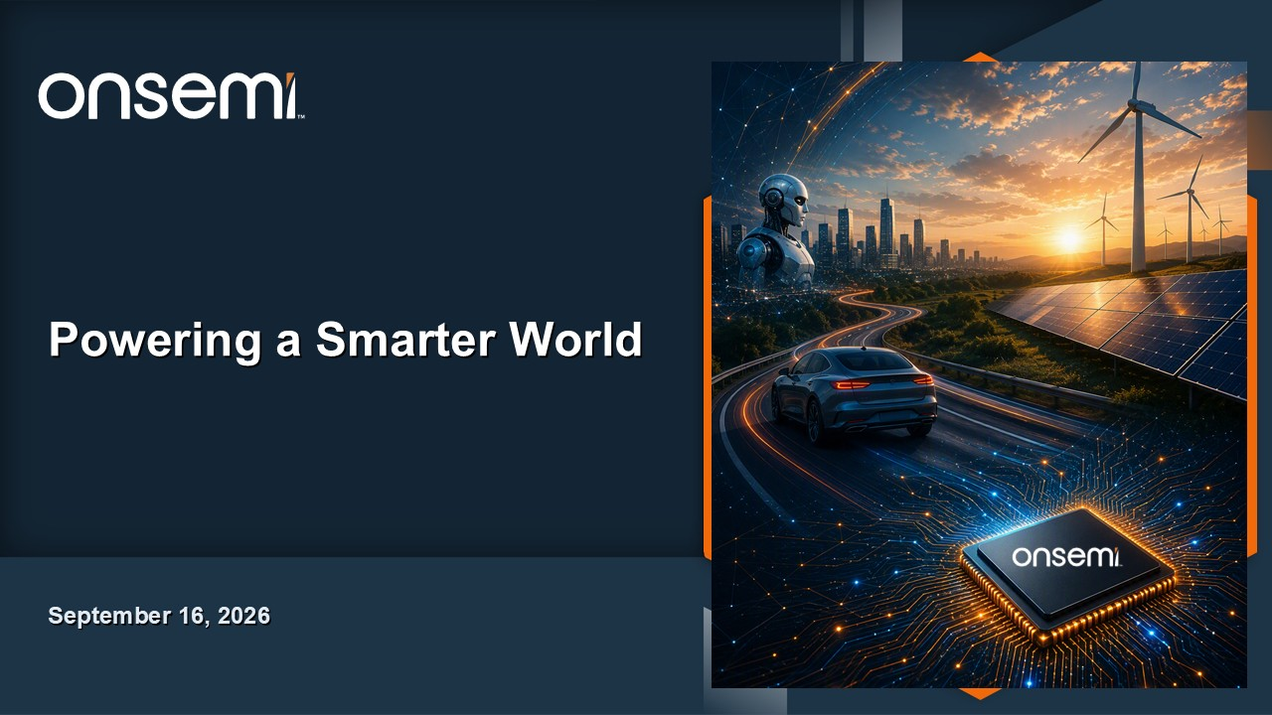
Powering a Smarter World September 16, 2026

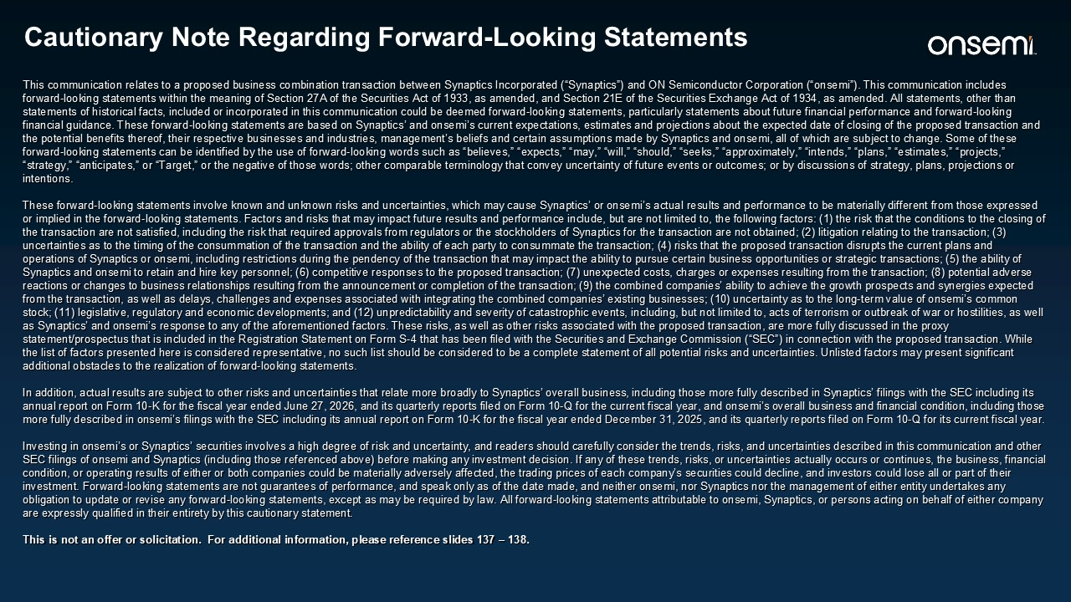
Cautionary Note Regarding Forward-Looking Statements This communication relates to a proposed business combination transaction between Synaptics Incorporated (“Synaptics”) and ON Semiconductor Corporation (“onsemi”). This communication includes forward-looking statements within the meaning of Section 27A of the Securities Act of 1933, as amended, and Section 21E of the Securities Exchange Act of 1934, as amended. All statements, other than statements of historical facts, included or incorporated in this communication could be deemed forward-looking statements, particularly statements about future financial performance and forward-looking financial guidance. These forward-looking statements are based on Synaptics’ and onsemi’s current expectations, estimates and projections about the expected date of closing of the proposed transaction and the potential benefits thereof, their respective businesses and industries, management’s beliefs and certain assumptions made by Synaptics and onsemi, all of which are subject to change. Some of these forward-looking statements can be identified by the use of forward-looking words such as “believes,” “expects,” “may,” “will,” “should,” “seeks,” “approximately,” “intends,” “plans,” “estimates,” “projects,” “strategy,” “anticipates,” or “Target,” or the negative of those words; other comparable terminology that convey uncertainty of future events or outcomes; or by discussions of strategy, plans, projections or intentions. These forward-looking statements involve known and unknown risks and uncertainties, which may cause Synaptics’ or onsemi’s actual results and performance to be materially different from those expressed or implied in the forward-looking statements. Factors and risks that may impact future results and performance include, but are not limited to, the following factors: (1) the risk that the conditions to the closing of the transaction are not satisfied, including the risk that required approvals from regulators or the stockholders of Synaptics for the transaction are not obtained; (2) litigation relating to the transaction; (3) uncertainties as to the timing of the consummation of the transaction and the ability of each party to consummate the transaction; (4) risks that the proposed transaction disrupts the current plans and operations of Synaptics or onsemi, including restrictions during the pendency of the transaction that may impact the ability to pursue certain business opportunities or strategic transactions; (5) the ability of Synaptics and onsemi to retain and hire key personnel; (6) competitive responses to the proposed transaction; (7) unexpected costs, charges or expenses resulting from the transaction; (8) potential adverse reactions or changes to business relationships resulting from the announcement or completion of the transaction; (9) the combined companies’ ability to achieve the growth prospects and synergies expected from the transaction, as well as delays, challenges and expenses associated with integrating the combined companies’ existing businesses; (10) uncertainty as to the long-term value of onsemi’s common stock; (11) legislative, regulatory and economic developments; and (12) unpredictability and severity of catastrophic events, including, but not limited to, acts of terrorism or outbreak of war or hostilities, as well as Synaptics’ and onsemi’s response to any of the aforementioned factors. These risks, as well as other risks associated with the proposed transaction, are more fully discussed in the proxy statement/prospectus that is included in the Registration Statement on Form S-4 that has been filed with the Securities and Exchange Commission (“SEC”) in connection with the proposed transaction. While the list of factors presented here is considered representative, no such list should be considered to be a complete statement of all potential risks and uncertainties. Unlisted factors may present significant additional obstacles to the realization of forward-looking statements. In addition, actual results are subject to other risks and uncertainties that relate more broadly to Synaptics’ overall business, including those more fully described in Synaptics’ filings with the SEC including its annual report on Form 10-K for the fiscal year ended June 27, 2026, and its quarterly reports filed on Form 10-Q for the current fiscal year, and onsemi’s overall business and financial condition, including those more fully described in onsemi’s filings with the SEC including its annual report on Form 10-K for the fiscal year ended December 31, 2025, and its quarterly reports filed on Form 10-Q for its current fiscal year. Investing in onsemi’s or Synaptics’ securities involves a high degree of risk and uncertainty, and readers should carefully consider the trends, risks, and uncertainties described in this communication and other SEC filings of onsemi and Synaptics (including those referenced above) before making any investment decision. If any of these trends, risks, or uncertainties actually occurs or continues, the business, financial condition, or operating results of either or both companies could be materially adversely affected, the trading prices of each company’s securities could decline, and investors could lose all or part of their investment. Forward-looking statements are not guarantees of performance, and speak only as of the date made, and neither onsemi, nor Synaptics nor the management of either entity undertakes any obligation to update or revise any forward-looking statements, except as may be required by law. All forward-looking statements attributable to onsemi, Synaptics, or persons acting on behalf of either company are expressly qualified in their entirety by this cautionary statement. This is not an offer or solicitation. For additional information, please reference slides 137 – 138.

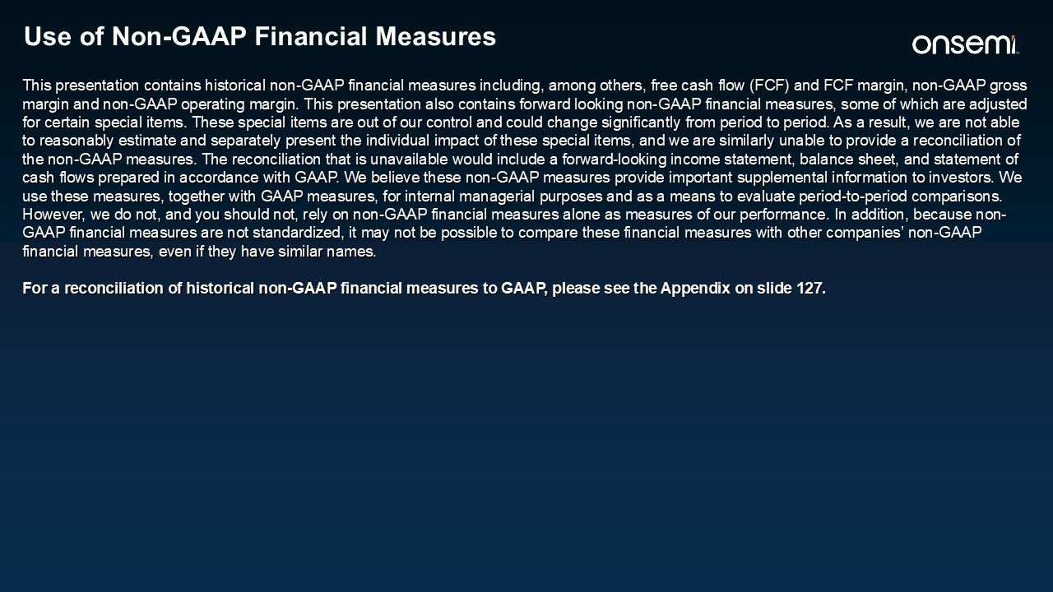
Use of Non-GAAP Financial Measures This presentation contains historical non-GAAP financial measures including, among others, free cash flow (FCF) and FCF margin, non-GAAP gross margin and non-GAAP operating margin. This presentation also contains forward looking non-GAAP financial measures, some of which are adjusted for certain special items. These special items are out of our control and could change significantly from period to period. As a result, we are not able to reasonably estimate and separately present the individual impact of these special items, and we are similarly unable to provide a reconciliation of the non-GAAP measures. The reconciliation that is unavailable would include a forward-looking income statement, balance sheet, and statement of cash flows prepared in accordance with GAAP. We believe these non-GAAP measures provide important supplemental information to investors. We use these measures, together with GAAP measures, for internal managerial purposes and as a means to evaluate period-to-period comparisons. However, we do not, and you should not, rely on non-GAAP financial measures alone as measures of our performance. In addition, because non-GAAP financial measures are not standardized, it may not be possible to compare these financial measures with other companies’ non-GAAP financial measures, even if they have similar names. For a reconciliation of historical non-GAAP financial measures to GAAP, please see the Appendix on slide 127.

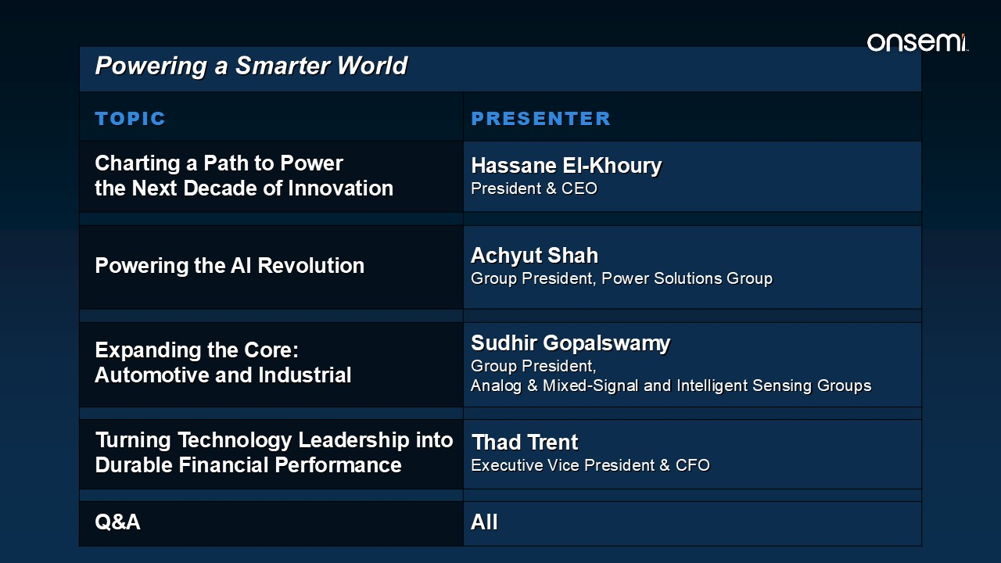
Powering a Smarter World TOPIC​​ PRESENTER​​ Charting a Path to Power the Next Decade of Innovation Hassane El-KhouryPresident & CEO​​ Powering the AI Revolution Achyut Shah Group President, Power Solutions Group Expanding the Core: Automotive and Industrial Sudhir Gopalswamy​​ Group President, Analog & Mixed-Signal and Intelligent Sensing Groups Turning Technology Leadership into Durable Financial Performance Thad Trent​​ Executive Vice President & CFO Q&A​​ All​​

Powering a Smarter World September 16, 2026




Charting a Path to Powerthe Next Decade of Innovation Hassane El-KhouryPresident and CEO

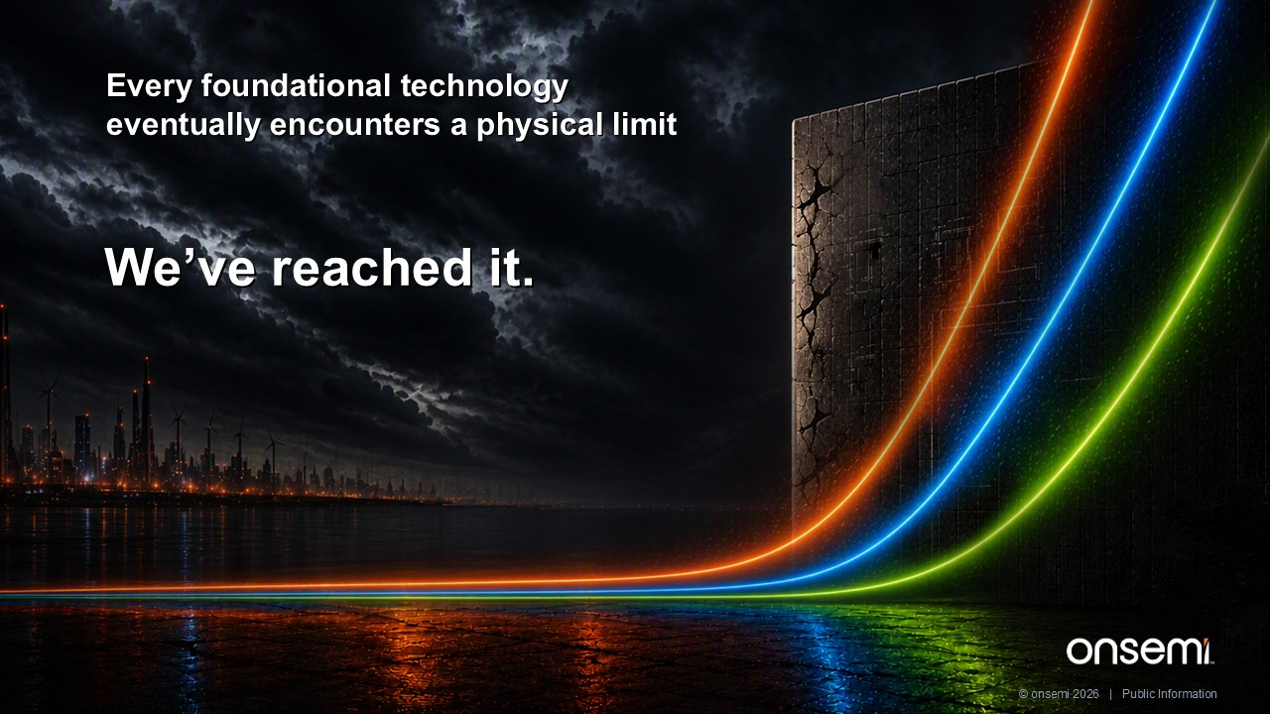
Every foundational technology eventually encounters a physical limit We’ve reached it. © onsemi 2026 | Public Information

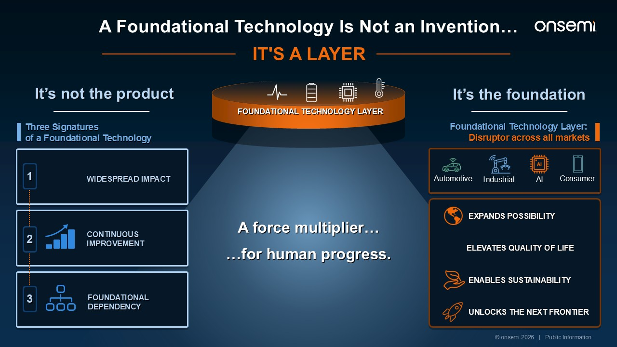
A Foundational Technology Is Not an Invention… Three Signatures of a Foundational Technology 1 WIDESPREAD IMPACT CONTINUOUS IMPROVEMENT FOUNDATIONAL DEPENDENCY 2 3 A force multiplier… …for human progress. IT'S A LAYER EXPANDS POSSIBILITY ELEVATES QUALITY OF LIFE ENABLES SUSTAINABILITY UNLOCKS THE NEXT FRONTIER It’s not the product It’s the foundation FOUNDATIONAL TECHNOLOGY LAYER Automotive Industrial AI Consumer Foundational Technology Layer: Disruptor across all markets © onsemi 2026 | Public Information

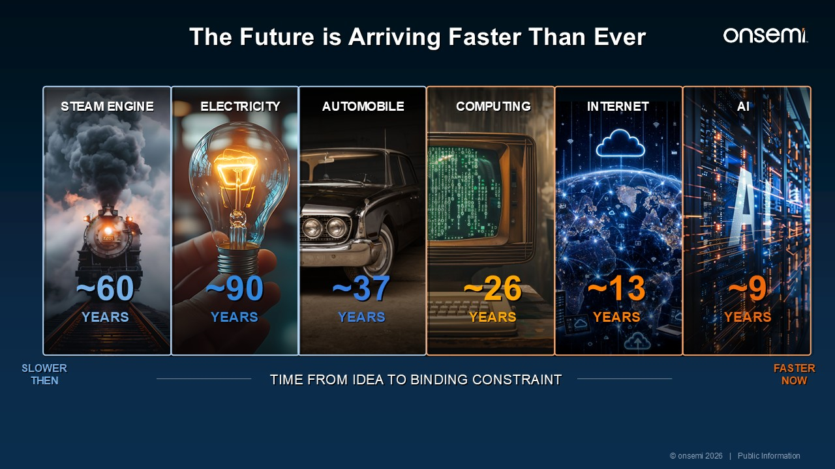
The Future is Arriving Faster Than Ever SLOWER THEN FASTER NOW STEAM ENGINE ~60 YEARS ~90 YEARS ~37 YEARS ~26 YEARS ~13 YEARS ~9 YEARS ELECTRICITY AUTOMOBILE COMPUTING INTERNET AI TIME FROM IDEA TO BINDING CONSTRAINT Every Foundational Technology Was Gated By A Physical Constraint Precision metalworking Grid & factory reorganization Petroleum refining, fuel distribution & road network Switching element – the transistor Bandwidth & local access infrastructure COMPUTE, MEMORY & POWER © onsemi 2026 | Public Information

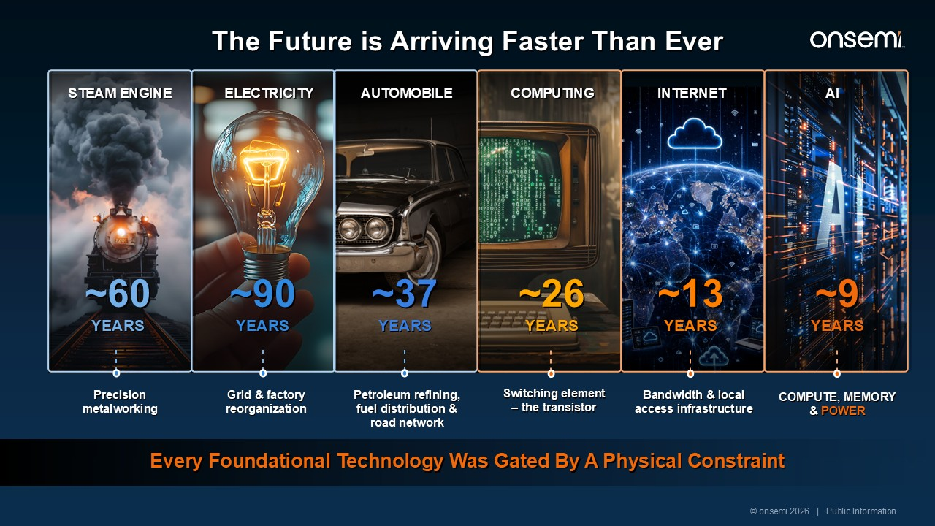
Every Foundational Technology Was Gated By A Physical Constraint Precision metalworking Grid & factory reorganization Petroleum refining, fuel distribution & road network Switching element – the transistor Bandwidth & local access infrastructure COMPUTE, MEMORY & POWER STEAM ENGINE ELECTRICITY AUTOMOBILE COMPUTING INTERNET AI ~60 YEARS ~90 YEARS ~37 YEARS ~26 YEARS ~13 YEARS ~9 YEARS © onsemi 2026 | Public Information The Future is Arriving Faster Than Ever

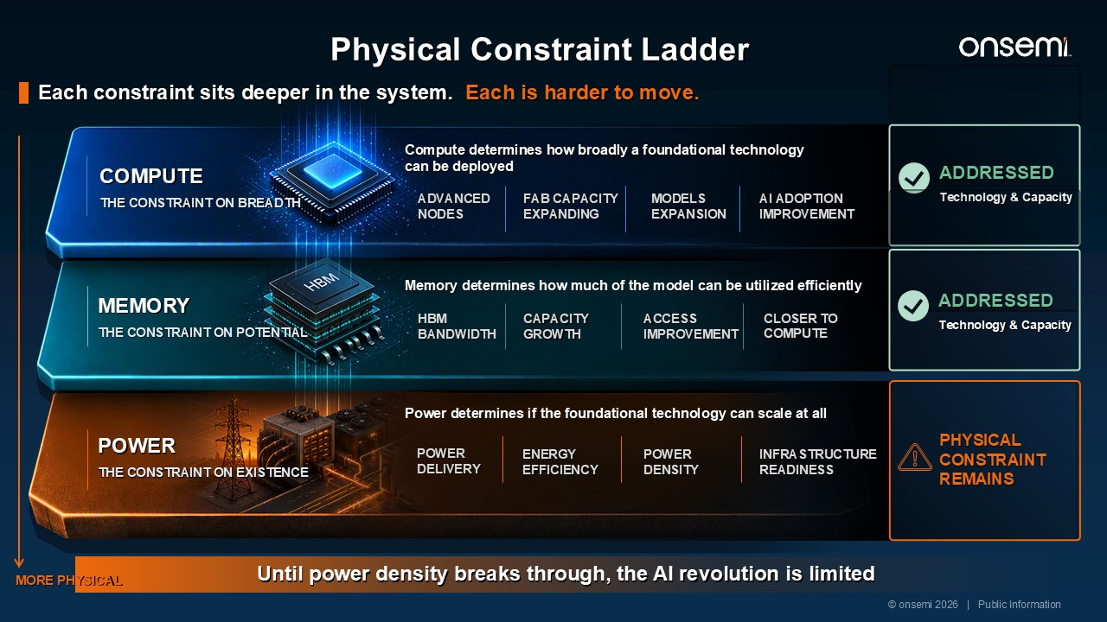
Physical Constraint Ladder Each constraint sits deeper in the system. Each is harder to move. Until power density breaks through, the AI revolution is limited COMPUTE THE CONSTRAINT ON BREADTH Compute determines how broadly a foundational technology can be deployed ADVANCEDNODES FAB CAPACITYEXPANDING MODELSEXPANSION AI ADOPTION IMPROVEMENT ADDRESSED Technology & Capacity MORE PHYSICAL MEMORY THE CONSTRAINT ON POTENTIAL Memory determines how much of the model can be utilized efficiently HBMBANDWIDTH CAPACITY GROWTH ACCESSIMPROVEMENT CLOSER TO COMPUTE ADDRESSED Technology & Capacity PHYSICAL CONSTRAINT REMAINS POWER THE CONSTRAINT ON EXISTENCE Power determines if the foundational technology can scale at all POWER DELIVERY ENERGY EFFICIENCY INFRASTRUCTURE READINESS POWER DENSITY © onsemi 2026 | Public Information

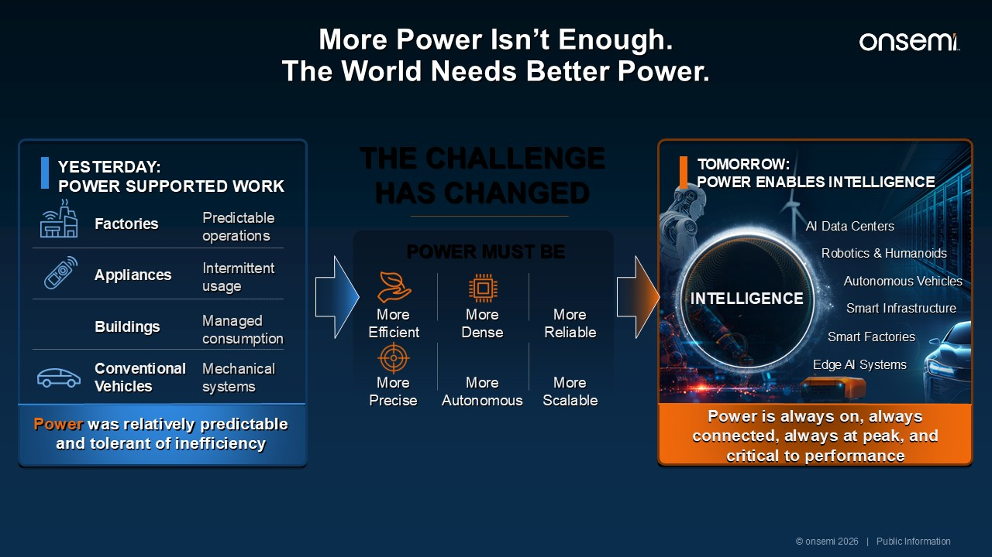
More Power Isn’t Enough. The World Needs Better Power. YESTERDAY: POWER SUPPORTED WORK Factories Predictable operations Appliances Intermittent usage Buildings Managed consumption Conventional Vehicles Mechanical systems Power was relatively predictable and tolerant of inefficiency TOMORROW: POWER ENABLES INTELLIGENCE Power is always on, always connected, always at peak, and critical to performance Autonomous Vehicles AI Data Centers Smart Factories Smart Infrastructure Robotics & Humanoids Edge AI Systems INTELLIGENCE THE CHALLENGE HAS CHANGED POWER MUST BE MoreEfficient MoreDense MoreReliable MorePrecise MoreAutonomous MoreScalable © onsemi 2026 | Public Information

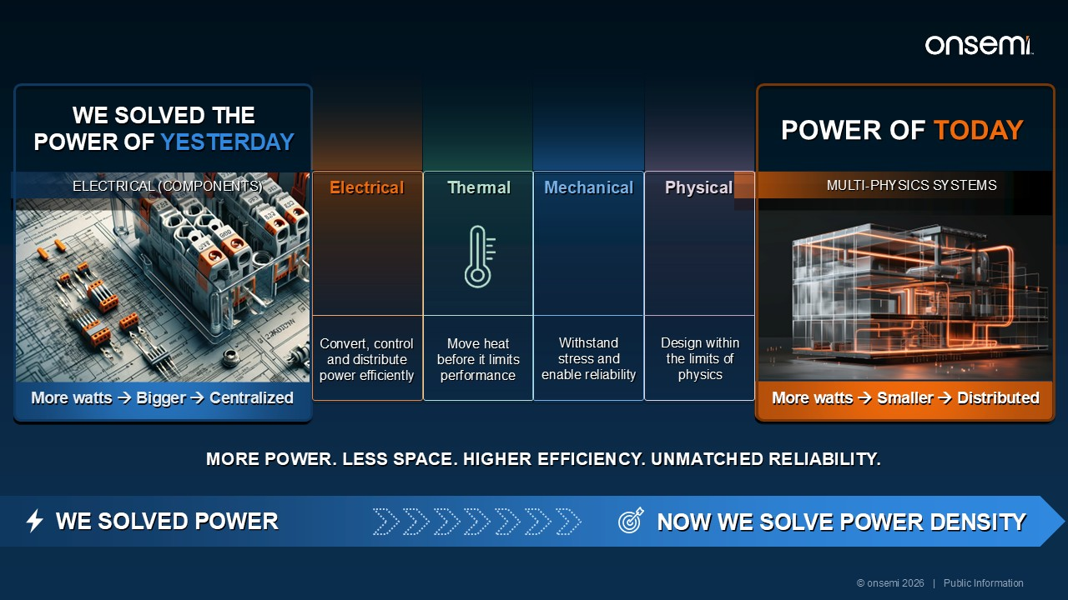
WE SOLVED POWER NOW WE SOLVE POWER DENSITY © onsemi 2026 | Public Information POWER OF TODAY WE SOLVED THE POWER OF YESTERDAY ELECTRICAL (COMPONENTS) MULTI-PHYSICS SYSTEMS More watts → Bigger → Centralized More watts → Smaller → Distributed Electrical Convert, control and distribute power efficiently Thermal Move heat before it limits performance Mechanical Withstand stress and enable reliability Physical Design within the limits of physics MORE POWER. LESS SPACE. HIGHER EFFICIENCY. UNMATCHED RELIABILITY.

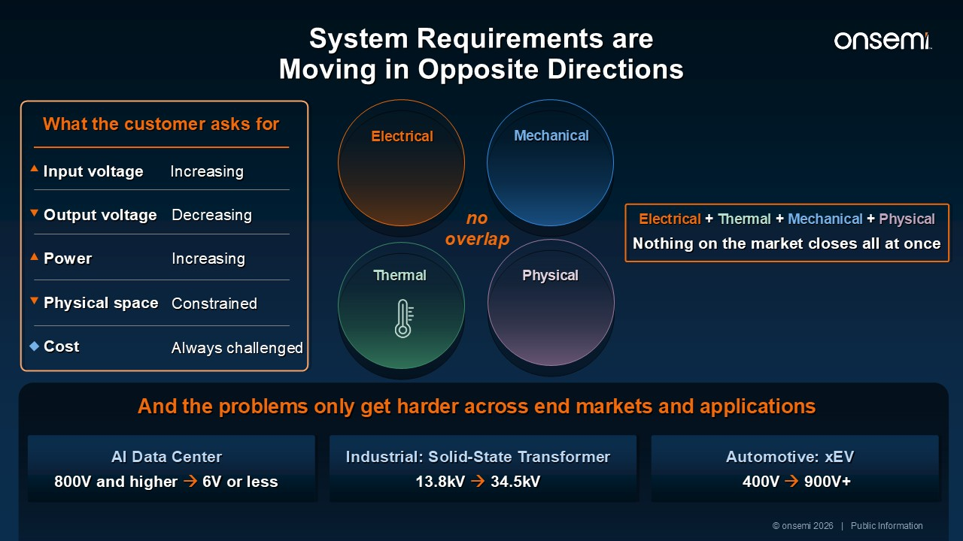
AI Data Center And the problems only get harder across end markets and applications 800V and higher → 6V or less Industrial: Solid-State Transformer 13.8kV → 34.5kV Automotive: xEV 400V → 900V+ © onsemi 2026 | Public Information no overlap Thermal Mechanical Electrical Physical What the customer asks for Input voltage Output voltage Power Physical space Cost Electrical + Thermal + Mechanical + Physical Nothing on the market closes all at once Always challenged Constrained Increasing Decreasing Increasing System Requirements are Moving in Opposite Directions

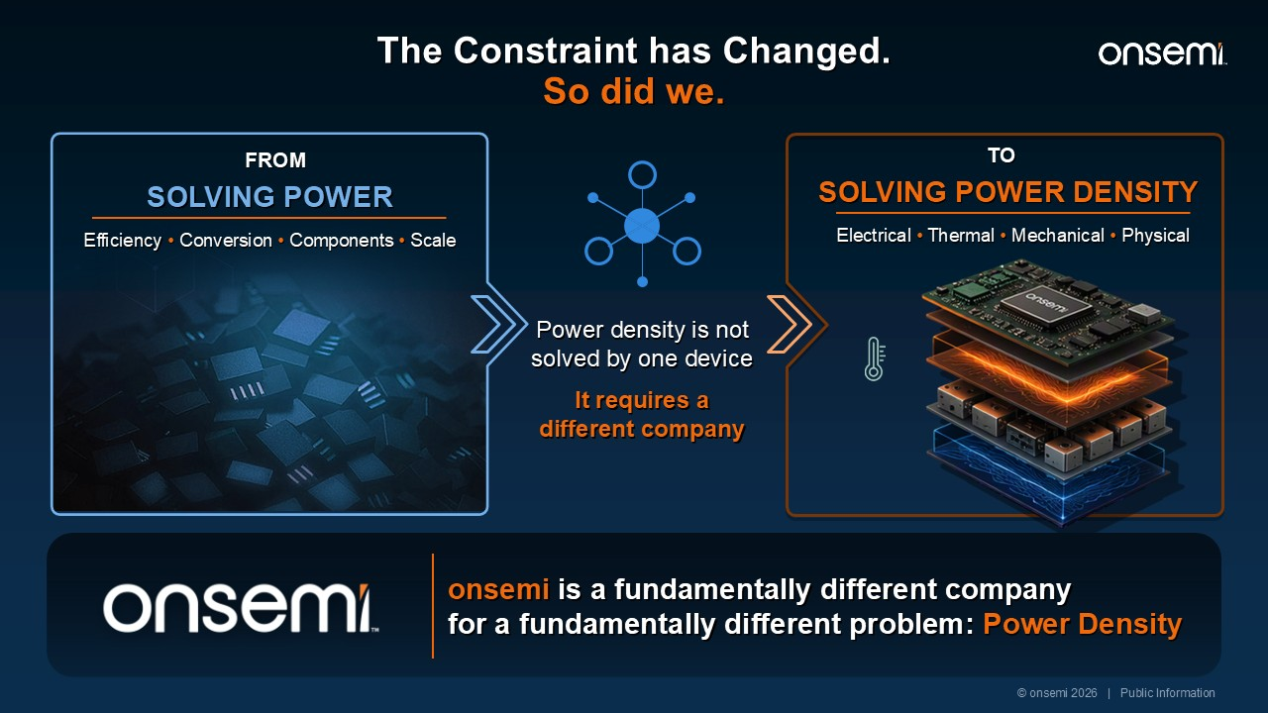
Power density is not solved by one device It requires a different company SOLVING POWER DENSITY TO Electrical • Thermal • Mechanical • Physical onsemi is a fundamentally different company for a fundamentally different problem: Power Density SOLVING POWER FROM Efficiency • Conversion • Components • Scale © onsemi 2026 | Public Information The Constraint has Changed. So did we.

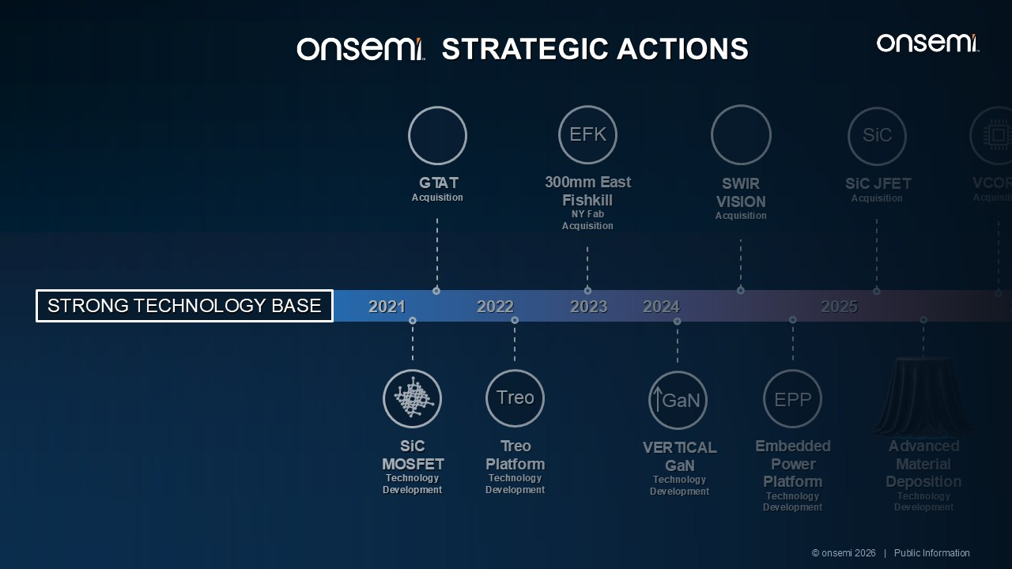
2021 GTAT Acquisition SWIR VISION Acquisition SiC JFETAcquisition SiC VCOREAcquisition Treo Platform Technology Development Treo LATERALGaNTechnology Development GaN VERTICALGaNTechnology Development GaN RISC-VAcquisition 300mm East Fishkill NY FabAcquisition EFK SiC MOSFET Technology Development Embedded Power Platform Technology Development EPP And Beyond Silver Atena Power Systems Acquisition SiA SynapticsAcquisition SYNA 2022 2023 2024 2025 2026 Advanced Material Deposition Technology Development STRATEGIC ACTIONS © onsemi 2026 | Public Information STRONG TECHNOLOGY BASE

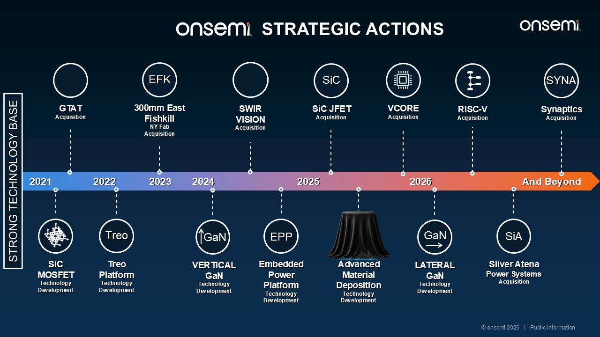
2021 GTAT Acquisition SWIR VISION Acquisition SiC JFETAcquisition SiC VCOREAcquisition Treo Platform Technology Development Treo LATERALGaNTechnology Development GaN VERTICALGaNTechnology Development GaN RISC-VAcquisition 300mm East Fishkill NY FabAcquisition EFK SiC MOSFET Technology Development Embedded Power Platform Technology Development EPP And Beyond Silver Atena Power Systems Acquisition SiA SynapticsAcquisition SYNA 2022 2023 2024 2025 2026 Advanced Material Deposition Technology Development STRONG TECHNOLOGY BASE © onsemi 2026 | Public Information STRATEGIC ACTIONS

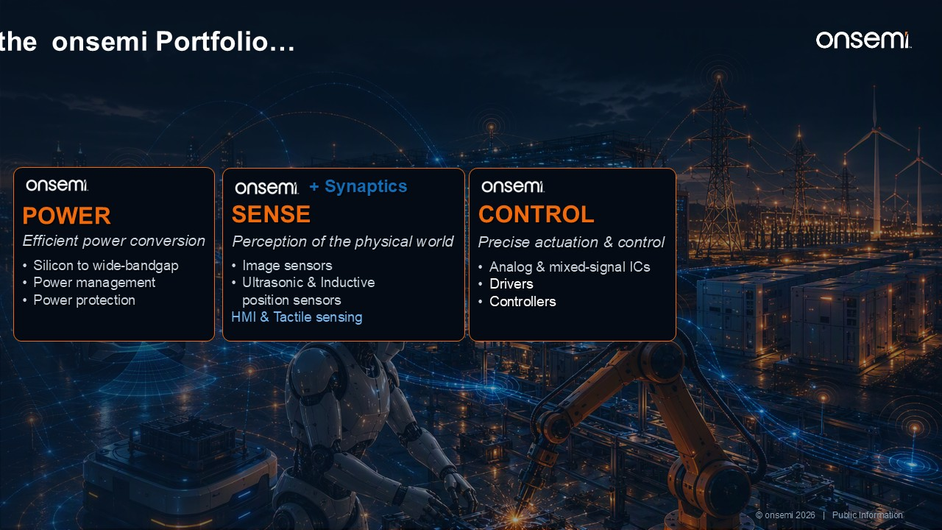
POWER Efficient power conversion Silicon to wide-bandgap Power management Power protection SENSE Perception of the physical world Image sensors Ultrasonic & Inductive position sensors HMI & Tactile sensing CONTROL Precise actuation & control Analog & mixed-signal ICs Drivers Controllers © onsemi 2026 | Public Information + Synaptics CONNECTED COMPUTE Edge intelligence & connectivity Single pair ethernet AI-First Compute Connectivity: Wi-Fi / BLE / Thread + Synaptics onsemi Portfolio… Synaptics Extends the

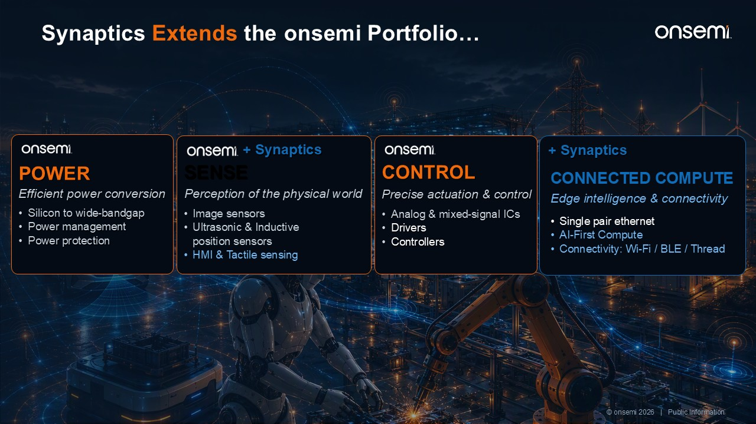
CONNECTED COMPUTE Edge intelligence & connectivity Single pair ethernet AI-First Compute Connectivity: Wi-Fi / BLE / Thread + Synaptics …completing the Four Pillars of Physical AI Machines that sense, decide, act and adapt © onsemi 2026 | Public Information Synaptics Extends the POWER Efficient power conversion Silicon to wide-bandgap Power management Power protection SENSE Perception of the physical world Image sensors Ultrasonic & Inductive position sensors HMI & Tactile sensing CONTROL Precise actuation & control Analog & mixed-signal ICs Drivers Controllers + Synaptics onsemi Portfolio…

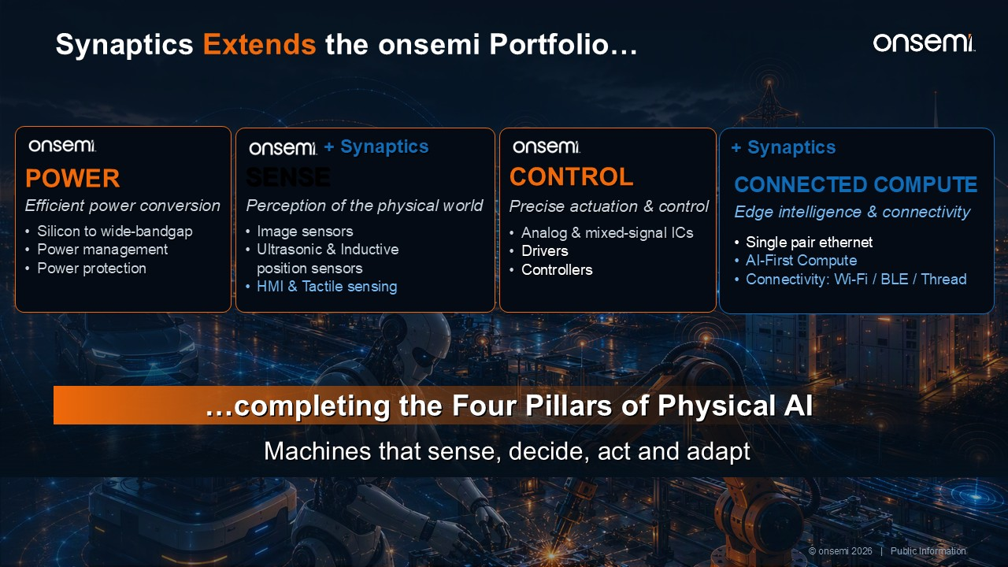
CONNECTED COMPUTE Edge intelligence & connectivity Single pair ethernet AI-First Compute Connectivity: Wi-Fi / BLE / Thread + Synaptics …completing the Four Pillars of Physical AI Machines that sense, decide, act and adapt © onsemi 2026 | Public Information Synaptics Extends the onsemi Portfolio… POWER Efficient power conversion Silicon to wide-bandgap Power management Power protection SENSE Perception of the physical world Image sensors Ultrasonic & Inductive position sensors HMI & Tactile sensing CONTROL Precise actuation & control Analog & mixed-signal ICs Drivers Controllers + Synaptics

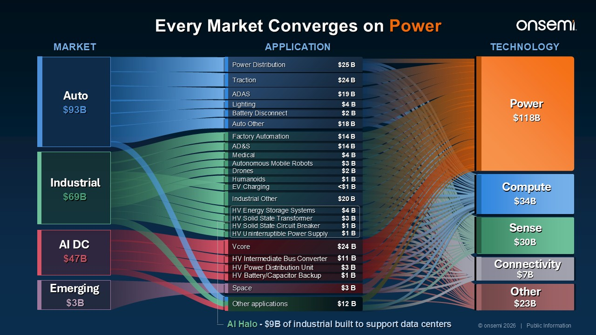
Auto Other $18 B AD&S $14 B Medical $4 B Autonomous Mobile Robots $3 B Drones $2 B Humanoids $1 B EV Charging <$1 B Industrial Other $20 B HV Energy Storage Systems $4 B HV Solid State Transformer $3 B HV Solid State Circuit Breaker $1 B HV Uninterruptible Power Supply $1 B Vcore $24 B HV Intermediate Bus Converter $11 B HV Power Distribution Unit $3 B HV Battery/Capacitor Backup $1 B Other applications $12 B MARKET APPLICATION TECHNOLOGY Auto $93B Power Distribution $25 B Traction $24 B ADAS $19 B Lighting $4 B Battery Disconnect $2 B Industrial $69B Factory Automation $14 B AI Halo - $9B of industrial built to support data centers AI DC $47B Emerging $3B Space $3 B Power $118B Compute $34B Sense $30B Connectivity $7B Other $23B © onsemi 2026 | Public Information Every Market Converges on Power

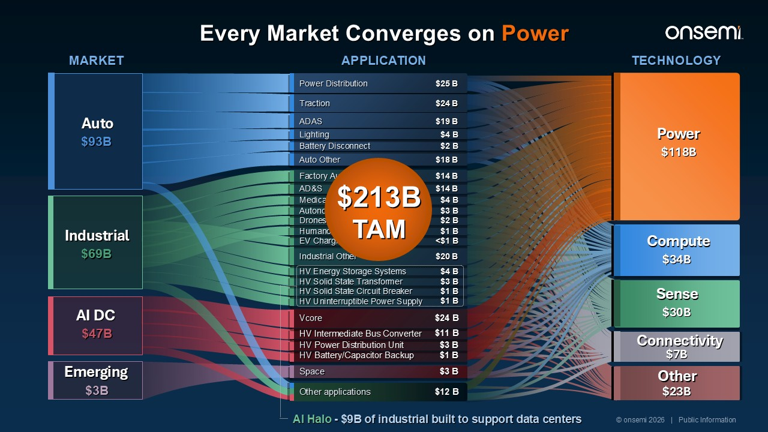
Auto Other $18 B AD&S $14 B Medical $4 B Autonomous Mobile Robots $3 B Drones $2 B Humanoids $1 B EV Charging <$1 B Industrial Other $20 B HV Energy Storage Systems $4 B HV Solid State Transformer $3 B HV Solid State Circuit Breaker $1 B HV Uninterruptible Power Supply $1 B Vcore $24 B HV Intermediate Bus Converter $11 B HV Power Distribution Unit $3 B HV Battery/Capacitor Backup $1 B Other applications $12 B MARKET APPLICATION TECHNOLOGY Auto $93B Power Distribution $25 B Traction $24 B ADAS $19 B Lighting $4 B Battery Disconnect $2 B Industrial $69B Factory Automation $14 B AI Halo - $9B of industrial built to support data centers AI DC $47B Emerging $3B Space $3 B Power $118B Compute $34B Sense $30B Connectivity $7B Other $23B © onsemi 2026 | Public Information Every Market Converges on Power $213B TAM Technology

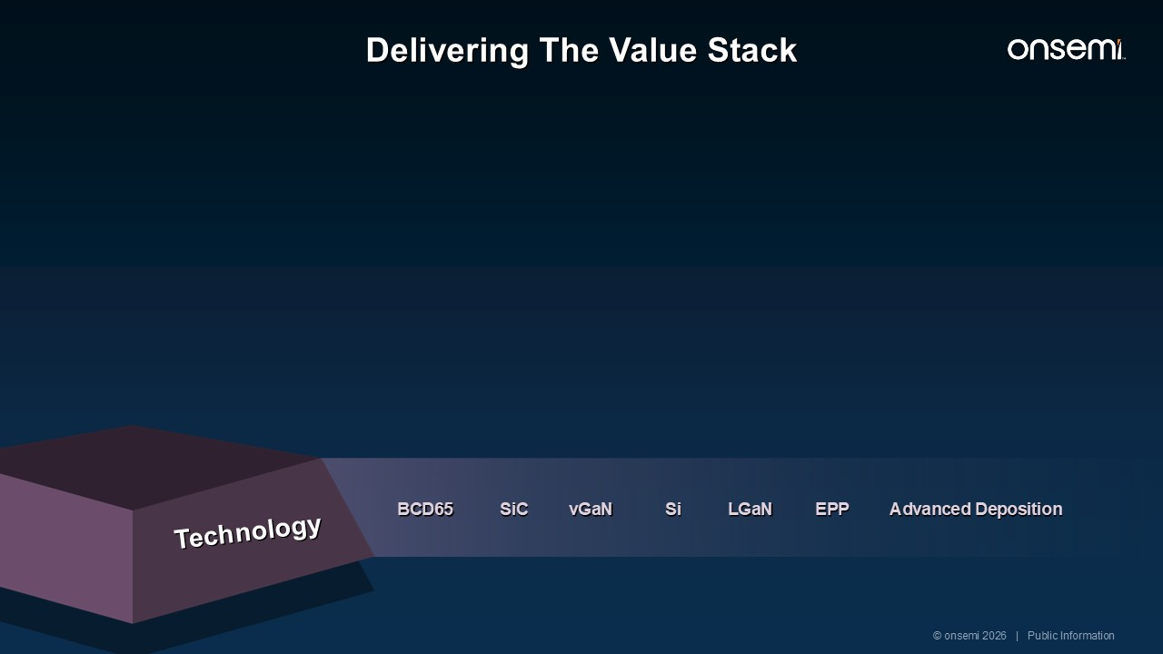
Delivering The Value Stack Technology SiC vGaN LGaN Si Advanced Deposition BCD65 EPP © onsemi 2026 | Public Information Products

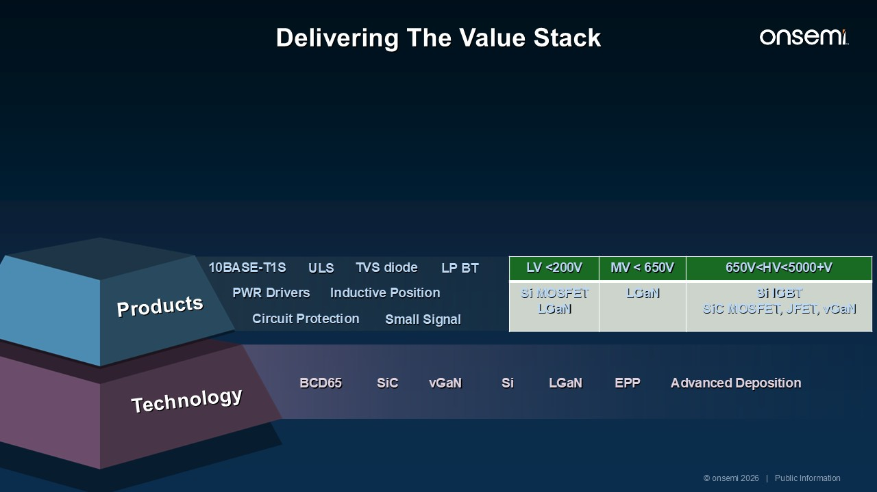
Delivering The Value Stack Products Technology SiC vGaN LGaN 10BASE-T1S PWR Drivers ULS Small Signal Si Advanced Deposition Circuit Protection BCD65 EPP Inductive Position LV <200V MV < 650V 650V<HV<5000+V Si MOSFET LGaN LGaN Si IGBT SiC MOSFET, JFET, vGaN TVS diode LP BT © onsemi 2026 | Public Information Solutions

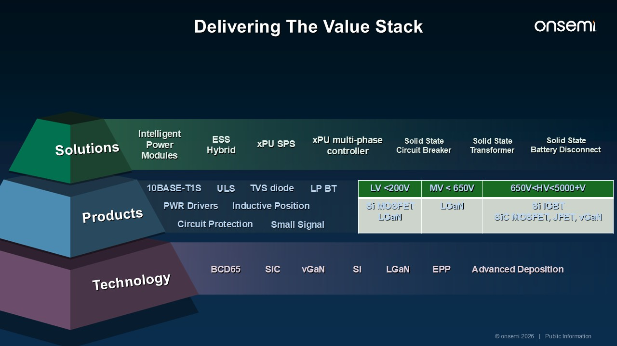
Delivering The Value Stack Products Technology Solutions SiC vGaN LGaN 10BASE-T1S PWR Drivers ULS Small Signal ESS Hybrid Intelligent Power Modules xPU SPS Solid State Transformer Solid State Circuit Breaker Si Advanced Deposition Circuit Protection BCD65 EPP Inductive Position Solid State Battery Disconnect xPU multi-phase controller LV <200V MV < 650V 650V<HV<5000+V Si MOSFET LGaN LGaN Si IGBT SiC MOSFET, JFET, vGaN TVS diode LP BT © onsemi 2026 | Public Information Systems

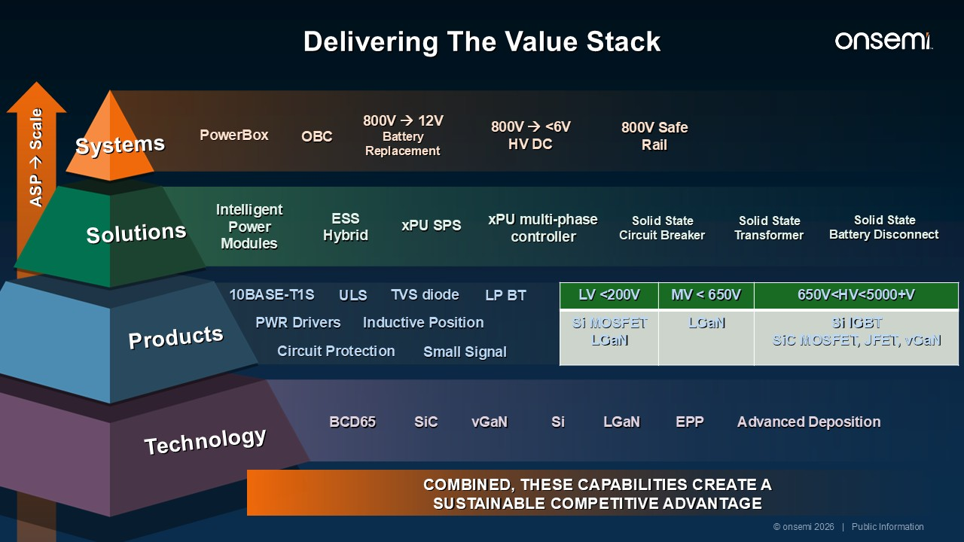
ASP → Scale Delivering The Value Stack Products Technology Solutions Systems COMBINED, THESE CAPABILITIES CREATE A SUSTAINABLE COMPETITIVE ADVANTAGE SiC vGaN LGaN 10BASE-T1S PWR Drivers ULS Small Signal ESS Hybrid Intelligent Power Modules xPU SPS Solid State Transformer PowerBox Solid State Circuit Breaker 800V → <6V HV DC Si Advanced Deposition Circuit Protection BCD65 EPP Inductive Position Solid State Battery Disconnect xPU multi-phase controller OBC 800V Safe Rail 800V → 12V Battery Replacement LV <200V MV < 650V 650V<HV<5000+V Si MOSFET LGaN LGaN Si IGBT SiC MOSFET, JFET, vGaN TVS diode LP BT © onsemi 2026 | Public Information

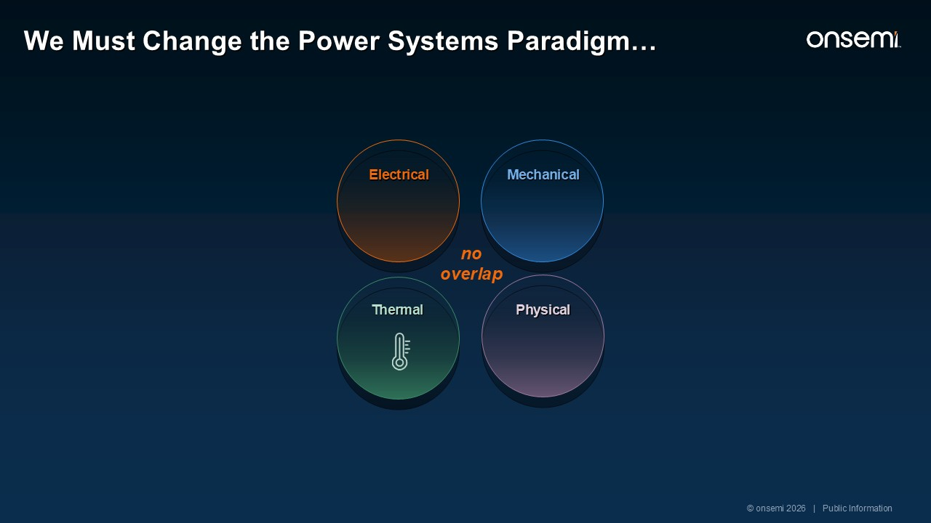
no overlap Thermal Mechanical Electrical Physical © onsemi 2026 | Public Information We Must Change the Power Systems Paradigm…

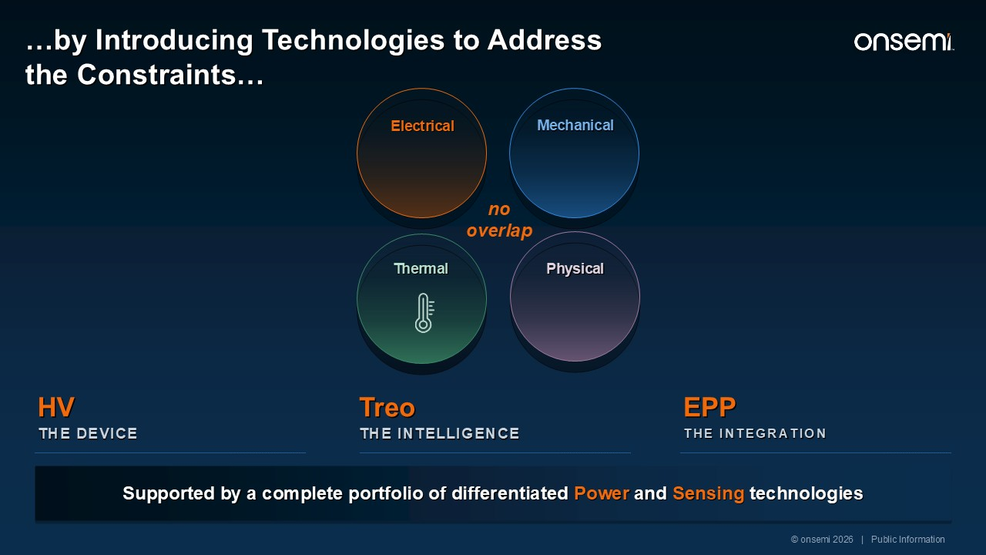
no overlap Thermal Mechanical Electrical Physical Supported by a complete portfolio of differentiated Power and Sensing technologies EPP THE INTEGRATION HV THE DEVICE Treo THE INTELLIGENCE © onsemi 2026 | Public Information …by Introducing Technologies to Address the Constraints…

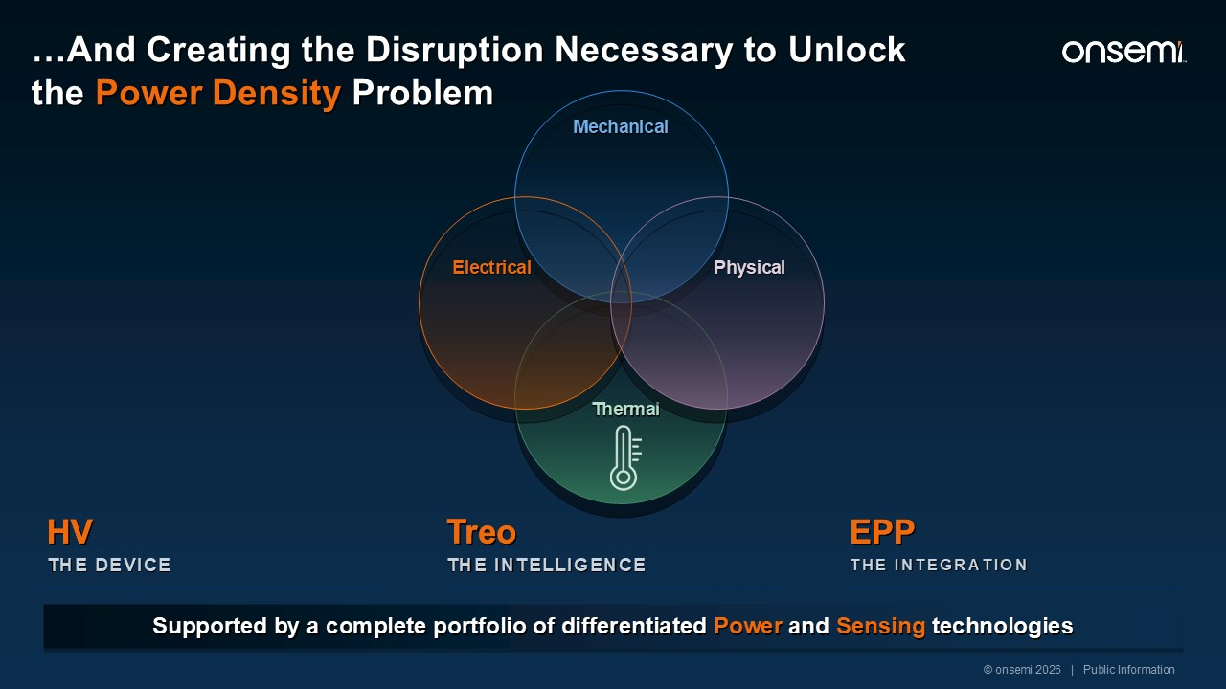
Mechanical Thermal Electrical Physical © onsemi 2026 | Public Information …And Creating the Disruption Necessary to Unlock the Power Density Problem Supported by a complete portfolio of differentiated Power and Sensing technologies EPP THE INTEGRATION HV THE DEVICE Treo THE INTELLIGENCE EPP Treo HV

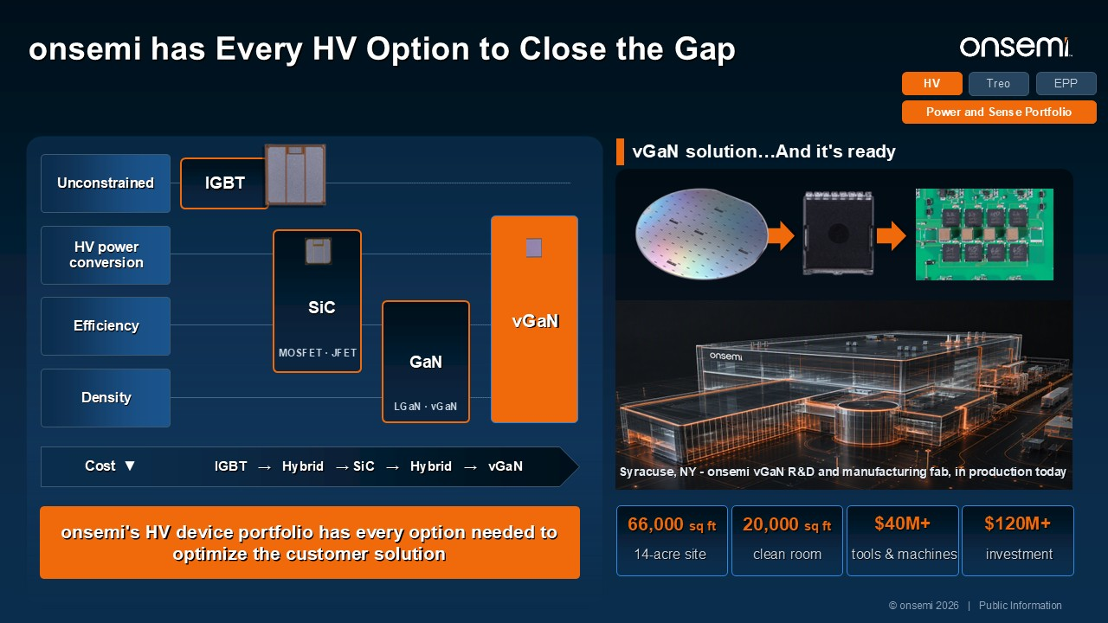
Unconstrained HV power conversion Efficiency Density IGBT SiC MOSFET · JFET GaN LGaN · vGaN Cost ▼ IGBT → Hybrid → SiC → Hybrid → vGaN onsemi's HV device portfolio has every option needed to optimize the customer solution vGaN solution…And it's ready 66,000 sq ft 14-acre site 20,000 sq ft clean room $40M+ tools & machines $120M+ investment Treo HV Power and Sense Portfolio Syracuse, NY - onsemi vGaN R&D and manufacturing fab, in production today vGaN © onsemi 2026 | Public Information EPP onsemi has Every HV Option to Close the Gap

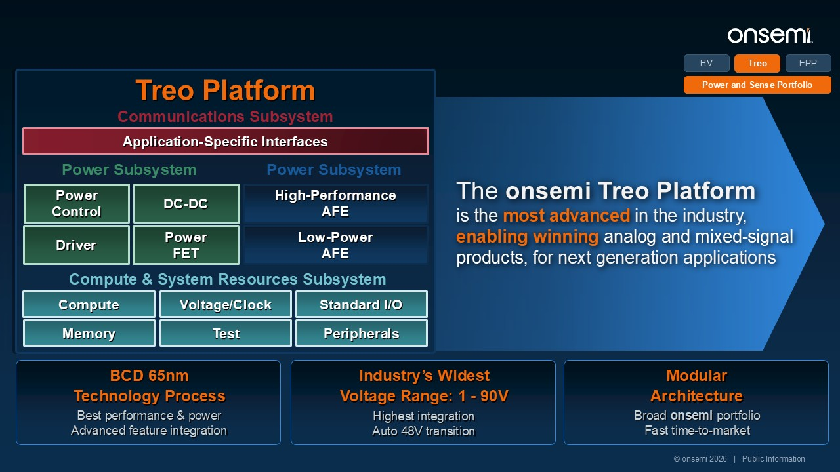
The onsemi Treo Platform is the most advanced in the industry, enabling winning analog and mixed-signal products, for next generation applications BCD 65nm Technology Process Best performance & power Advanced feature integration Industry’s Widest Voltage Range: 1 - 90V Highest integration Auto 48V transition Modular Architecture Broad onsemi portfolio Fast time-to-market Treo HV EPP Power and Sense Portfolio Treo Platform Application-Specific Interfaces Communications Subsystem Power Control Power Subsystem DC-DC Driver Power FET Power Subsystem High-PerformanceAFE Low-Power AFE Compute & System Resources Subsystem Compute Voltage/Clock Standard I/O Memory Test Peripherals © onsemi 2026 | Public Information

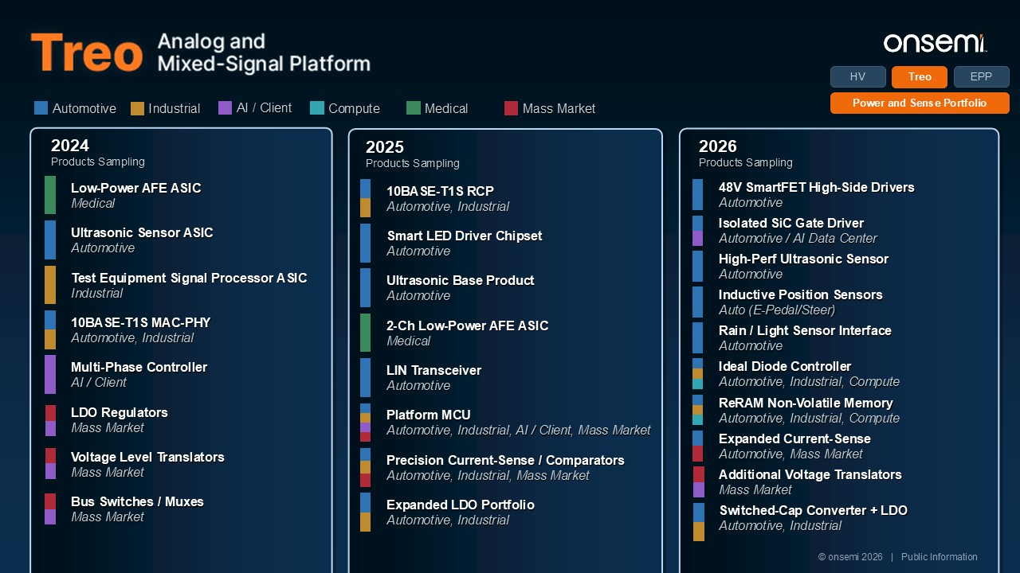
Automotive Industrial AI / Client Compute Mass Market Medical 2024 Products Sampling Low-Power AFE ASIC Medical Ultrasonic Sensor ASIC Automotive Test Equipment Signal Processor ASIC Industrial 10BASE-T1S MAC-PHY Automotive, Industrial Multi-Phase Controller AI / Client LDO Regulators Mass Market Voltage Level Translators Mass Market Bus Switches / Muxes Mass Market 2025 Products Sampling 10BASE-T1S RCP Automotive, Industrial Smart LED Driver Chipset Automotive Ultrasonic Base Product Automotive 2-Ch Low-Power AFE ASIC Medical LIN Transceiver Automotive Platform MCU Automotive, Industrial, AI / Client, Mass Market Precision Current-Sense / Comparators Automotive, Industrial, Mass Market Expanded LDO Portfolio Automotive, Industrial 2026 Products Sampling 48V SmartFET High-Side Drivers Automotive Isolated SiC Gate Driver Automotive / AI Data Center High-Perf Ultrasonic Sensor Automotive Inductive Position Sensors Auto (E-Pedal/Steer) Rain / Light Sensor Interface Automotive Ideal Diode Controller Automotive, Industrial, Compute ReRAM Non-Volatile Memory Automotive, Industrial, Compute Expanded Current-Sense Automotive, Mass Market Additional Voltage Translators Mass Market Switched-Cap Converter + LDO Automotive, Industrial Treo HV EPP Power and Sense Portfolio © onsemi 2026 | Public Information

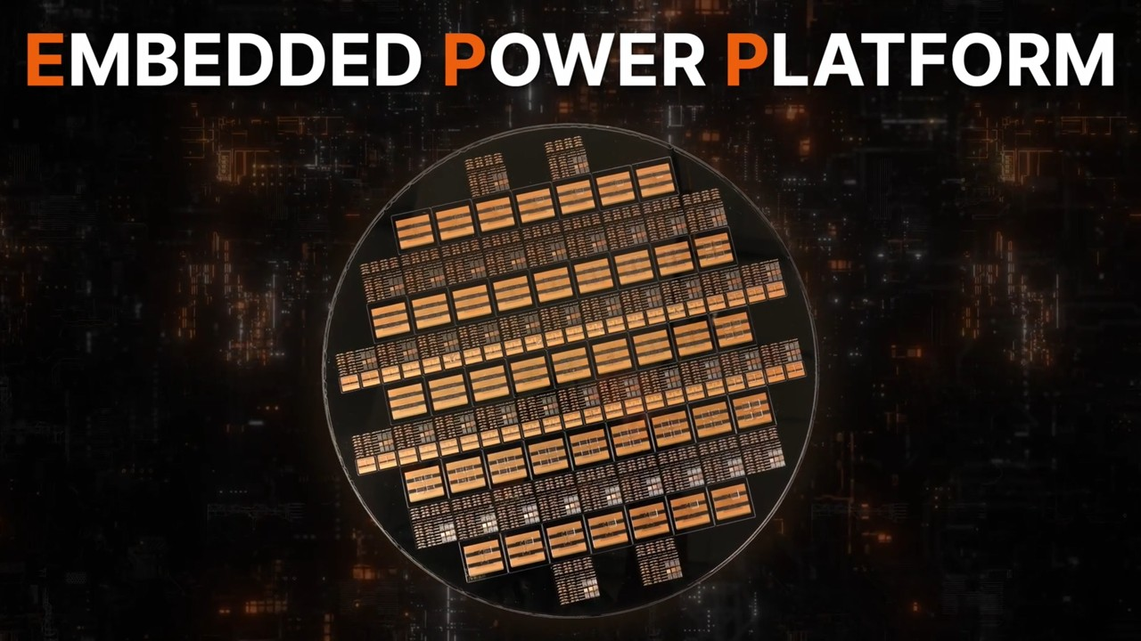

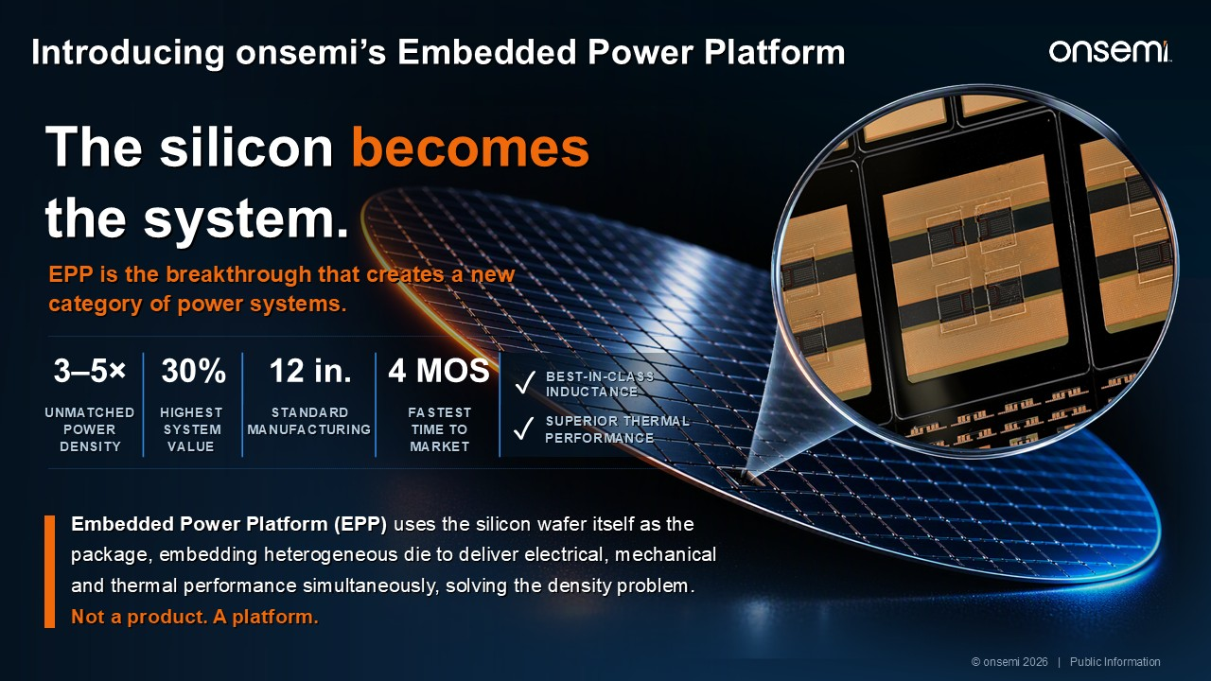
The silicon becomes the system. EPP is the breakthrough that creates a new category of power systems. Embedded Power Platform (EPP) uses the silicon wafer itself as the package, embedding heterogeneous die to deliver electrical, mechanical and thermal performance simultaneously, solving the density problem. Not a product. A platform. 3–5× UNMATCHED POWER DENSITY 30% HIGHEST SYSTEM VALUE 12 in. STANDARD MANUFACTURING 4 MOS FASTEST TIME TO MARKET ✓ SUPERIOR THERMAL PERFORMANCE BEST-IN-CLASS INDUCTANCE ✓ © onsemi 2026 | Public Information Introducing onsemi’s Embedded Power Platform

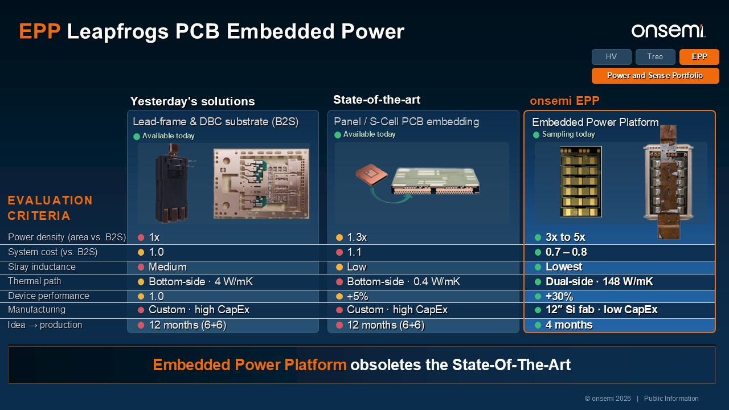
Yesterday's solutions Lead-frame & DBC substrate (B2S) Available today Available today Sampling today EVALUATION CRITERIA Power density (area vs. B2S) 1x 1.3x 3x to 5x System cost (vs. B2S) 1.0 1.1 0.7 – 0.8 Stray inductance Medium Low Lowest Thermal path Bottom-side · 4 W/mK Bottom-side · 0.4 W/mK Dual-side · 148 W/mK Device performance 1.0 +5% +30% Manufacturing Custom · high CapEx Custom · high CapEx 12″ Si fab · low CapEx Idea → production 12 months (6+6) 12 months (6+6) 4 months Embedded Power Platform obsoletes the State-Of-The-Art State-of-the-art Panel / S-Cell PCB embedding onsemi EPP Embedded Power Platform Treo HV EPP Power and Sense Portfolio © onsemi 2026 | Public Information EPP Leapfrogs PCB Embedded Power

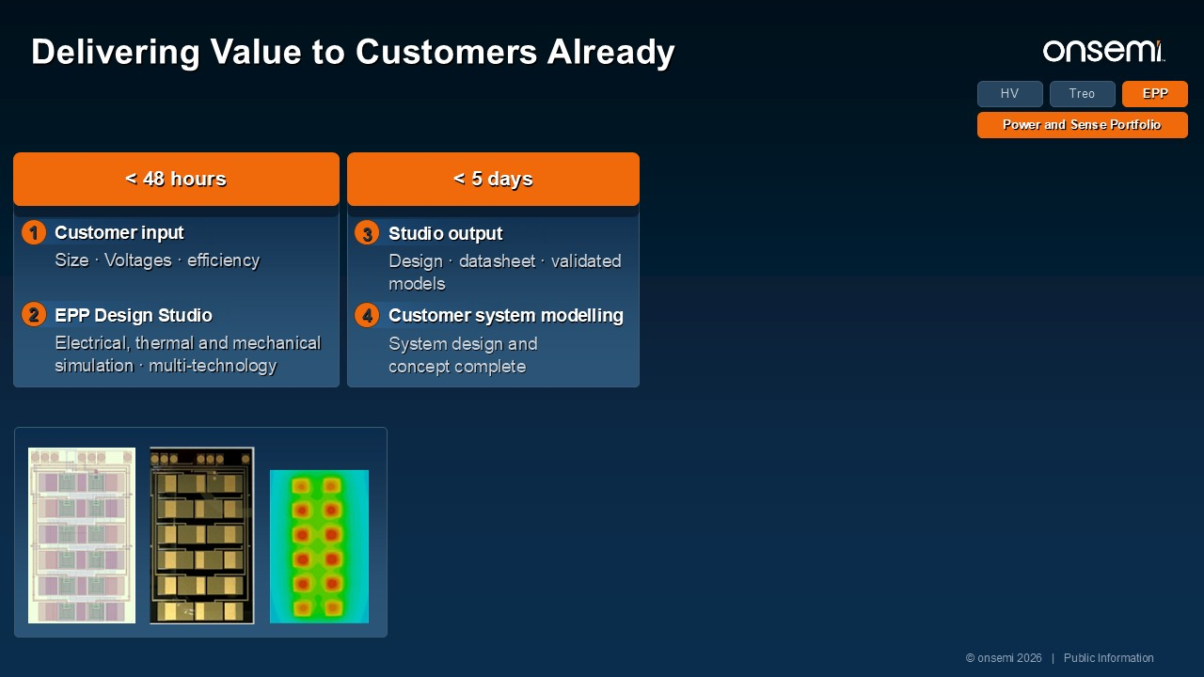
< 48 hours Size · Voltages · efficiency 1 Customer input Electrical, thermal and mechanical simulation · multi-technology 2 EPP Design Studio < 5 days System design and concept complete 4 Customer system modelling Design · datasheet · validated models 3 Studio output < 3 months 12″ silicon fab · standard process 6 Interposer manufacturing No new CapEx or custom tooling to bring up 5 No custom back-end Customer / project dependent Validation at the customer, on the customer's schedule 7 System integration Wafer-level test · standard flow 8 Production AI DC Customer Industrial Customer Treo HV EPP Power and Sense Portfolio © onsemi 2026 | Public Information Delivering Value to Customers Already

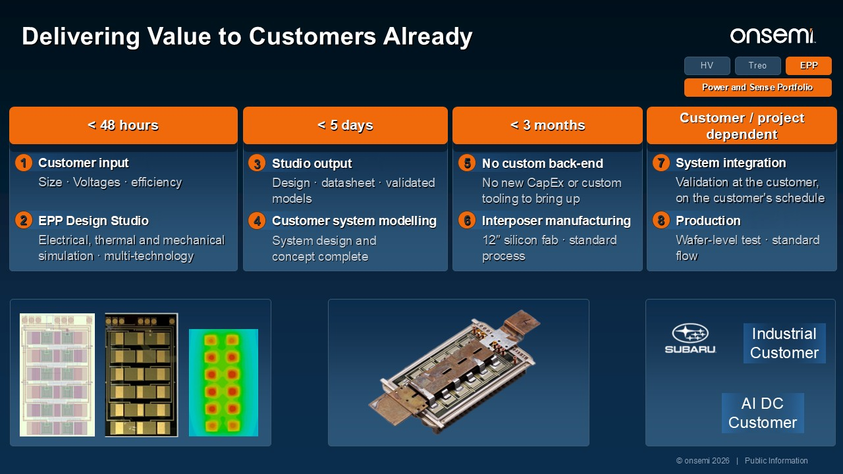
< 48 hours Size · Voltages · efficiency 1 Customer input Electrical, thermal and mechanical simulation · multi-technology 2 EPP Design Studio < 5 days System design and concept complete 4 Customer system modelling Design · datasheet · validated models 3 Studio output < 3 months 12″ silicon fab · standard process 6 Interposer manufacturing No new CapEx or custom tooling to bring up 5 No custom back-end Customer / project dependent Validation at the customer, on the customer's schedule 7 System integration Wafer-level test · standard flow 8 Production AI DC Customer Industrial Customer Treo HV EPP Power and Sense Portfolio © onsemi 2026 | Public Information Delivering Value to Customers Already

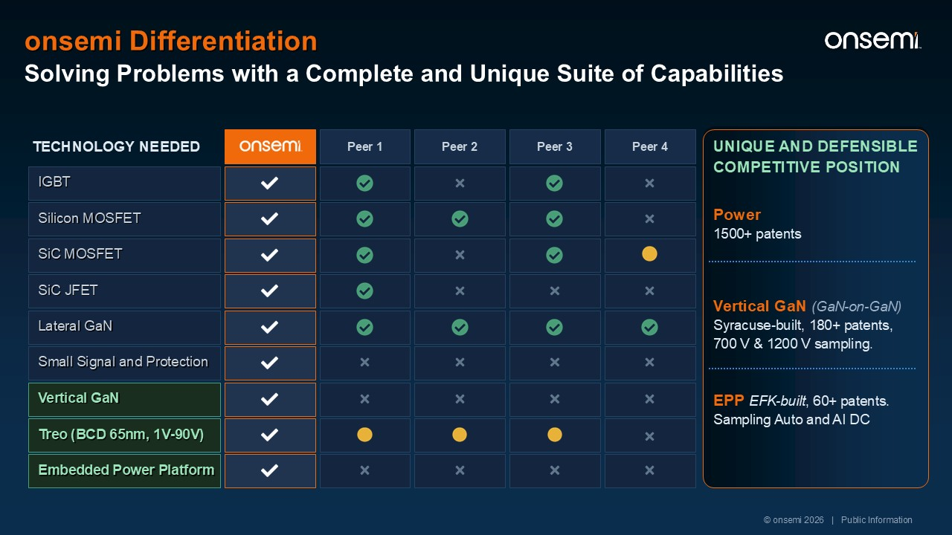
Solving Problems with a Complete and Unique Suite of Capabilities Peer 1 Peer 2 Peer 3 Peer 4 TECHNOLOGY NEEDED IGBT Silicon MOSFET SiC MOSFET SiC JFET Lateral GaN Vertical GaN Treo (BCD 65nm, 1V-90V) UNIQUE AND DEFENSIBLE COMPETITIVE POSITION Power 1500+ patents Vertical GaN (GaN-on-GaN) Syracuse-built, 180+ patents, 700 V & 1200 V sampling. EPP EFK-built, 60+ patents. Sampling Auto and AI DC Embedded Power Platform Small Signal and Protection © onsemi 2026 | Public Information onsemi Differentiation

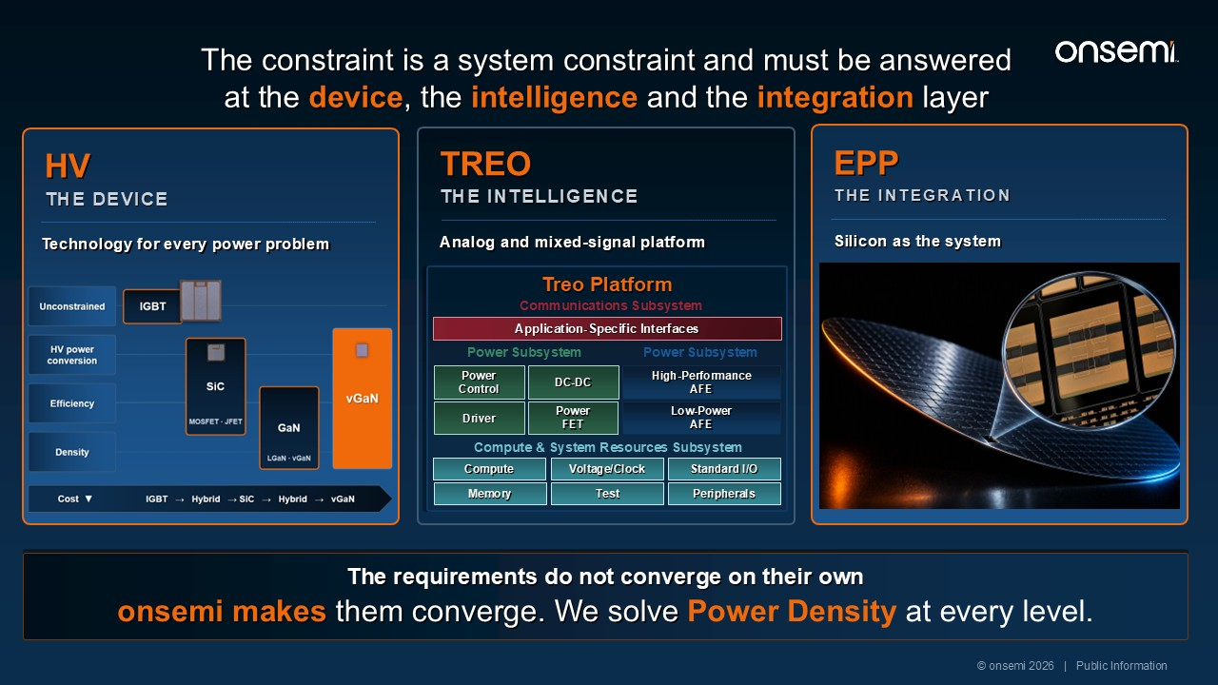
EPP THE INTEGRATION Silicon as the system The requirements do not converge on their own onsemi makes them converge. We solve Power Density at every level. TREO THE INTELLIGENCE Analog and mixed-signal platform HV THE DEVICE Technology for every power problem © onsemi 2026 | Public Information The constraint is a system constraint and must be answered at the device, the intelligence and the integration layer Treo Platform Application-Specific Interfaces Communications Subsystem Power Control Power Subsystem DC-DC Driver Power FET Power Subsystem High-PerformanceAFE Low-Power AFE Compute & System Resources Subsystem Compute Voltage/Clock Standard I/O Memory Test Peripherals




onsemi: Powering the AI Revolution Achyut ShahGroup President, Power Solutions Group

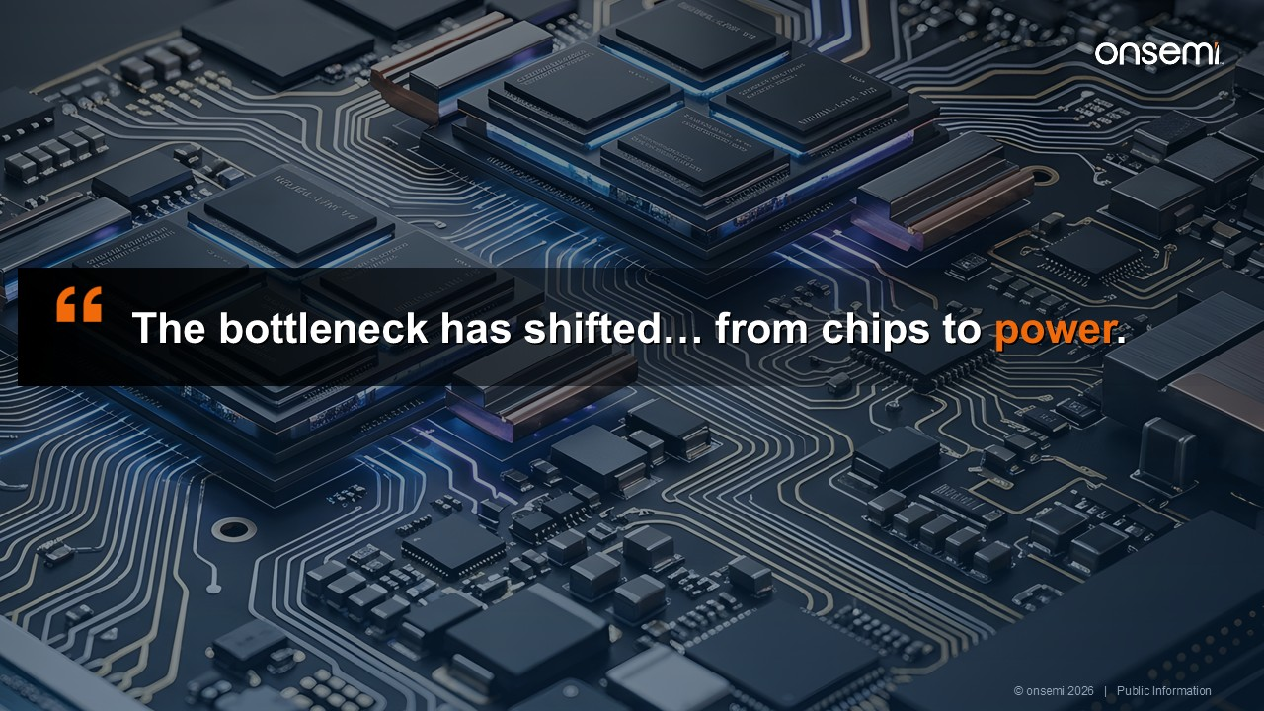
The bottleneck has shifted… from chips to power. from chips to power. © onsemi 2026 | Public Information

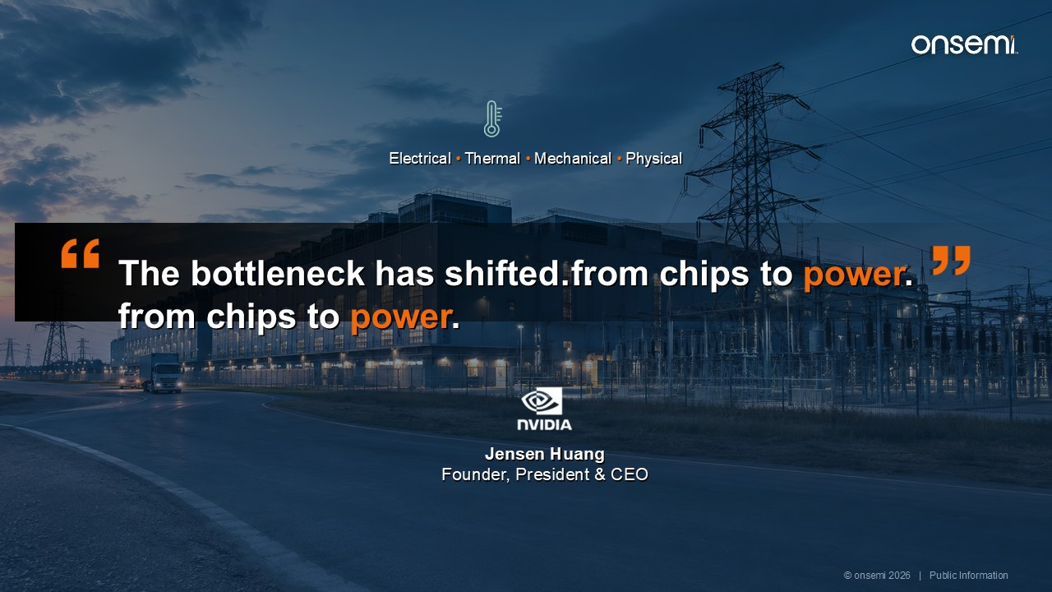
Jensen Huang Founder, President & CEO Electrical • Thermal • Mechanical • Physical from chips to power. The bottleneck has shifted… from chips to power. © onsemi 2026 | Public Information

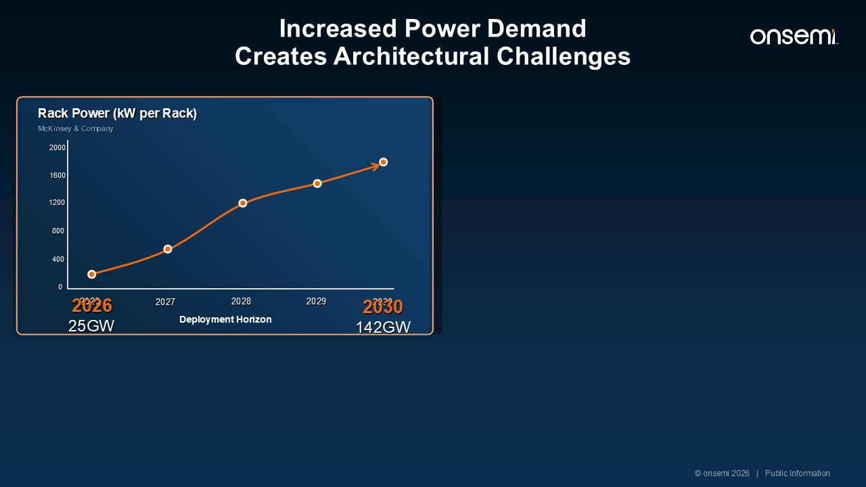
GPU kW vs Deployment Horizon Source: McKinsey & Company Increased Power Demand Creates Architectural Challenges 2000 1600 0 1200 800 400 2026 2027 2028 2029 2030 Deployment Horizon 2030 142GW 2026 25GW Rack Power (kW per Rack) McKinsey & Company © onsemi 2026 | Public Information

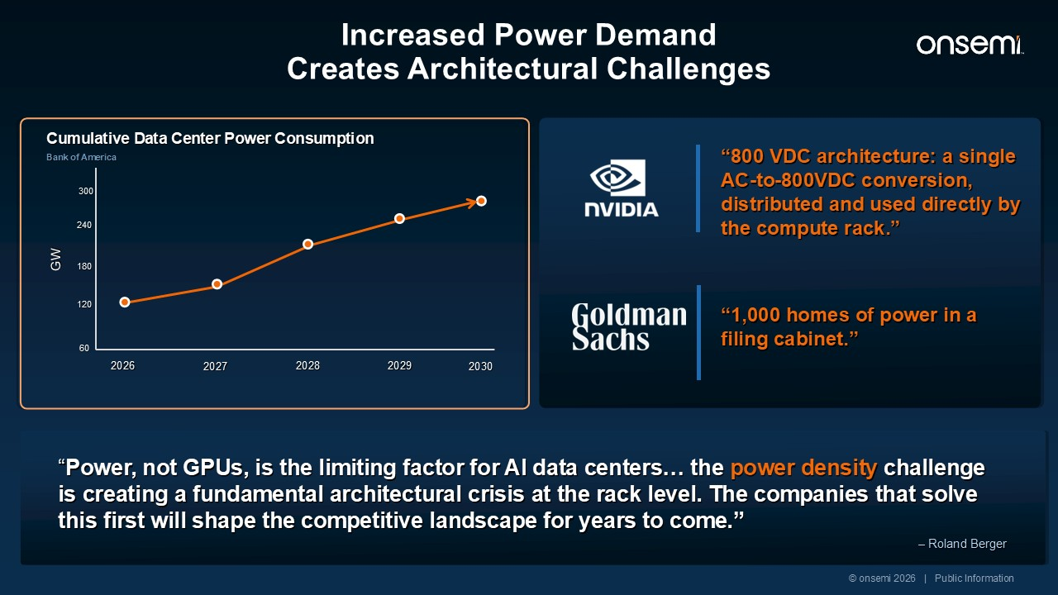
“Power, not GPUs, is the limiting factor for AI data centers… the power density challenge is creating a fundamental architectural crisis at the rack level. The companies that solve this first will shape the competitive landscape for years to come.” – Roland Berger “800 VDC architecture: a single AC-to-800VDC conversion, distributed and used directly by the compute rack.” “1,000 homes of power in a filing cabinet.” GPU kW vs Deployment Horizon Source: McKinsey & Company Increased Power Demand Creates Architectural Challenges 300 60 GW 240 180 120 2026 2027 2028 2029 2030 Cumulative Data Center Power Consumption Bank of America © onsemi 2026 | Public Information

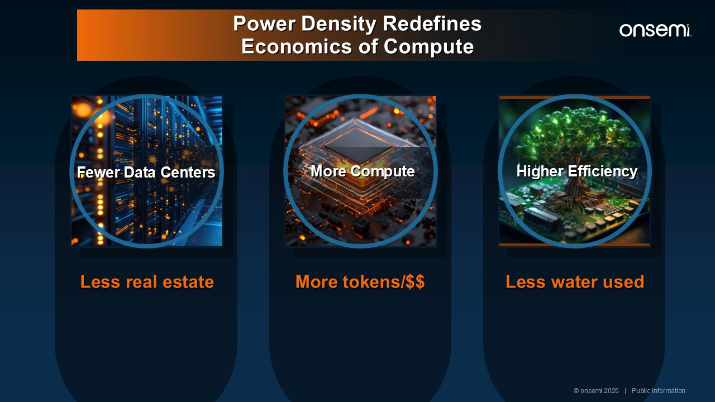
Less real estate More tokens/$$ Less water used Fewer Data Centers More Compute Higher Efficiency © onsemi 2026 | Public Information Power Density Redefines Economics of Compute

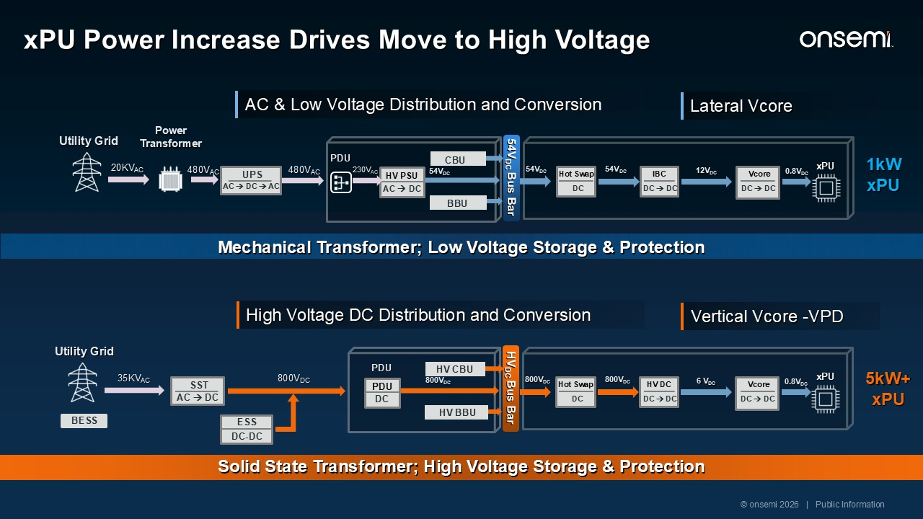
2030 12VDC 0.8VDC DC Hot Swap DC → DC DC → DC Vcore PDU UPS AC → DC → AC HV PSU AC → DC 480VAC 20KVAC 54VDC 54VDC xPU Power Transformer 480VAC 230VAC 54VDC Utility Grid BBU CBU 54VDC Bus Bar IBC AC & Low Voltage Distribution and Conversion Lateral Vcore 1kW xPU Mechanical Transformer; Low Voltage Storage & Protection xPU Power Increase Drives Move to High Voltage 6 VDC 0.8VDC 5kW+ xPU DC Hot Swap DC → DC Vcore PDU Utility Grid SST AC → DC PDU DC 35KVAC 800VDC 800VDC 800VDC ESS DC-DC xPU BESS 800VDC HV BBU HV CBU DC → DC HV DC HVDC Bus Bar High Voltage DC Distribution and Conversion Vertical Vcore -VPD Solid State Transformer; High Voltage Storage & Protection © onsemi 2026 | Public Information

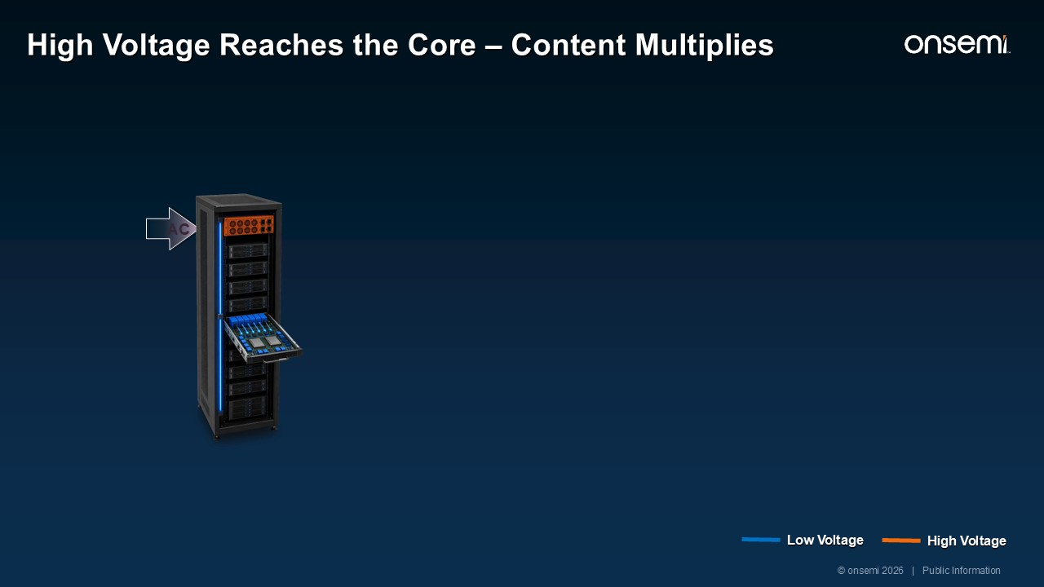
AC High Voltage Reaches the Core – Content Multiplies © onsemi 2026 | Public Information Low Voltage High Voltage

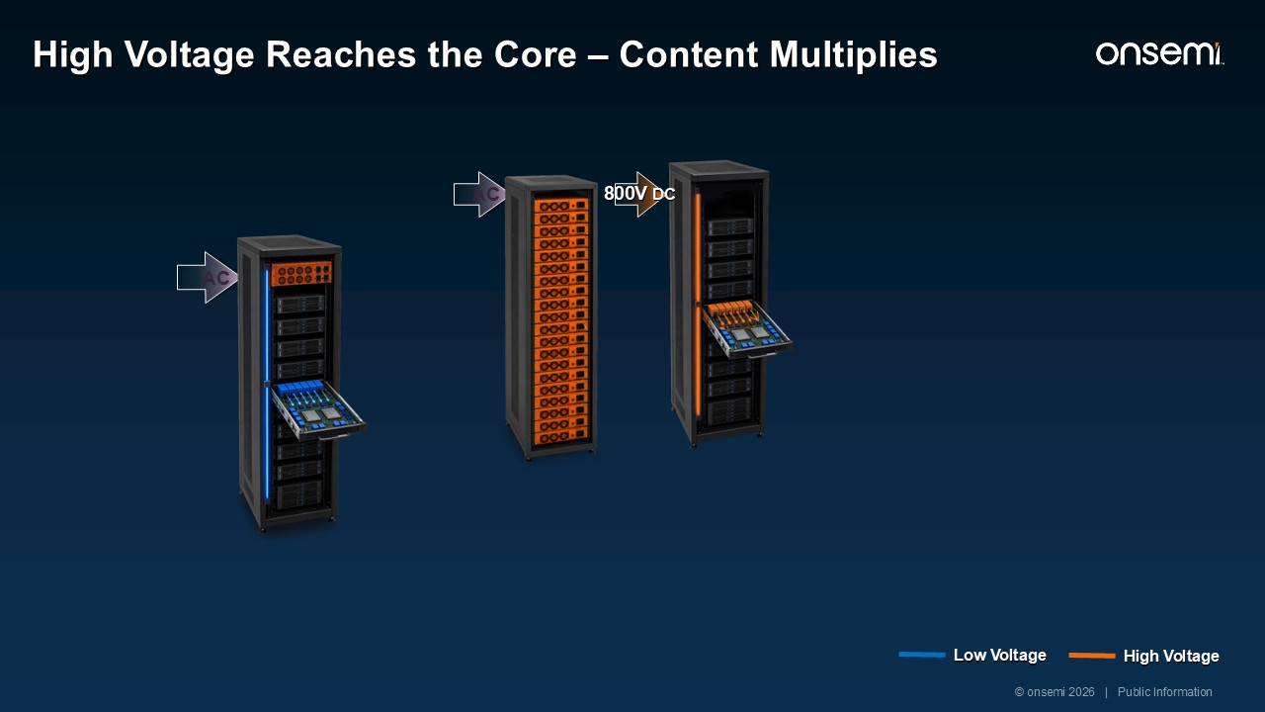
AC High Voltage Reaches the Core – Content Multiplies AC 800V DC Low Voltage © onsemi 2026 | Public Information High Voltage

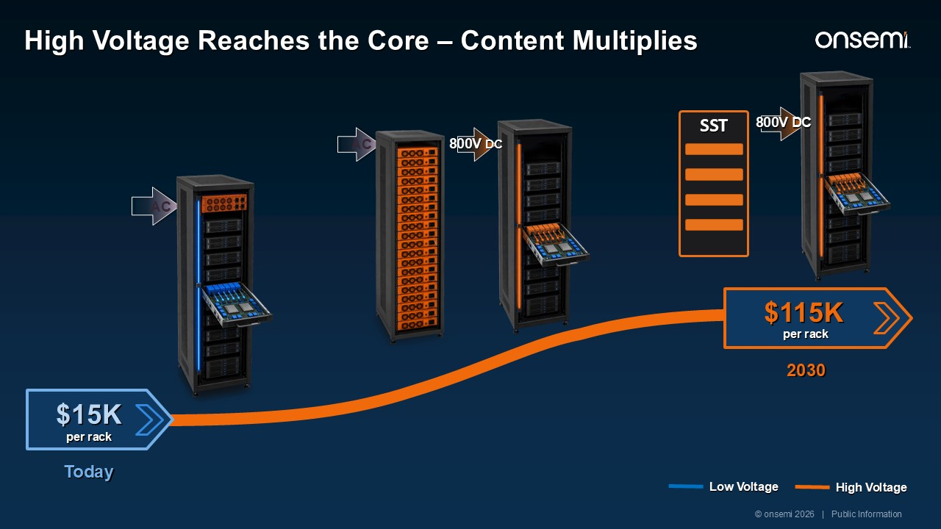
AC High Voltage Reaches the Core – Content Multiplies SST 800V DC AC 800V DC Low Voltage © onsemi 2026 | Public Information High Voltage $15K $115K Today 2030 per rack per rack

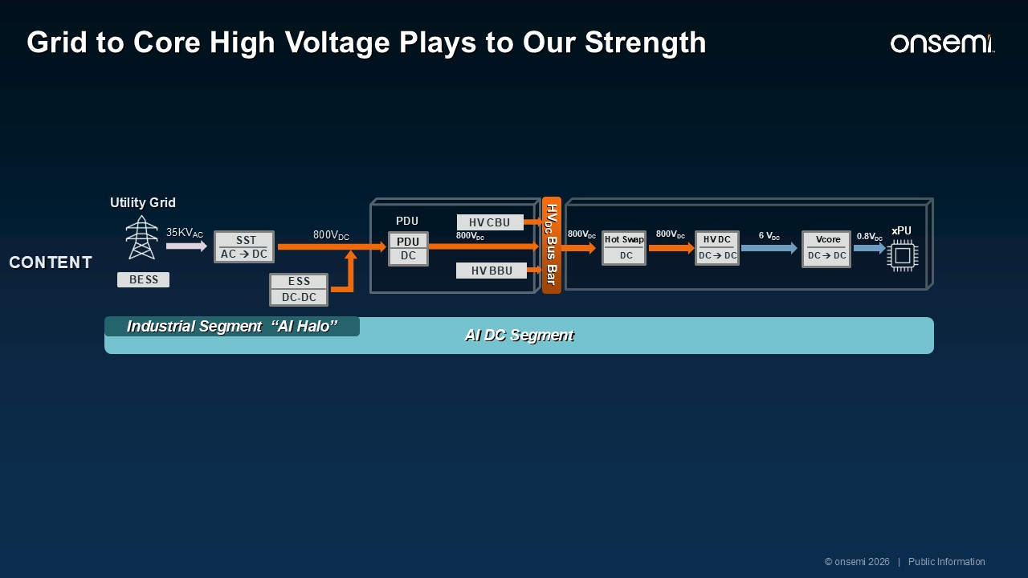
AI DC Segment 6 VDC 0.8VDC DC Hot Swap DC → DC HV DC DC → DC Vcore PDU Utility Grid SST AC → DC HV BBU PDU DC 35KVAC 800VDC 800VDC 800VDC ESS DC-DC xPU HV CBU BESS Grid to Core High Voltage Plays to Our Strength 800VDC HVDC Bus Bar Industrial Segment “AI Halo” © onsemi 2026 | Public Information More Power, Limited Space More High Voltage Content More Energy Storage & Load Balancing Mechanical to Semiconductor Content More Control, Intelligence, Safety CONTENT

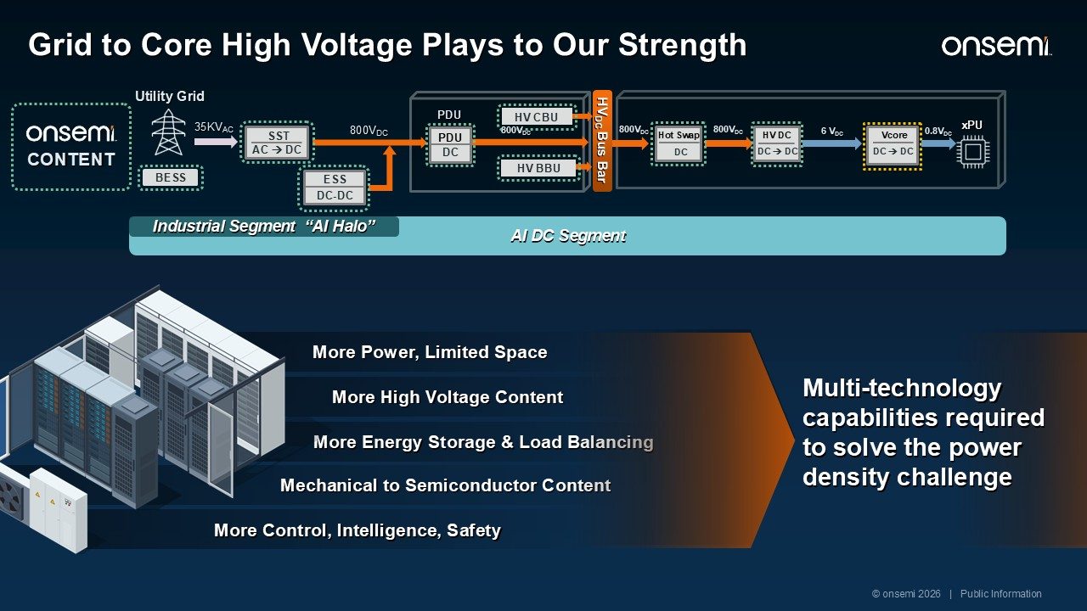
AI DC Segment 6 VDC 0.8VDC DC Hot Swap DC → DC HV DC DC → DC Vcore PDU Utility Grid SST AC → DC HV BBU PDU DC 35KVAC 800VDC 800VDC 800VDC ESS DC-DC xPU HV CBU More Power, Limited Space BESS Grid to Core High Voltage Plays to Our Strength 800VDC More High Voltage Content More Energy Storage & Load Balancing Mechanical to Semiconductor Content More Control, Intelligence, Safety HVDC Bus Bar Industrial Segment “AI Halo” Multi-technology capabilities required to solve the power density challenge © onsemi 2026 | Public Information CONTENT

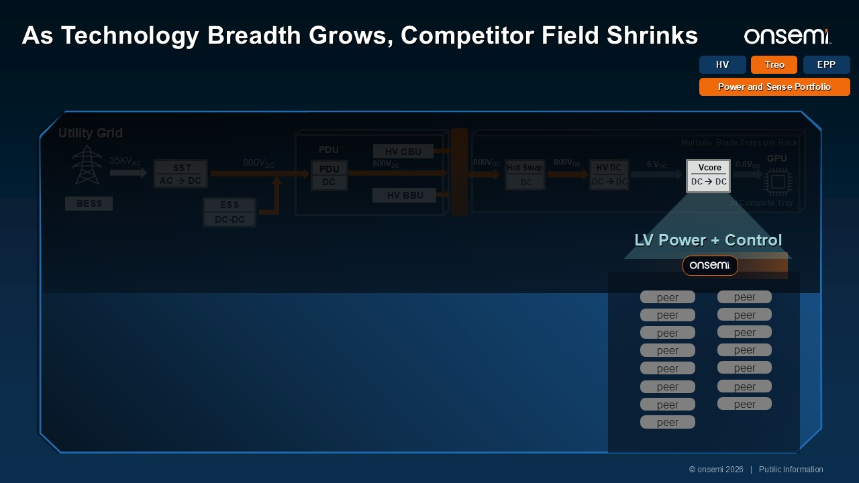
Treo HV EPP Power and Sense Portfolio 6 VDC 0.8VDC AI Compute Tray Multiple Blade Trays per Rack DC Hot Swap DC → DC HV DC PDU Utility Grid SST AC → DC HV BBU PDU DC 35KVAC 800VDC 800VDC 800VDC ESS DC-DC GPU HV CBU BESS 800VDC DC → DC Vcore peer peer peer peer peer peer peer peer peer peer peer peer peer peer peer © onsemi 2026 | Public Information LV Power + Control As Technology Breadth Grows, Competitor Field Shrinks

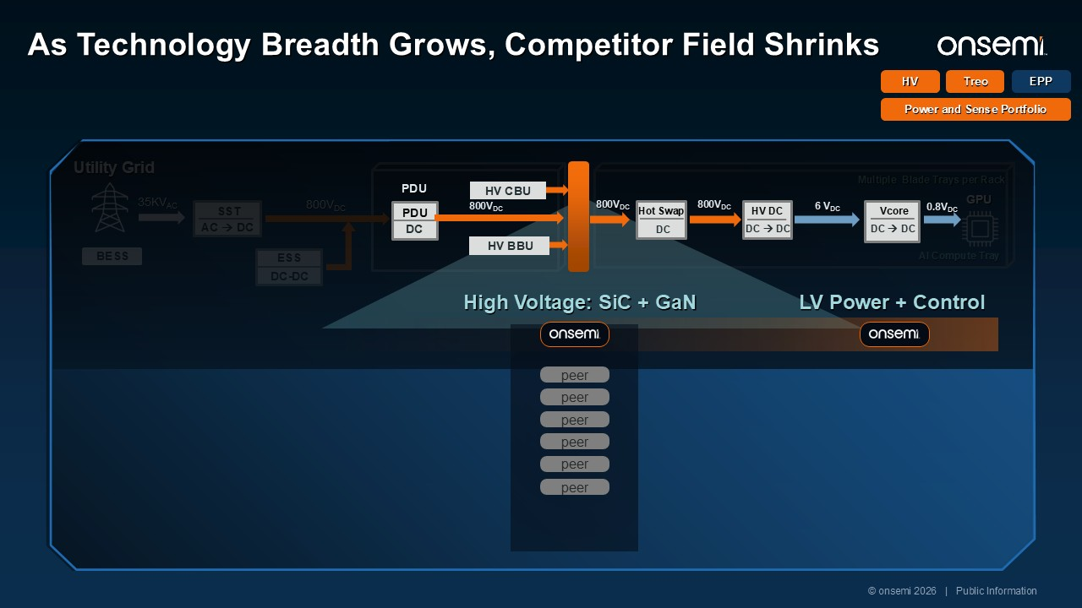
Treo HV EPP Power and Sense Portfolio 6 VDC 0.8VDC AI Compute Tray Multiple Blade Trays per Rack Utility Grid SST AC → DC 35KVAC 800VDC ESS DC-DC GPU BESS DC → DC Vcore DC → DC HV DC PDU PDU DC 800VDC 800VDC HV CBU 800VDC DC Hot Swap HV BBU peer peer peer peer peer peer © onsemi 2026 | Public Information High Voltage: SiC + GaN As Technology Breadth Grows, Competitor Field Shrinks LV Power + Control 6 VDC 0.8VDC

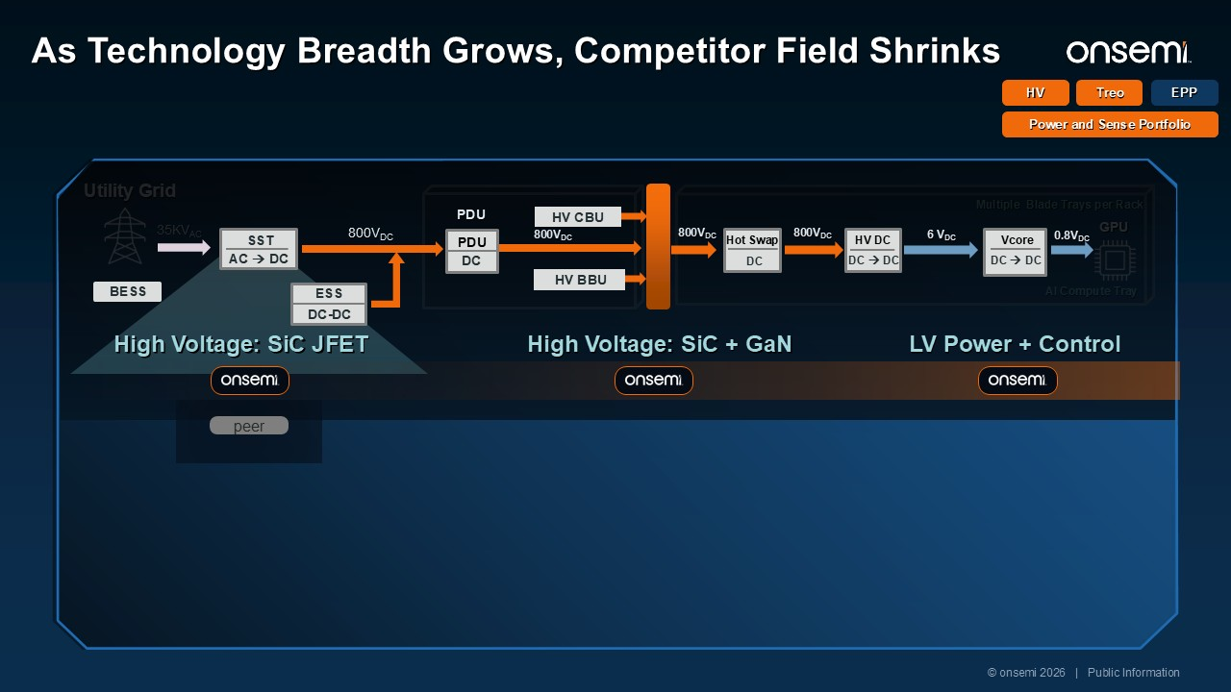
6 VDC 0.8VDC AI Compute Tray Multiple Blade Trays per Rack Utility Grid GPU 35KVAC DC → DC Vcore DC Hot Swap DC → DC HV DC PDU HV BBU PDU DC 800VDC 800VDC HV CBU 800VDC 800VDC ESS DC-DC SST AC → DC BESS peer © onsemi 2026 | Public Information High Voltage: SiC JFET As Technology Breadth Grows, Competitor Field Shrinks Treo HV EPP Power and Sense Portfolio High Voltage: SiC + GaN LV Power + Control 6 VDC 0.8VDC

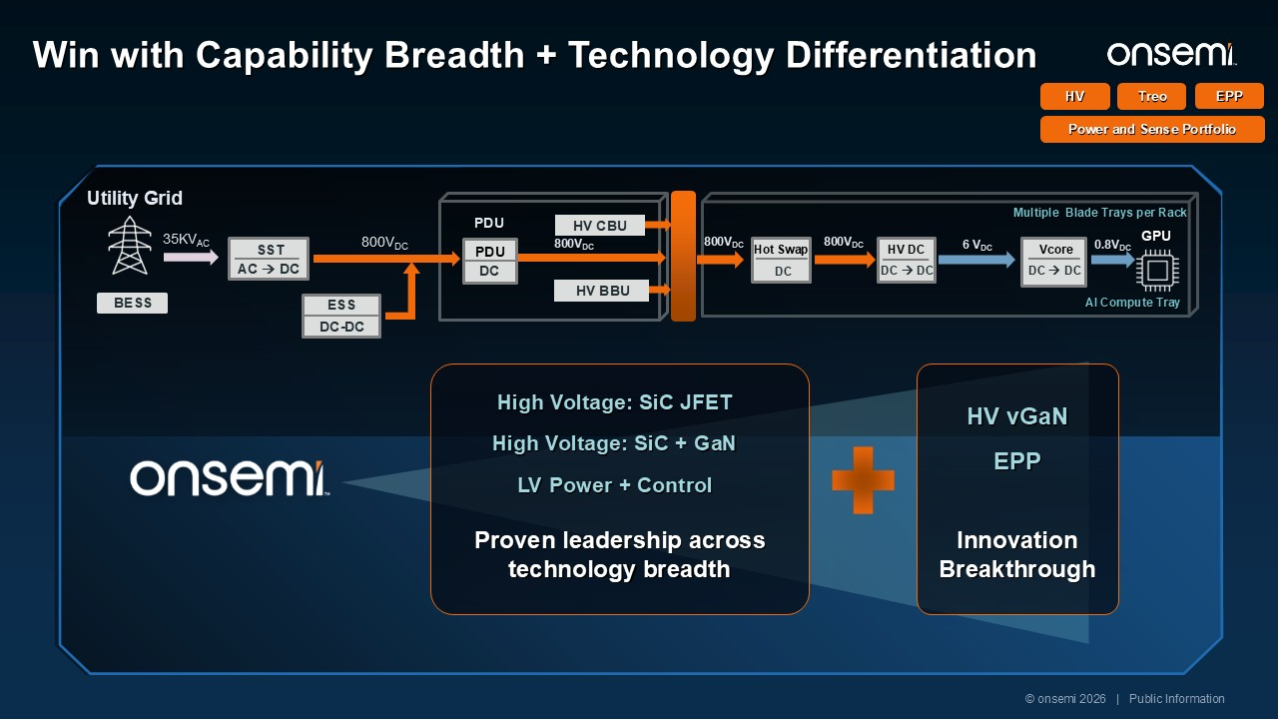
Treo HV EPP Power and Sense Portfolio 6 VDC 0.8VDC AI Compute Tray Multiple Blade Trays per Rack Utility Grid GPU 35KVAC DC → DC Vcore DC Hot Swap DC → DC HV DC PDU HV BBU PDU DC 800VDC 800VDC HV CBU 800VDC SST AC → DC 800VDC ESS DC-DC BESS Proven leadership across technology breadth High Voltage: SiC JFET High Voltage: SiC + GaN LV Power + Control Innovation Breakthrough HV vGaN EPP © onsemi 2026 | Public Information Win with Capability Breadth + Technology Differentiation

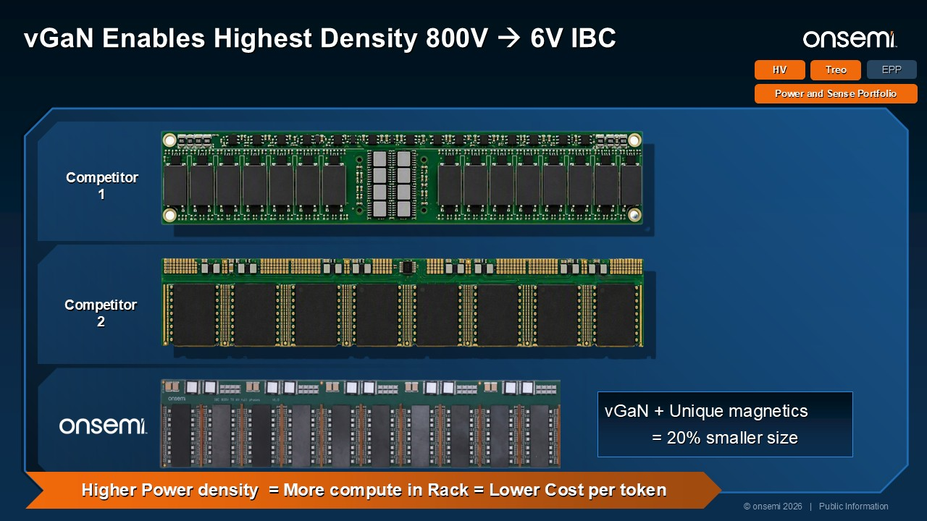
Treo HV EPP Power and Sense Portfolio Competitor 1 Competitor 2 Higher Power density = More compute in Rack = Lower Cost per token vGaN + Unique magnetics = 20% smaller size © onsemi 2026 | Public Information vGaN Enables Highest Density 800V → 6V IBC

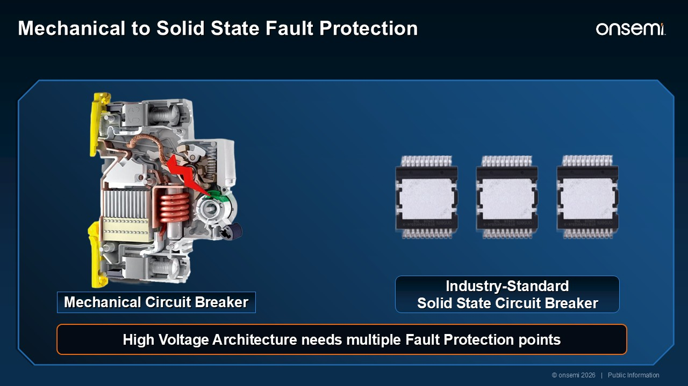
Mechanical Circuit Breaker High Voltage Architecture needs multiple Fault Protection points © onsemi 2026 | Public Information Industry-Standard Solid State Circuit Breaker Mechanical to Solid State Fault Protection

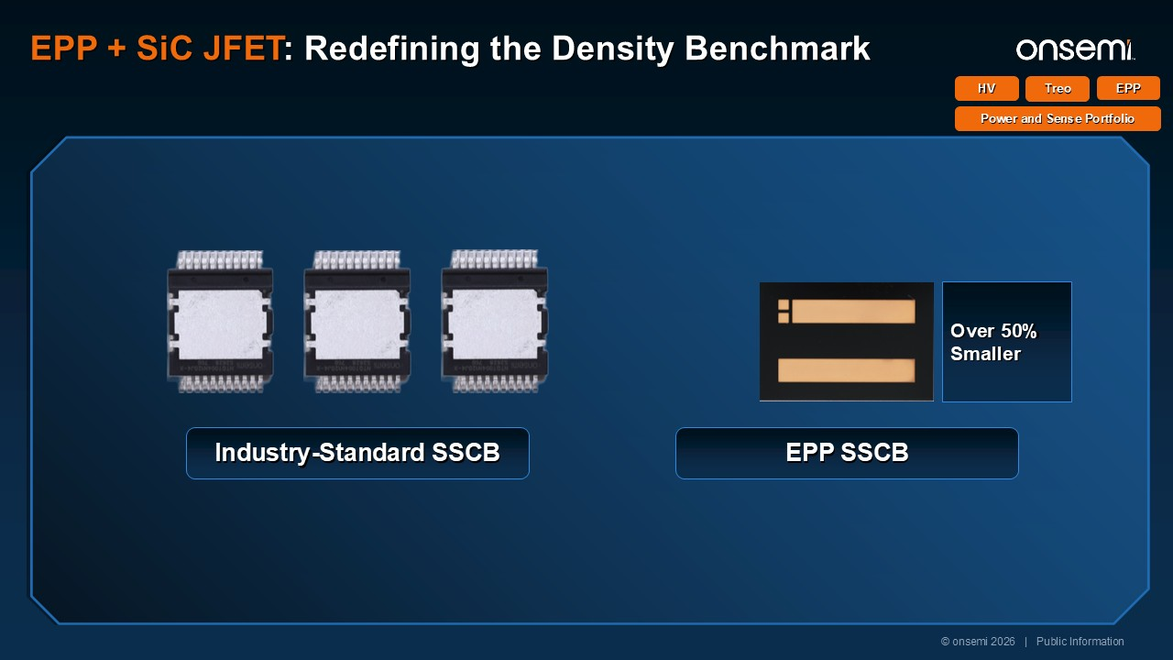
Treo HV EPP Power and Sense Portfolio EPP SSCB Industry-Standard SSCB © onsemi 2026 | Public Information EPP + SiC JFET: Redefining the Density Benchmark Over 50% Smaller 20% cooler thermals Over 50% Smaller

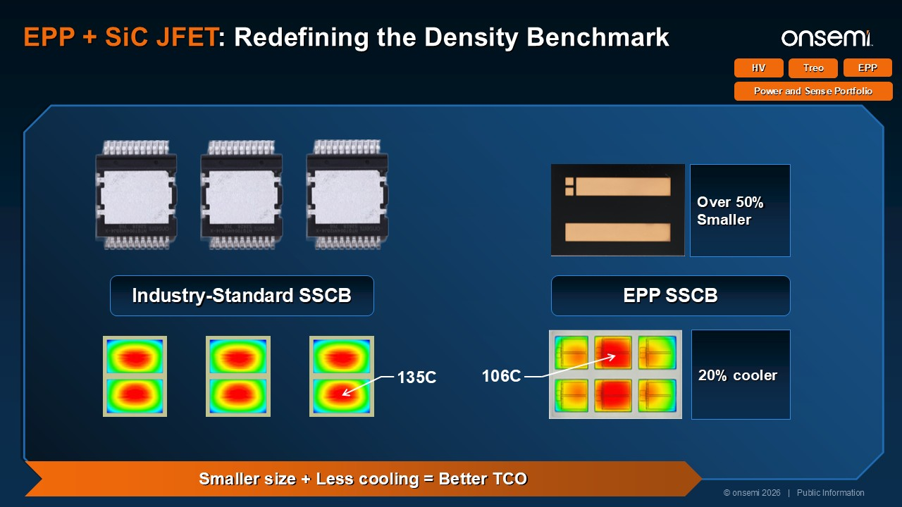
Treo HV EPP Power and Sense Portfolio Over 50% Smaller 106C 20% cooler Industry-Standard SSCB EPP SSCB 135C © onsemi 2026 | Public Information EPP + SiC JFET: Redefining the Density Benchmark Smaller size + Less cooling = Better TCO

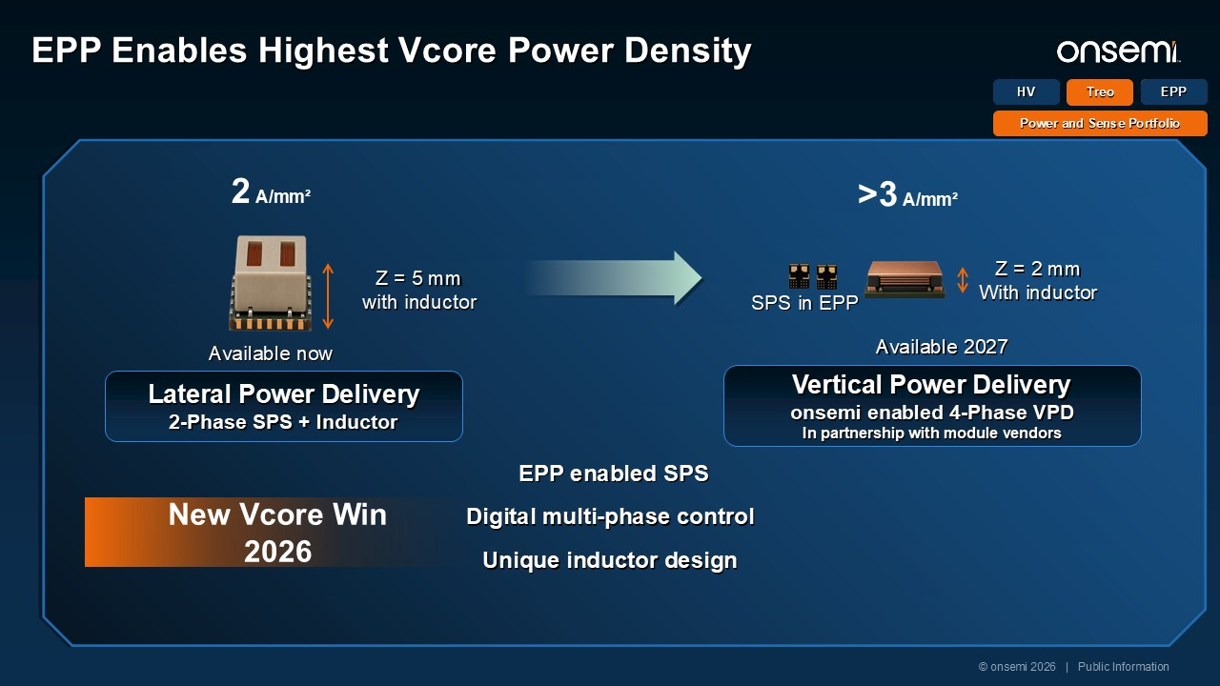
Treo HV EPP Power and Sense Portfolio Digital multi-phase control Lateral Power Delivery 2-Phase SPS + Inductor 2 A/mm² Z = 5 mm with inductor >3 A/mm² Vertical Power Delivery onsemi enabled 4-Phase VPD In partnership with module vendors EPP enabled SPS Unique inductor design Z = 2 mm With inductor New Vcore Win 2026 © onsemi 2026 | Public Information EPP Enables Highest Vcore Power Density Available now Available 2027 SPS in EPP EPP

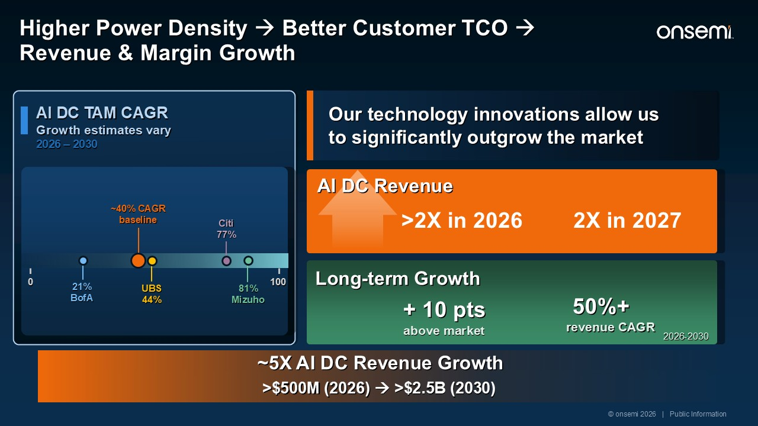
>2X in 2026 Long-term Growth + 10 pts above market AI DC Revenue 2X in 2027 50%+ revenue CAGR 2026-2030 AI DC TAM CAGRGrowth estimates vary 2026 – 2030 100 0 UBS 44% 21% BofA Citi 77% 81% Mizuho ~40% CAGR baseline ~5X AI DC Revenue Growth >$500M (2026) → >$2.5B (2030) Our technology innovations allow us to significantly outgrow the market © onsemi 2026 | Public Information Higher Power Density → Better Customer TCO → Revenue & Margin Growth

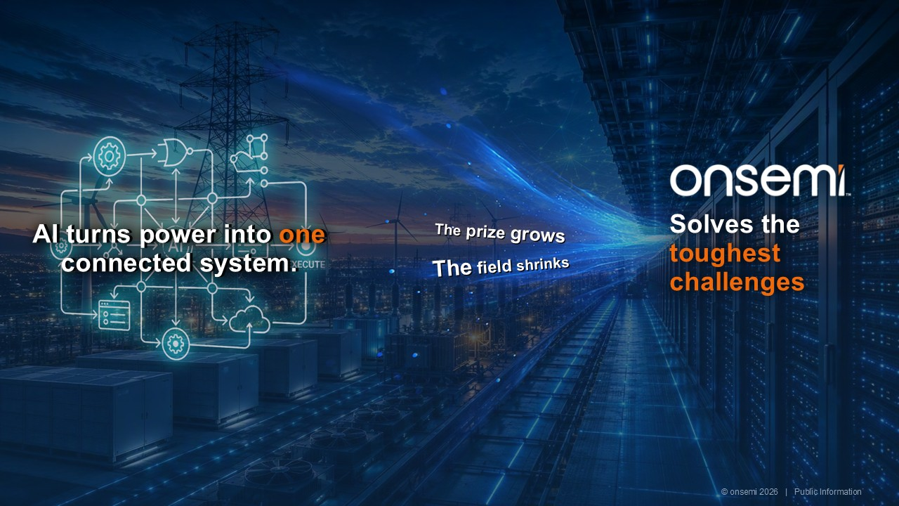
Solves the toughestchallenges AI turns power into one connected system. The field shrinks The prize grows © onsemi 2026 | Public Information



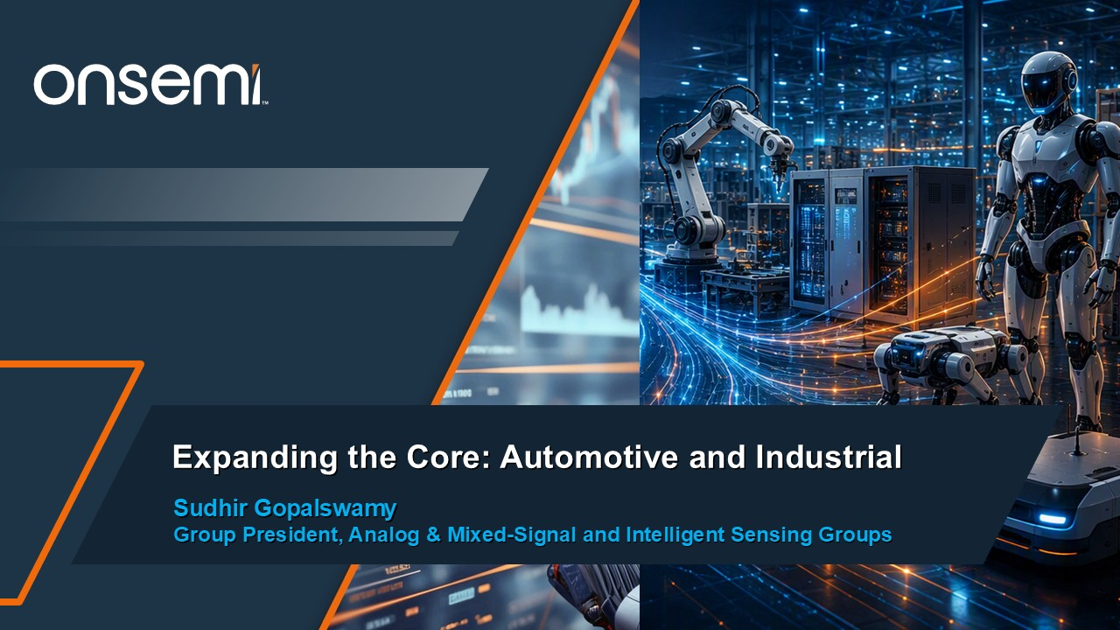
Expanding the Core: Automotive and Industrial Sudhir GopalswamyGroup President, Analog & Mixed-Signal and Intelligent Sensing Groups

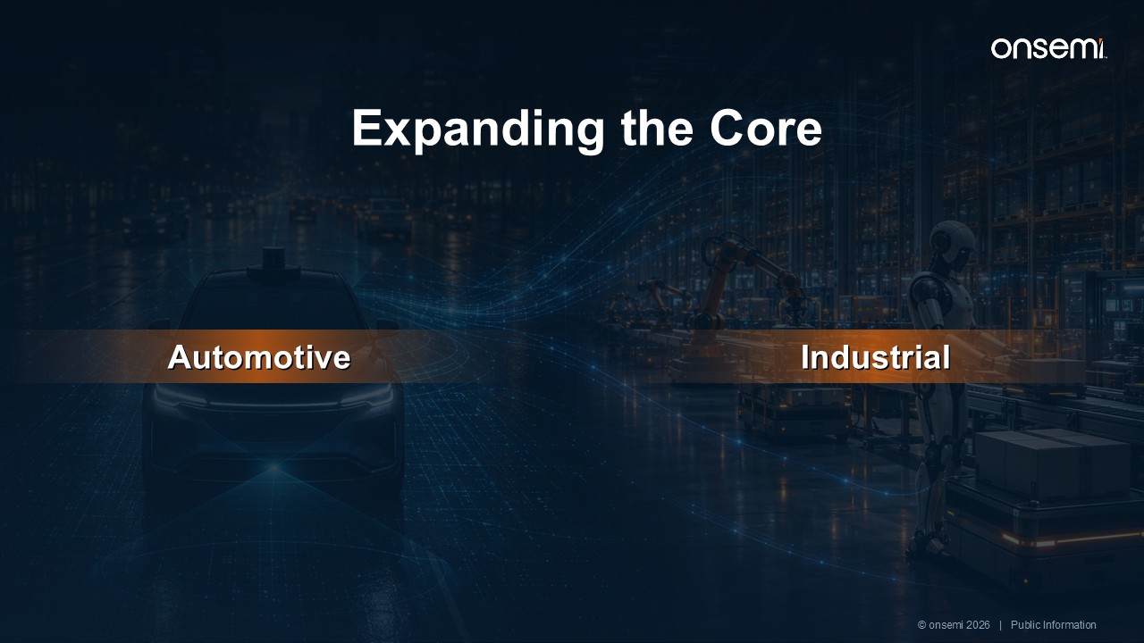
Expanding the Core Automotive Industrial © onsemi 2026 | Public Information

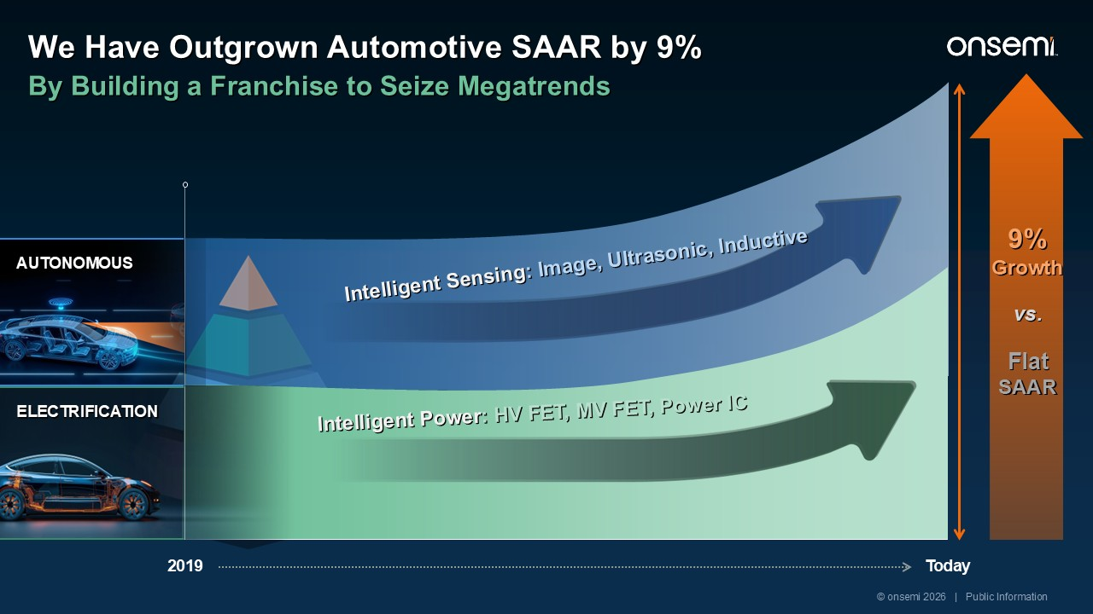
2019 Today 9% Growth vs. Flat SAAR We Have Outgrown Automotive SAAR by 9% By Building a Franchise to Seize Megatrends ELECTRIFICATION AUTONOMOUS Intelligent Sensing: Image, Ultrasonic, Inductive Intelligent Power: HV FET, MV FET, Power IC © onsemi 2026 | Public Information 2030

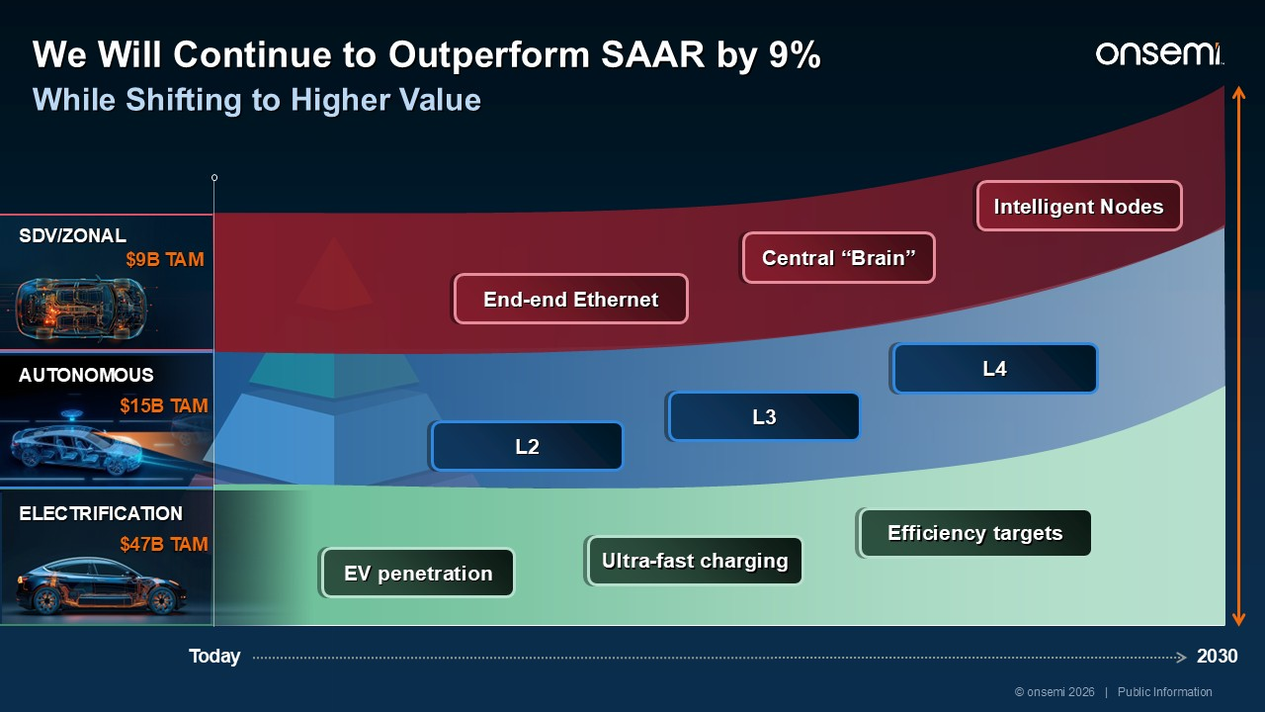
AUTONOMOUS L2 L3 L4 End-end Ethernet Central “Brain” Intelligent Nodes 2030 ELECTRIFICATION EV penetration Ultra-fast charging Efficiency targets Today SDV/ZONAL $47B TAM $15B TAM $9B TAM © onsemi 2026 | Public Information We Will Continue to Outperform SAAR by 9% While Shifting to Higher Value

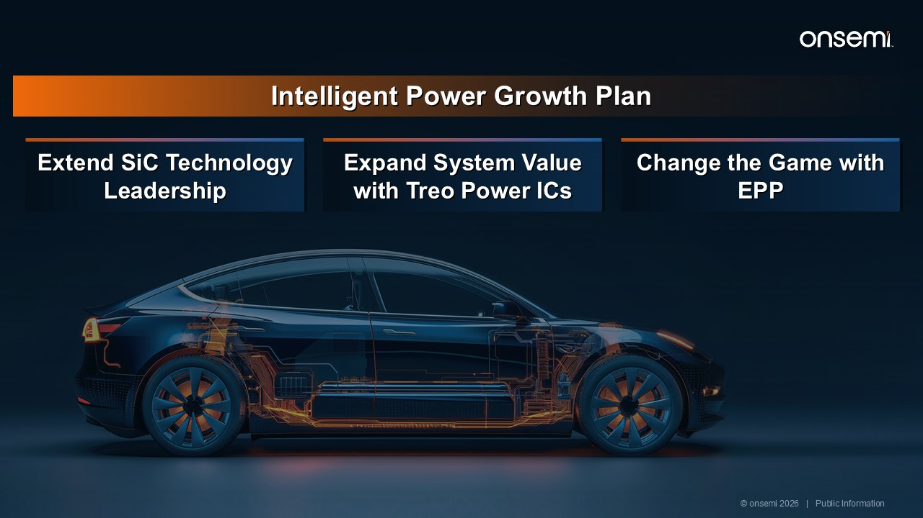
Intelligent Power Growth Plan Extend SiC Technology Leadership Expand System Value with Treo Power ICs Change the Game with EPP © onsemi 2026 | Public Information

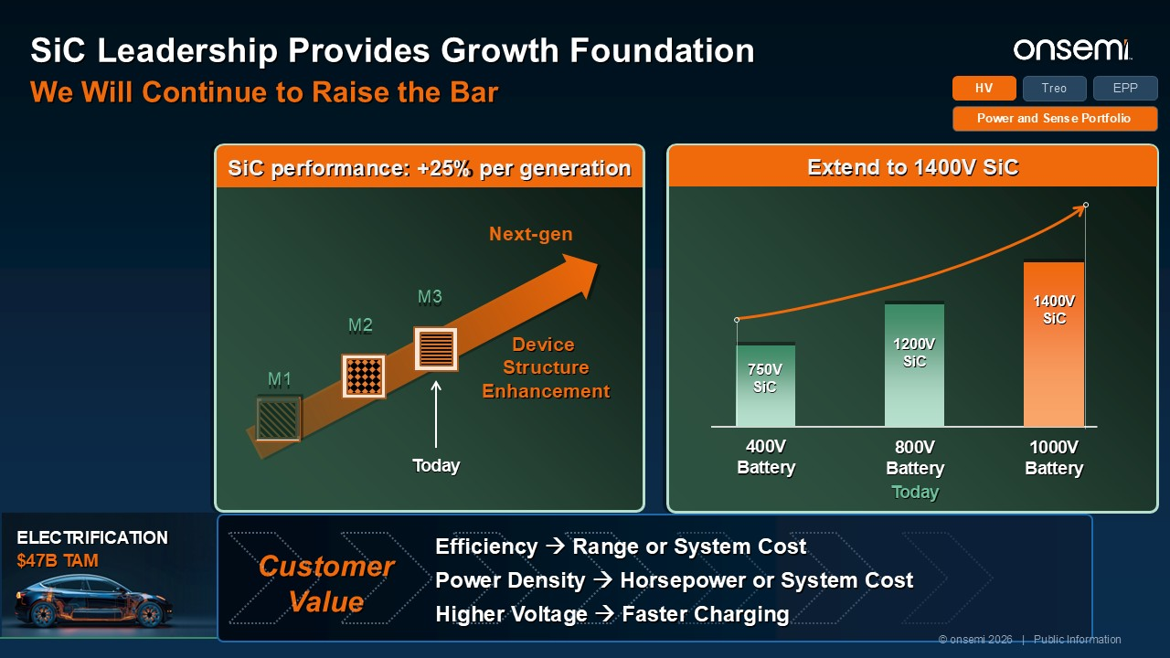
SiC performance: +25% per generation Next-gen M1 M2 M3 Extend to 1400V SiC 400VBattery 800V Battery Today 1000V Battery 750VSiC 1200VSiC 1400VSiC Device Structure Enhancement Today Treo HV EPP Power and Sense Portfolio ELECTRIFICATION $47B TAM CustomerValue Efficiency → Range or System Cost Power Density → Horsepower or System Cost Higher Voltage → Faster Charging © onsemi 2026 | Public Information SiC Leadership Provides Growth Foundation We Will Continue to Raise the Bar

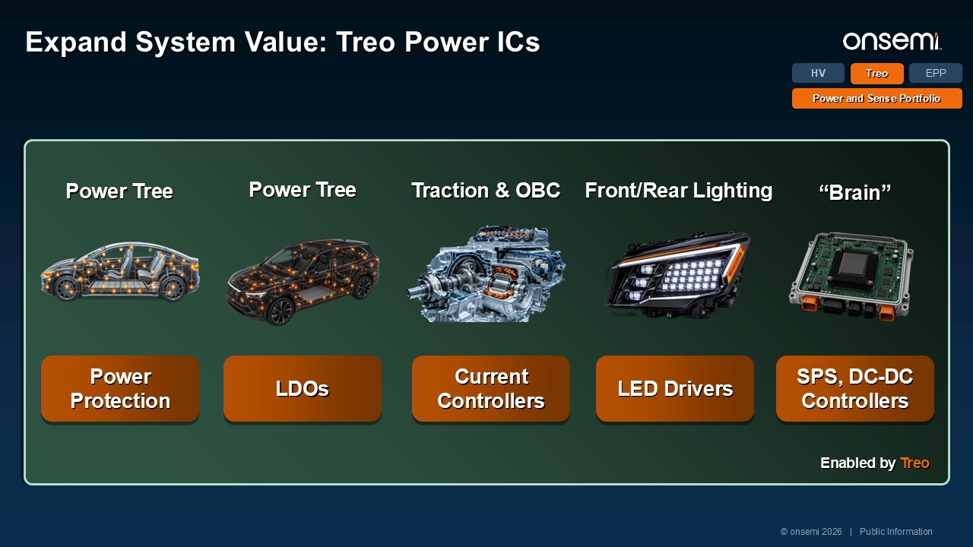
Treo HV EPP Power and Sense Portfolio Enabled by Treo LED Drivers Front/Rear Lighting SPS, DC-DC Controllers “Brain” Power Protection Power Tree Current Controllers Traction & OBC © onsemi 2026 | Public Information Expand System Value: Treo Power ICs LDOs Power Tree

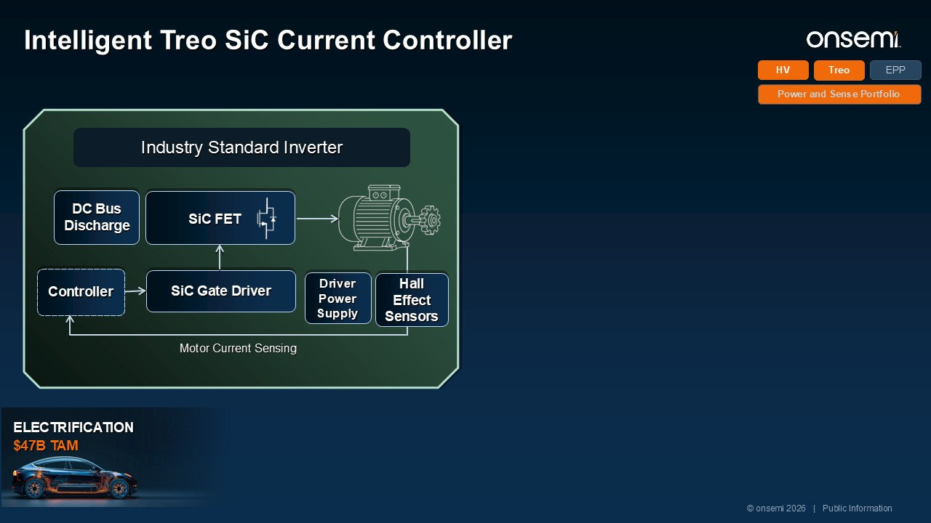
Intelligent Treo SiC Current Controller Treo HV EPP Power and Sense Portfolio Controller SiC Gate Driver DC Bus Discharge Driver Power Supply SiC FET Hall Effect Sensors Motor Current Sensing Industry Standard Inverter © onsemi 2026 | Public Information ELECTRIFICATION $47B TAM 1-Gen SiC Boost 5% BOM Savings

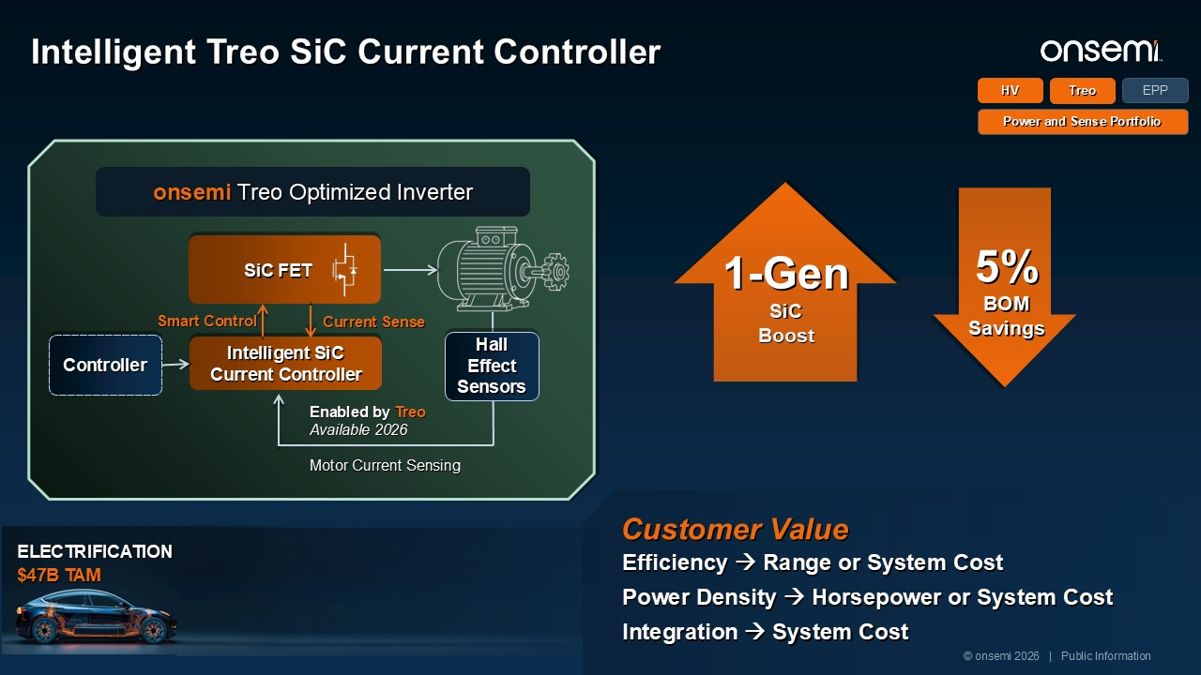
Intelligent Treo SiC Current Controller Treo HV EPP Power and Sense Portfolio Controller Intelligent SiC Current Controller Motor Current Sensing SiC FET Smart Control Current Sense onsemi Treo Optimized Inverter 1-Gen SiC Boost 5% BOM Savings Hall Effect Sensors Enabled by Treo Available 2026 Customer Value Efficiency → Range or System Cost Power Density → Horsepower or System Cost Integration → System Cost © onsemi 2026 | Public Information ELECTRIFICATION $47B TAM

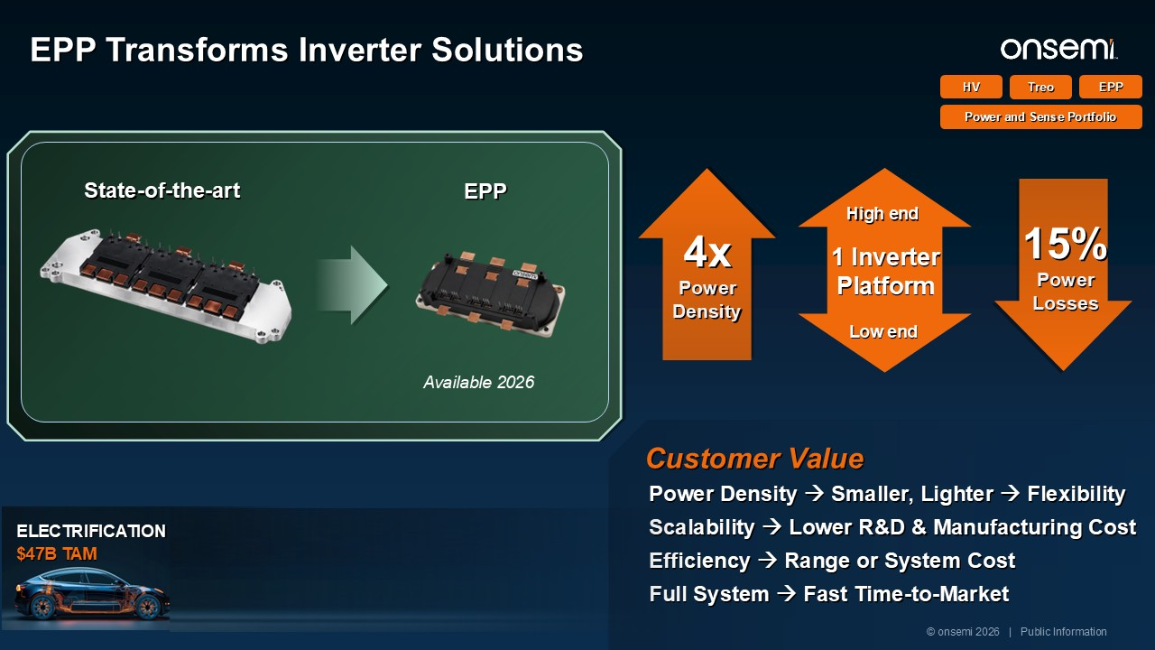
ELECTRIFICATION $47B TAM Customer Value Power Density → Smaller, Lighter → Flexibility Scalability → Lower R&D & Manufacturing Cost Efficiency → Range or System Cost Full System → Fast Time-to-Market EPP Transforms Inverter Solutions Treo HV EPP Power and Sense Portfolio 4x Power Density 15% Power Losses 1 Inverter Platform High end Low end © onsemi 2026 | Public Information State-of-the-art EPP Available 2026

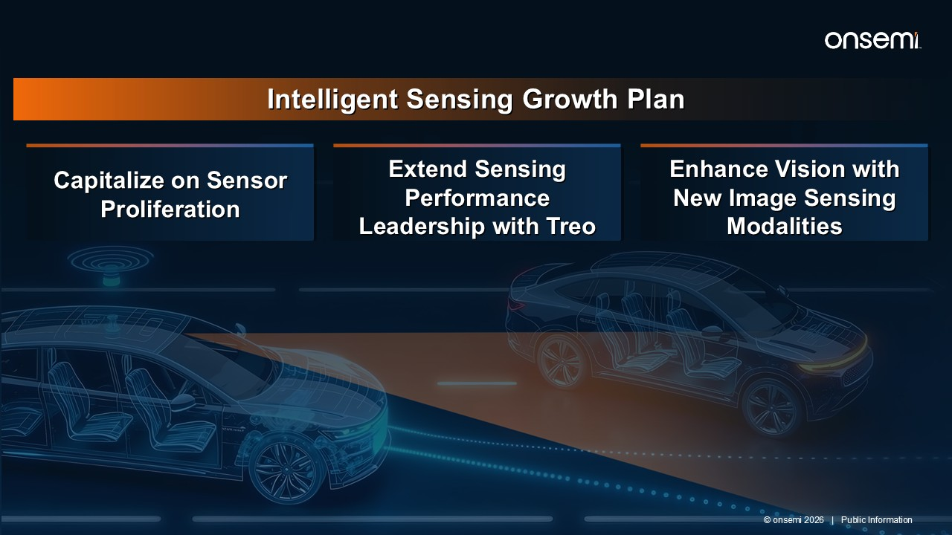
Intelligent Sensing Growth Plan Capitalize on Sensor Proliferation Extend Sensing Performance Leadership with Treo Enhance Vision with New Image Sensing Modalities © onsemi 2026 | Public Information

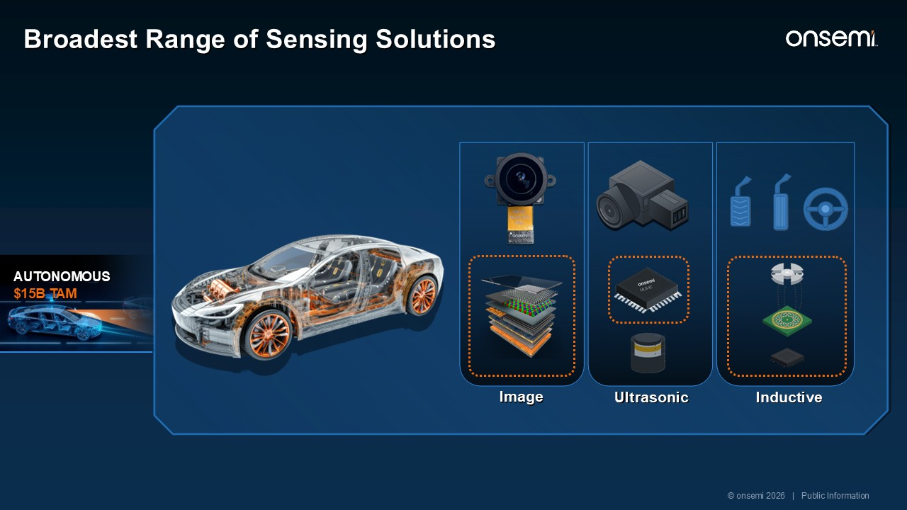
Broadest Range of Sensing Solutions Image Ultrasonic Inductive AUTONOMOUS $15B TAM © onsemi 2026 | Public Information

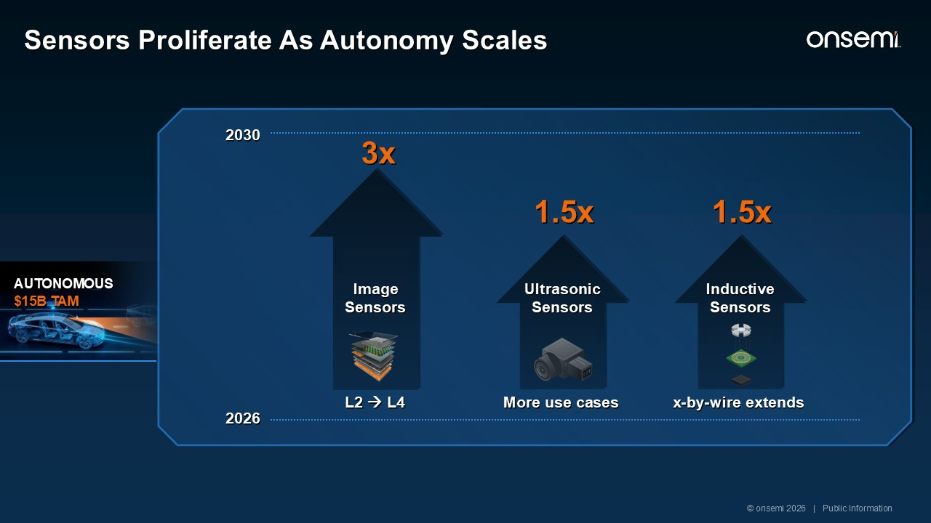
AUTONOMOUS $15B TAM Sensors Proliferate As Autonomy Scales 2026 2030 L2 → L4 Image Sensors Ultrasonic Sensors More use cases Inductive Sensors x-by-wire extends 1.5x 1.5x 3x © onsemi 2026 | Public Information

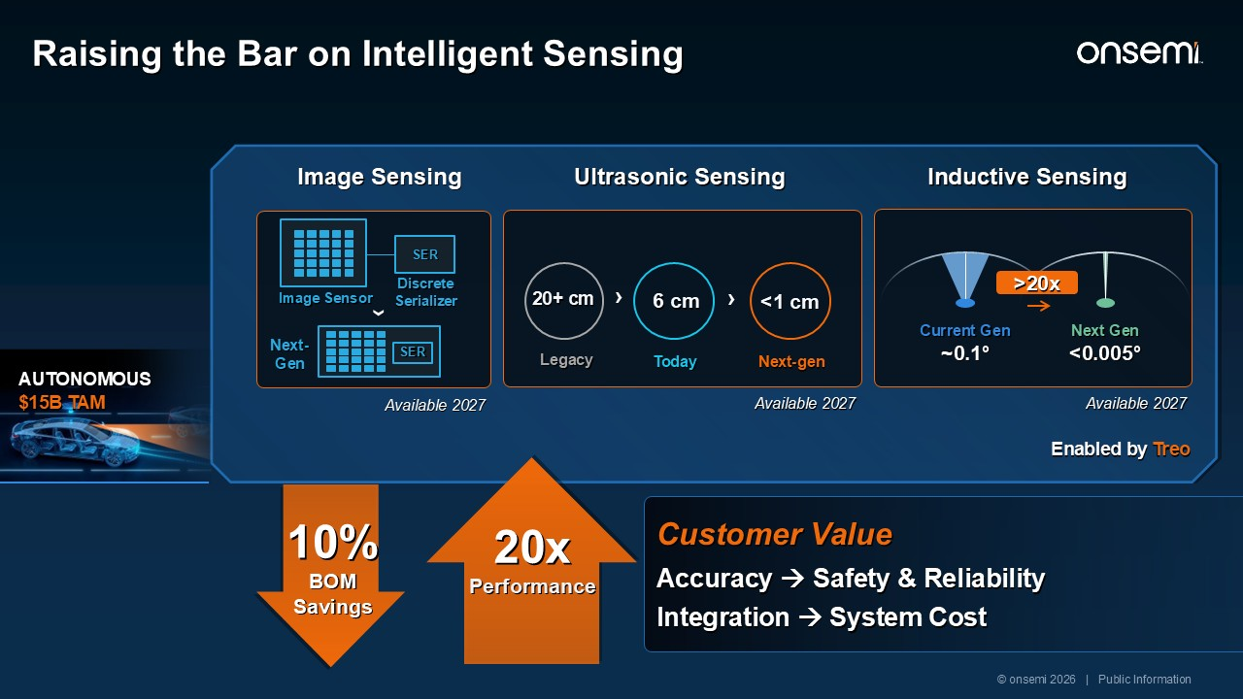
AUTONOMOUS $15B TAM Customer Value Accuracy → Safety & Reliability Integration → System Cost Raising the Bar on Intelligent Sensing Image Sensing Ultrasonic Sensing Enabled by Treo Inductive Sensing 20+ cm Legacy › 6 cm Today <1 cm Next-gen › Current Gen ~0.1° Next Gen <0.005° >20x 20x Performance 10% BOM Savings Image Sensor SER Discrete Serializer › SER Next- Gen Available 2027 Available 2027 Available 2027 © onsemi 2026 | Public Information

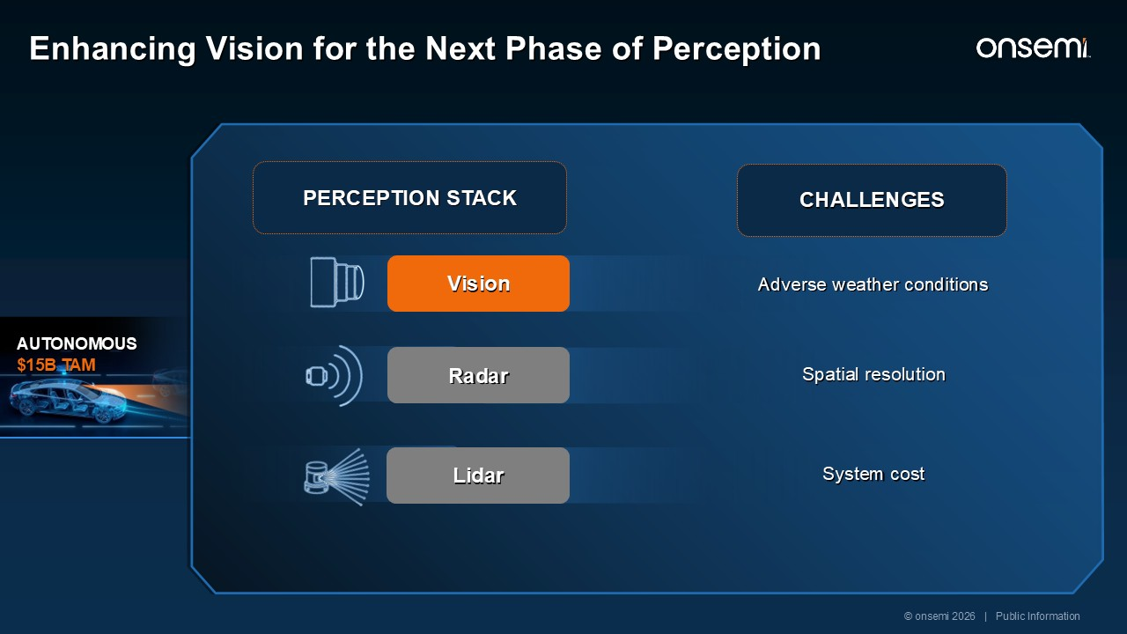
AUTONOMOUS $15B TAM PERCEPTION STACK Vision Adverse weather conditions Spatial resolution System cost CHALLENGES © onsemi 2026 | Public Information Enhancing Vision for the Next Phase of Perception Radar Lidar SWIR See through fog and rain Industrial avail today, Auto in Advanced R&D iToF High-res depth at <15M Detect hazard at 100M Industrial avail today, Auto in Proof-of-concept Vision Capture detail in any light HDR avail today Super-Human Vision Customer Value Enhanced Vision → Safety iToF → System Cost

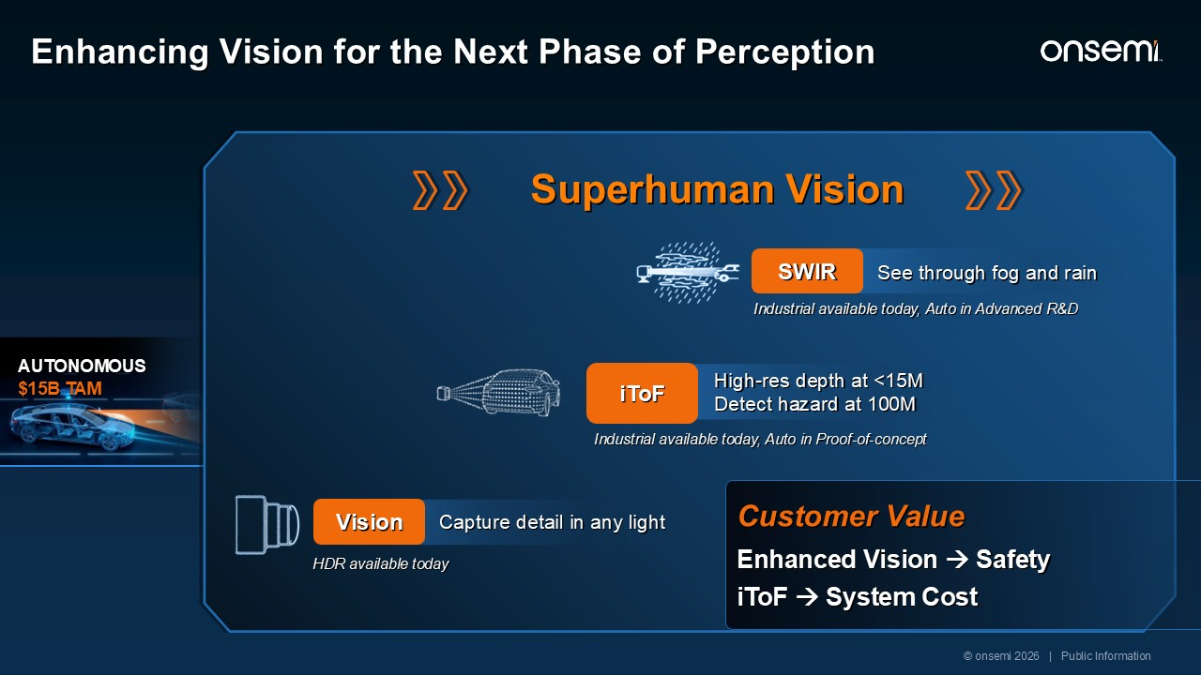
AUTONOMOUS $15B TAM SWIR See through fog and rain Industrial available today, Auto in Advanced R&D iToF High-res depth at <15M Detect hazard at 100M Industrial available today, Auto in Proof-of-concept Superhuman Vision Customer Value Enhanced Vision → Safety iToF → System Cost Vision Capture detail in any light HDR available today © onsemi 2026 | Public Information Enhancing Vision for the Next Phase of Perception

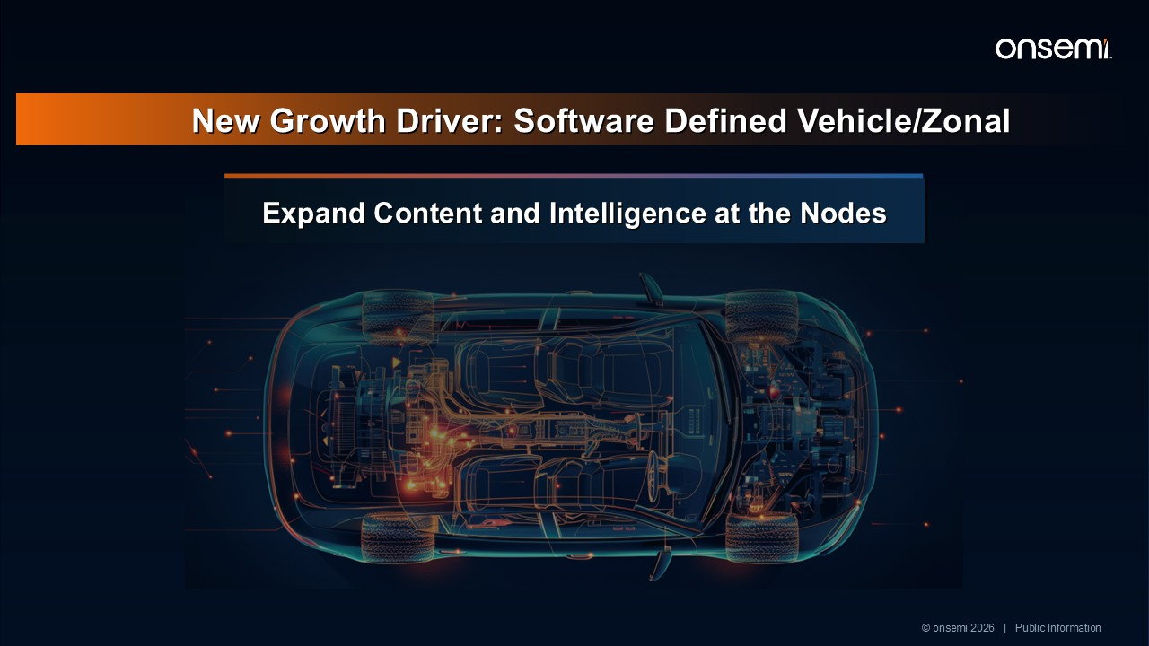
New Growth Driver: Software Defined Vehicle/Zonal Expand Content and Intelligence at the Nodes © onsemi 2026 | Public Information

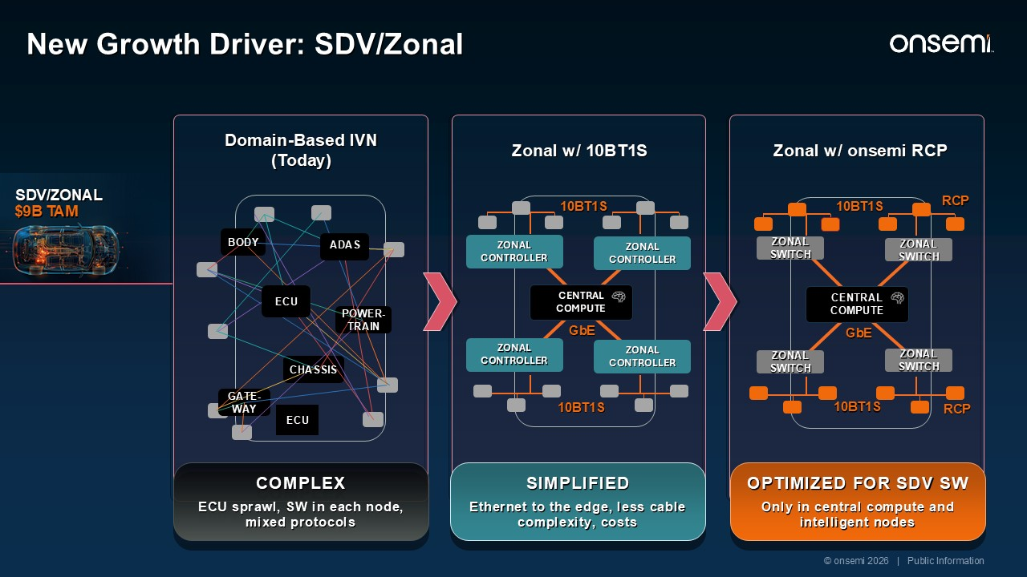
Domain-Based IVN (Today) COMPLEX ECU sprawl, SW in each node, mixed protocols ADAS ECU ECU ADAS BODY POWER-TRAIN CHASSIS GATE-WAY Zonal w/ 10BT1S Zonal w/ onsemi RCP ZONAL CONTROLLER CENTRAL COMPUTE ZONAL CONTROLLER ZONAL CONTROLLER ZONAL CONTROLLER ZONAL SWITCH CENTRAL COMPUTE ZONAL SWITCH ZONAL SWITCH ZONAL SWITCH SIMPLIFIED Ethernet to the edge, less cable complexity, costs OPTIMIZED FOR SDV SW Only in central compute and intelligent nodes SDV/ZONAL $9B TAM 10BT1S 10BT1S RCP GbE GbE 10BT1S 10BT1S RCP © onsemi 2026 | Public Information New Growth Driver: SDV/Zonal onsemi VALUE

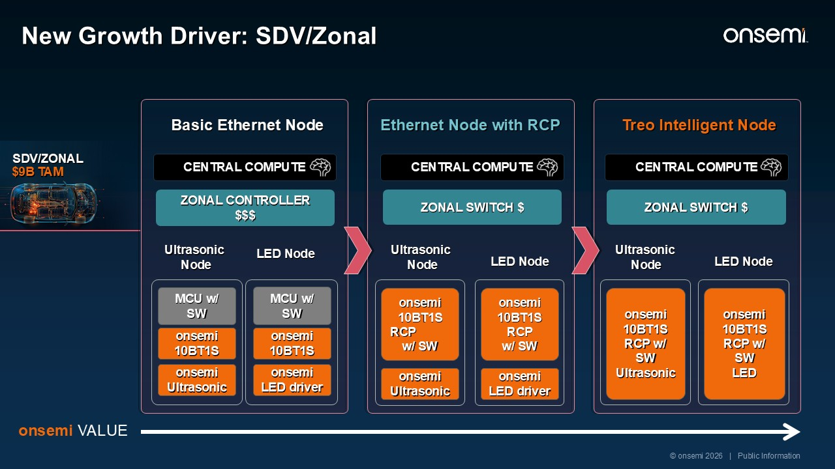
SDV/ZONAL $9B TAM Basic Ethernet Node Ethernet Node with RCP Treo Intelligent Node MCU w/ SW onsemi 10BT1S onsemiUltrasonic CENTRAL COMPUTE ZONAL CONTROLLER $$$ MCU w/ SW onsemi 10BT1S onsemiLED driver Ultrasonic Node LED Node onsemi 10BT1S RCP w/ SW onsemiUltrasonic CENTRAL COMPUTE ZONAL SWITCH $ onsemi 10BT1S RCP w/ SW onsemiLED driver Ultrasonic Node LED Node onsemi 10BT1S RCP w/ SW Ultrasonic CENTRAL COMPUTE ZONAL SWITCH $ onsemi 10BT1S RCP w/ SW LED Ultrasonic Node LED Node onsemi VALUE New Growth Driver: SDV/Zonal © onsemi 2026 | Public Information

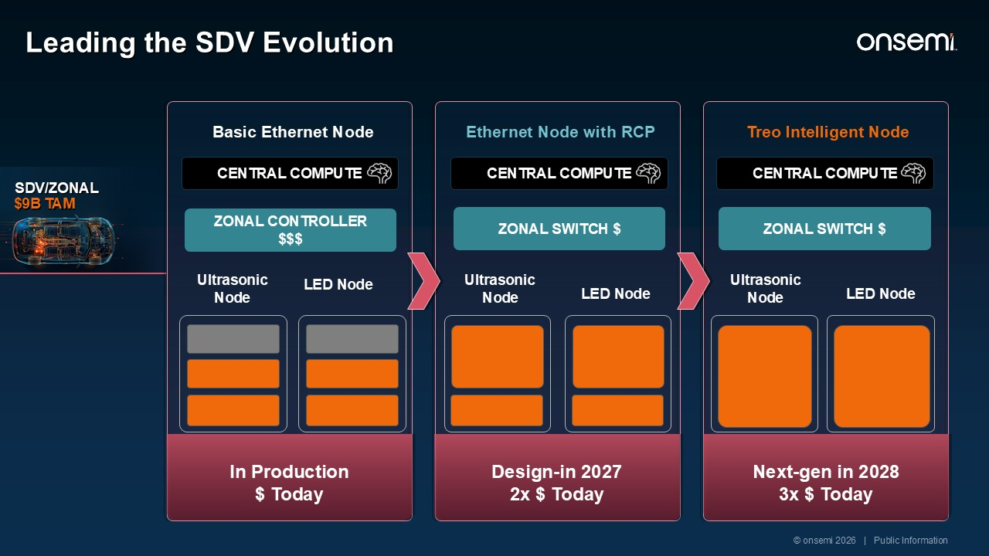
SDV/ZONAL $9B TAM Basic Ethernet Node Ethernet Node with RCP Treo Intelligent Node ZONAL CONTROLLER $$$ Ultrasonic Node LED Node ZONAL SWITCH $ Ultrasonic Node LED Node ZONAL SWITCH $ Ultrasonic Node LED Node In Production $ Today Design-in 2027 2x $ Today Next-gen in 2028 3x $ Today Leading the SDV Evolution © onsemi 2026 | Public Information CENTRAL COMPUTE CENTRAL COMPUTE CENTRAL COMPUTE

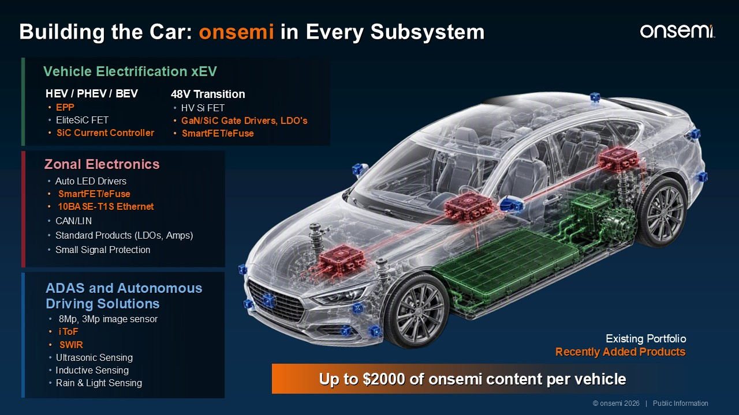
Up to $2000 of onsemi content per vehicle Existing Portfolio Recently Added Products © onsemi 2026 | Public Information Building the Car: onsemi in Every Subsystem ADAS and Autonomous Driving Solutions 8Mp, 3Mp image sensor iToF SWIR Ultrasonic Sensing Inductive Sensing Rain & Light Sensing Zonal Electronics Auto LED Drivers SmartFET/eFuse 10BASE-T1S Ethernet CAN/LIN Standard Products (LDOs, Amps) Small Signal Protection HEV / PHEV / BEV EPP EliteSiC FET SiC Current Controller 48V Transition HV Si FET GaN/SiC Gate Drivers, LDO's SmartFET/eFuse Vehicle Electrification xEV

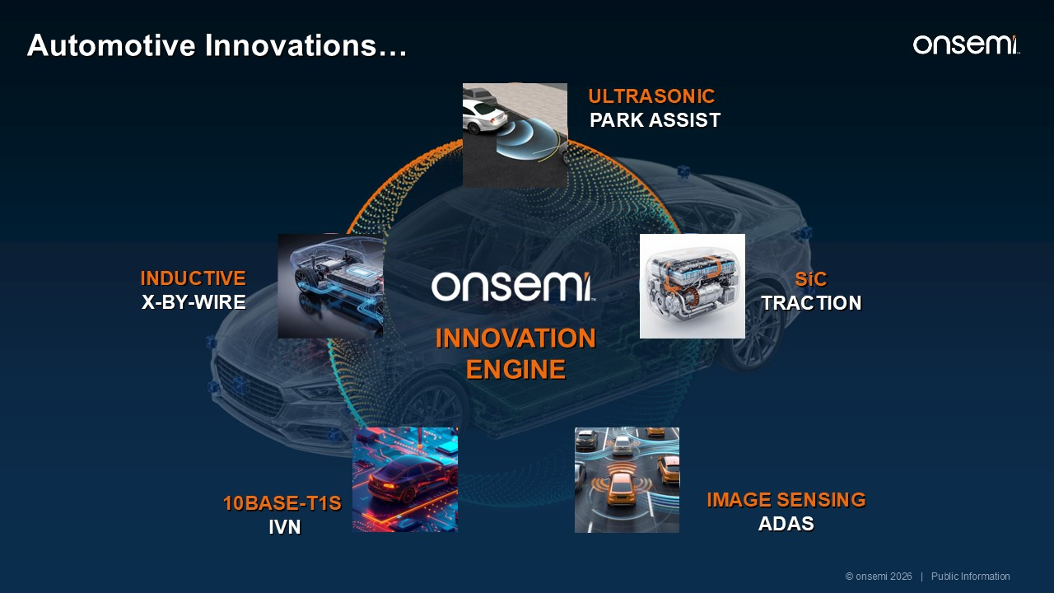
SiC TRACTION IMAGE SENSING ADAS 10BASE-T1S IVN INDUCTIVE X-BY-WIRE INNOVATION ENGINE © onsemi 2026 | Public Information Automotive Innovations… ULTRASONIC PARK ASSIST

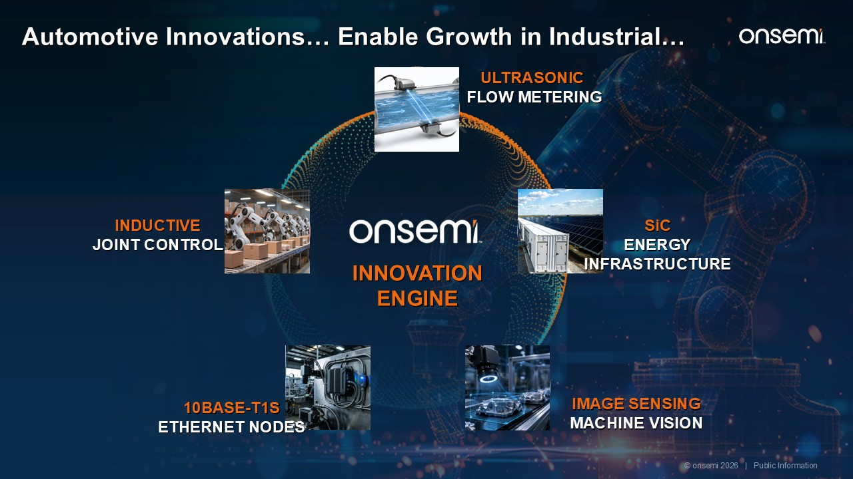
IMAGE SENSING MACHINE VISION 10BASE-T1S ETHERNET NODES INDUCTIVE JOINT CONTROL Automotive Innovations… Enable Growth in Industrial… INNOVATION ENGINE SiC ENERGY INFRASTRUCTURE ULTRASONIC FLOW METERING © onsemi 2026 | Public Information

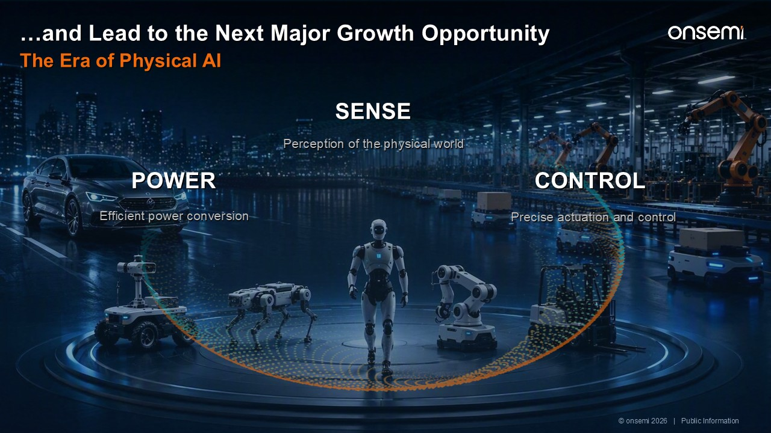
POWER Efficient power conversion SENSE Perception of the physical world CONTROL Precise actuation and control …and Lead to the Next Major Growth Opportunity The Era of Physical AI © onsemi 2026 | Public Information

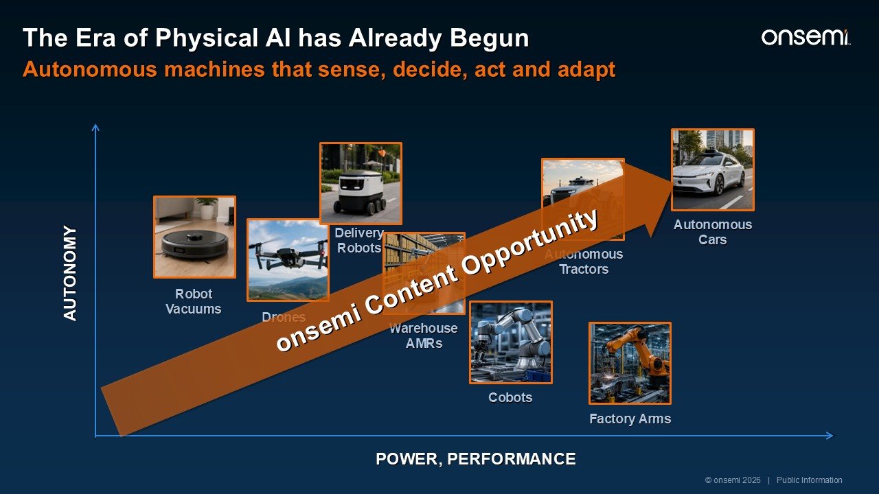
POWER, PERFORMANCE AUTONOMY Robot Vacuums Drones Delivery Robots Warehouse AMRs Cobots Factory Arms Autonomous Tractors Autonomous Cars onsemi Content Opportunity © onsemi 2026 | Public Information The Era of Physical AI has Already Begun Autonomous machines that sense, decide, act and adapt Warehouse AMRs Autonomous Cars Factory Arms Legged AMR “Reasoning”Vehicles Dexterous Hands + Autonomy, Legs + Gripper Hands, Force Sensing + Multi-modal VLA, Reasoning 2x to $6B by 2030

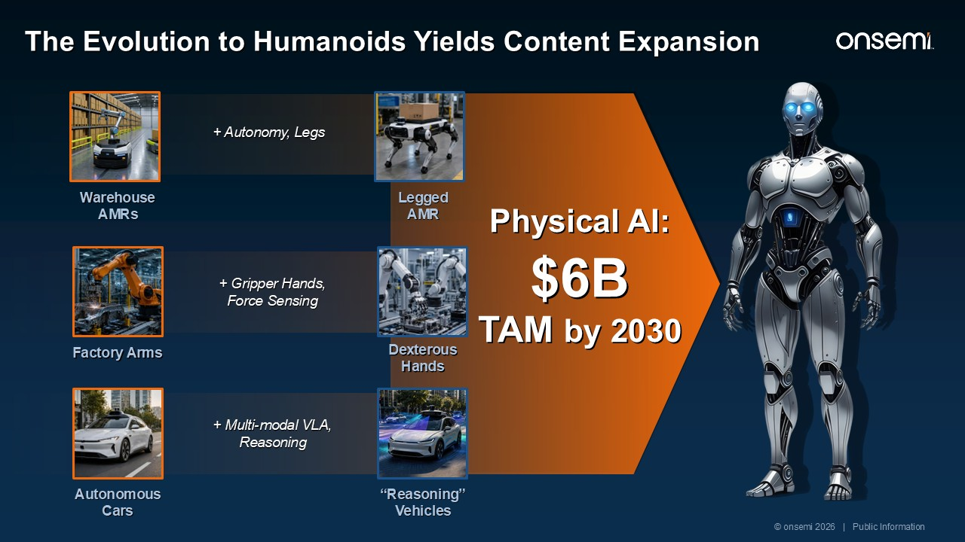
Warehouse AMRs Autonomous Cars Factory Arms Legged AMR “Reasoning”Vehicles Dexterous Hands + Autonomy, Legs + Gripper Hands, Force Sensing + Multi-modal VLA, Reasoning Physical AI: $6B TAM by 2030 © onsemi 2026 | Public Information The Evolution to Humanoids Yields Content Expansion

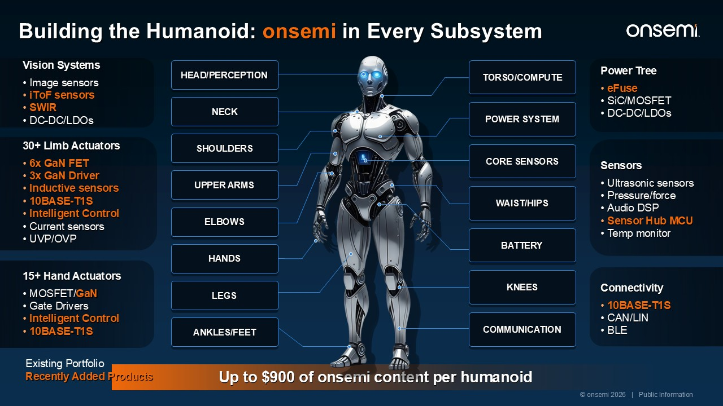
Up to $900 of onsemi content per humanoid HEAD/PERCEPTION NECK SHOULDERS UPPER ARMS ELBOWS HANDS LEGS ANKLES/FEET TORSO/COMPUTE POWER SYSTEM CORE SENSORS WAIST/HIPS BATTERY KNEES COMMUNICATION 30+ Limb Actuators 6x GaN FET 3x GaN Driver Inductive sensors 10BASE-T1S Intelligent Control Current sensors UVP/OVP 15+ Hand Actuators MOSFET/GaN Gate Drivers Intelligent Control 10BASE-T1S Sensors Ultrasonic sensors Pressure/force Audio DSP Sensor Hub MCU Temp monitor Power Tree eFuse SiC/MOSFET DC-DC/LDOs Connectivity 10BASE-T1S CAN/LIN BLE Vision Systems Image sensors iToF sensors SWIR DC-DC/LDOs Existing Portfolio Recently Added Products © onsemi 2026 | Public Information Building the Humanoid: onsemi in Every Subsystem

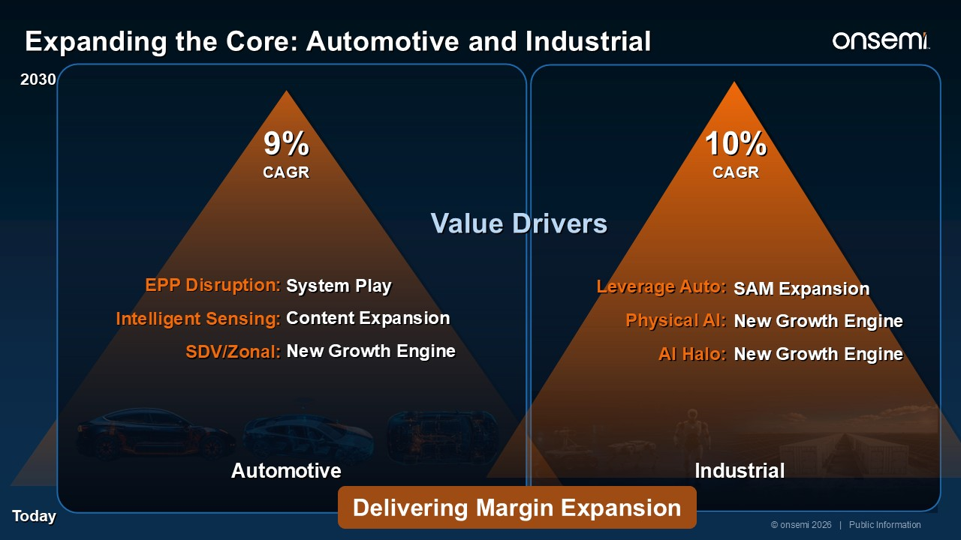
Today 2030 EPP Disruption: Intelligent Sensing: SDV/Zonal: System Play Content Expansion New Growth Engine 9% CAGR Industrial Leverage Auto: Physical AI: AI Halo: SAM Expansion New Growth Engine New Growth Engine 10% CAGR © onsemi 2026 | Public Information Expanding the Core: Automotive and Industrial Automotive Value Drivers Delivering Margin Expansion




Turning Technology Leadership intoDurable Financial Performance Thad TrentExecutive Vice President and CFO

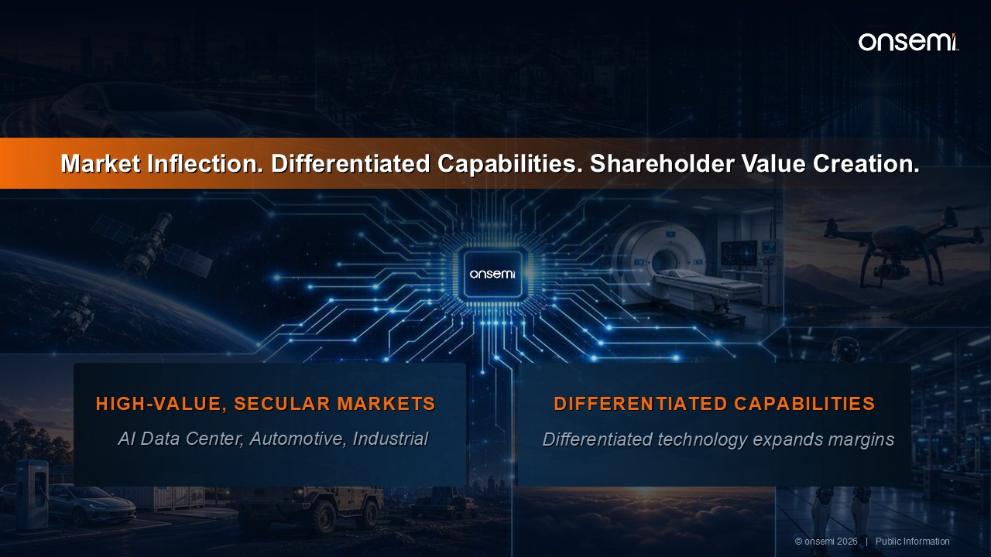
Market Inflection. Differentiated Capabilities. Shareholder Value Creation. HIGH-VALUE, SECULAR MARKETS​ AI Data Center, Automotive, Industrial DIFFERENTIATED CAPABILITIES Differentiated technology expands margins​ © onsemi 2026 | Public Information

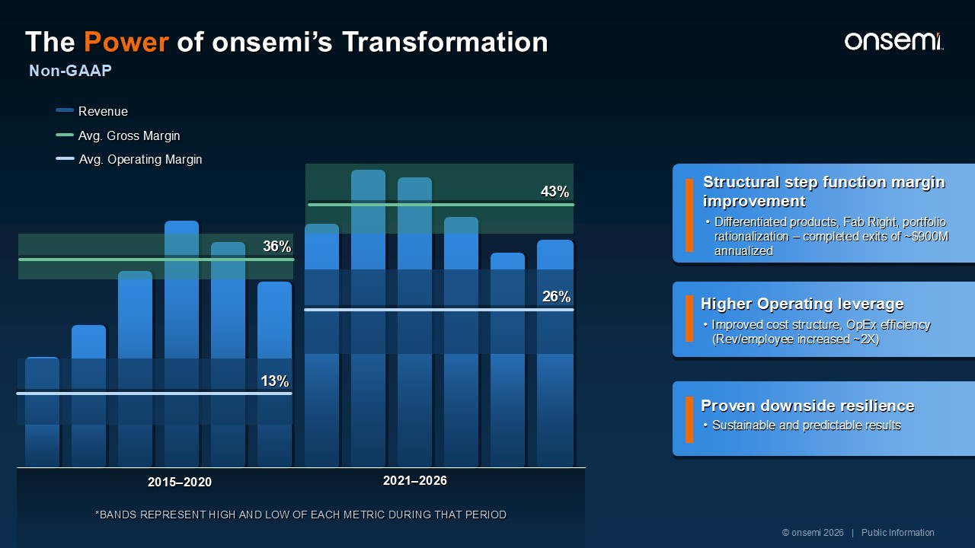
Non-GAAP 2015–2020 2021–2026 Avg. Gross Margin Avg. Operating Margin 26% 43% 36% 13% *BANDS REPRESENT HIGH AND LOW OF EACH METRIC DURING THAT PERIOD Revenue Sustainable and predictable results Proven downside resilience Improved cost structure, OpEx efficiency (Rev/employee increased ~2X) Higher Operating leverage Differentiated products, Fab Right, portfolio rationalization – completed exits of ~$900M annualized Structural step function margin improvement Transform from Manufacturing Co. to a Product Co. Brownfield capacity expansion Strong Free Cash Flow Generation AVG FREE CASH FLOW % © onsemi 2026 | Public Information The Power of onsemi’s Transformation

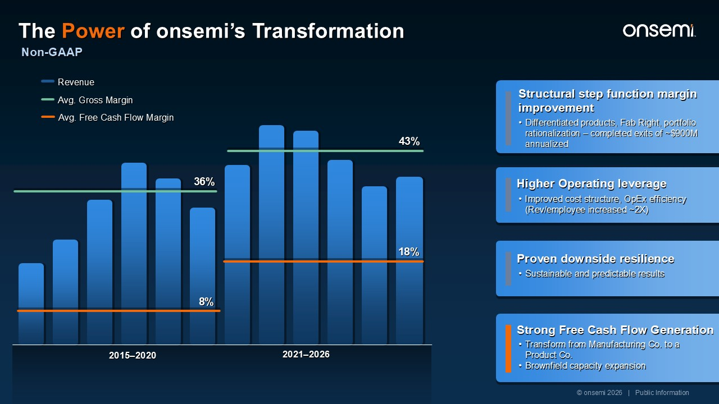
2015–2020 2021–2026 Avg. Gross Margin Avg. Free Cash Flow Margin Revenue 18% 8% Sustainable and predictable results Proven downside resilience Improved cost structure, OpEx efficiency (Rev/employee increased ~2X) Higher Operating leverage Differentiated products, Fab Right, portfolio rationalization – completed exits of ~$900M annualized Structural step function margin improvement Transform from Manufacturing Co. to a Product Co. Brownfield capacity expansion Strong Free Cash Flow Generation 43% 36% © onsemi 2026 | Public Information Non-GAAP The Power of onsemi’s Transformation

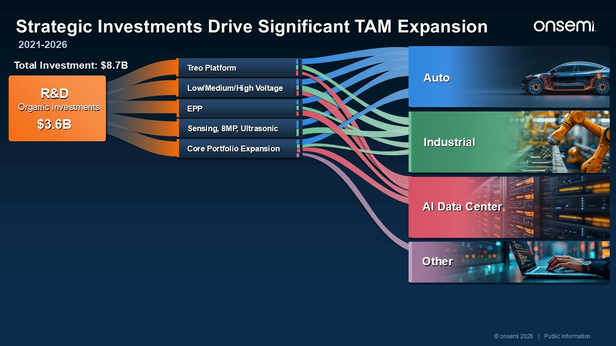
R&D $3.6B Organic Investments EPP Sensing, 8MP, Ultrasonic Core Portfolio Expansion Treo Platform Low/Medium/High Voltage Strategic Investments Drive Significant TAM Expansion Auto Industrial AI Data Center​ Other © onsemi 2026 | Public Information 2021-2026 Total Investment: $8.7B

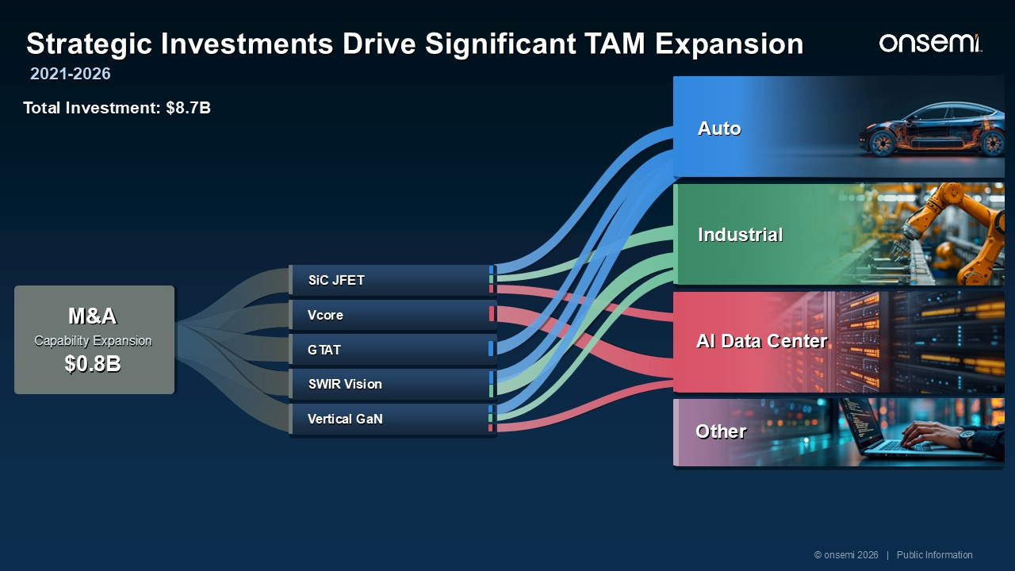
GTAT Vcore SiC JFET SWIR Vision Vertical GaN M&A Capability Expansion $0.8B Strategic Investments Drive Significant TAM Expansion Auto Industrial AI Data Center​ Other © onsemi 2026 | Public Information 2021-2026 Total Investment: $8.7B

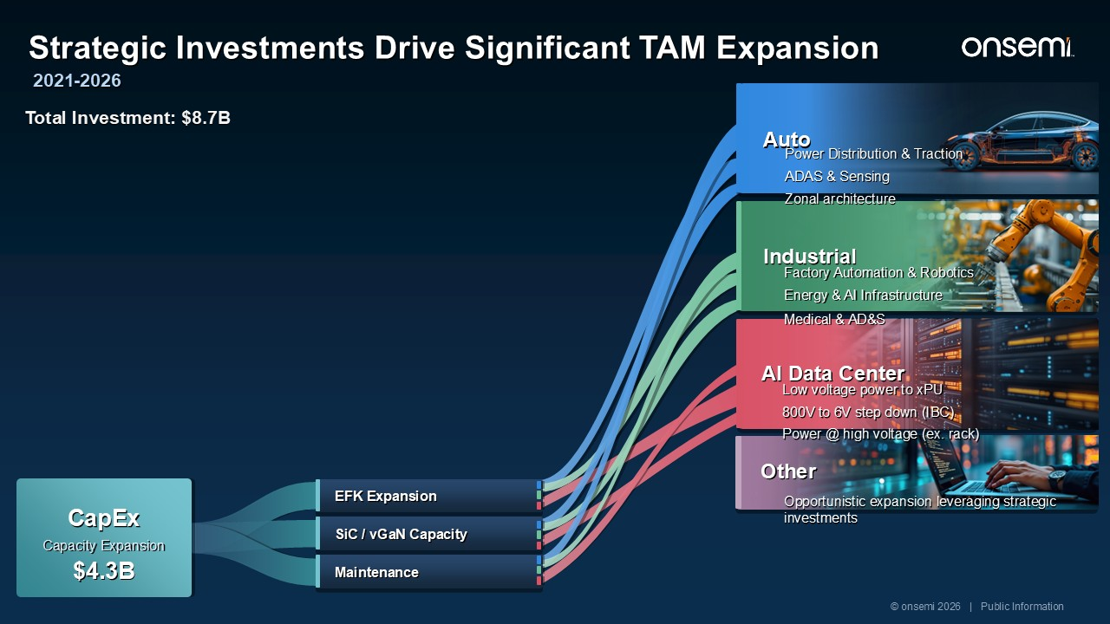
CapEx Capacity Expansion $4.3B EFK Expansion SiC / vGaN Capacity Maintenance Strategic Investments Drive Significant TAM Expansion Auto © onsemi 2026 | Public Information 2021-2026 Total Investment: $8.7B Auto Opportunistic expansion leveraging strategic investments Power Distribution & Traction ADAS & Sensing Zonal architecture Energy & AI Infrastructure Medical & AD&S Low voltage power to xPU 800V to 6V step down (IBC) Power @ high voltage (ex. rack) Factory Automation & Robotics Industrial AI Data Center​ Other

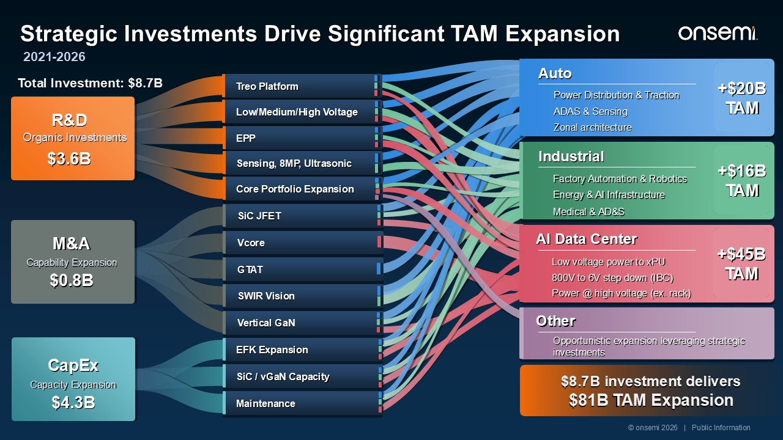
Total Investment: $8.7B $8.7B investment delivers $81B TAM Expansion R&D $3.6B Organic Investments GTAT Vcore SiC JFET SWIR Vision Vertical GaN M&A Capability Expansion $0.8B CapEx Capacity Expansion $4.3B EFK Expansion SiC / vGaN Capacity Maintenance EPP Sensing, 8MP, Ultrasonic Core Portfolio Expansion Treo Platform Low/Medium/High Voltage © onsemi 2026 | Public Information Strategic Investments Drive Significant TAM Expansion 2021-2026 Auto Power Distribution & Traction ADAS & Sensing Zonal architecture +$20B TAM AI Data Center​ Low voltage power to xPU 800V to 6V step down (IBC) Power @ high voltage (ex. rack) +$45B TAM Other Opportunistic expansion leveraging strategic investments Industrial Energy & AI Infrastructure Medical & AD&S Factory Automation & Robotics +$16B TAM

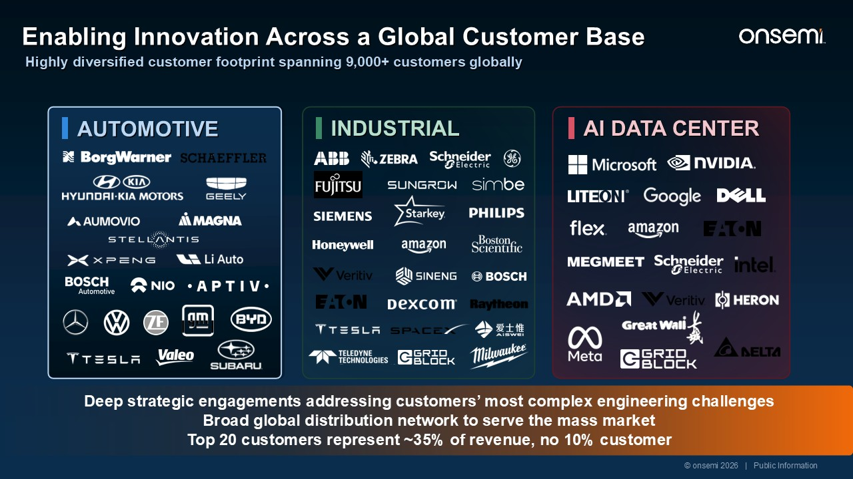
Deep strategic engagements addressing customers’ most complex engineering challenges Broad global distribution network to serve the mass market Top 20 customers represent ~35% of revenue, no 10% customer © onsemi 2026 | Public Information Highly diversified customer footprint spanning 9,000+ customers globally Enabling Innovation Across a Global Customer Base AUTOMOTIVE AI DATA CENTER INDUSTRIAL

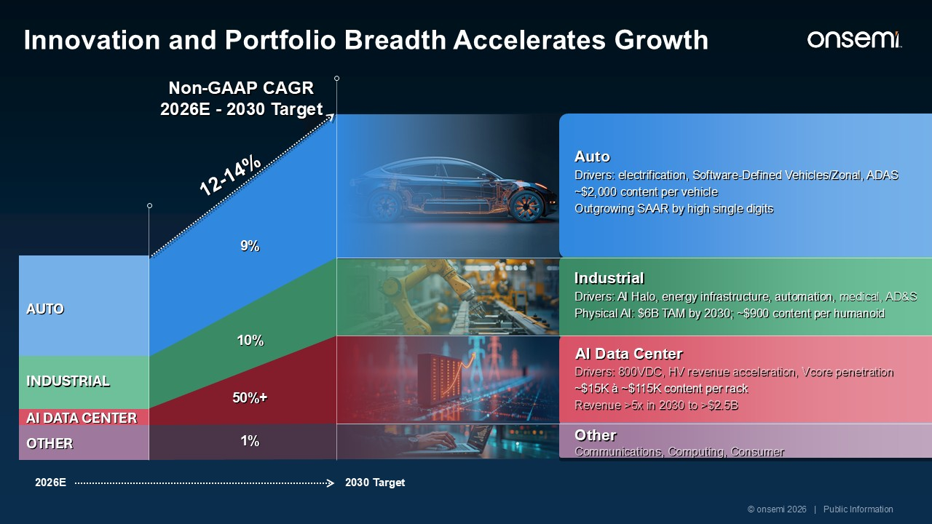
Innovation and Portfolio Breadth Accelerates Growth Other Communications, Computing, Consumer AUTO INDUSTRIAL AI DATA CENTER OTHER Non-GAAP CAGR 2026E - 2030 Target 9% 10% 50%+ 1% 12-14% 2026E 2030 Target Auto Drivers: electrification, Software-Defined Vehicles/Zonal, ADAS ~$2,000 content per vehicle Outgrowing SAAR by high single digits Industrial Drivers: AI Halo, energy infrastructure, automation, medical, AD&S Physical AI: $6B TAM by 2030; ~$900 content per humanoid © onsemi 2026 | Public Information AI Data Center​ Drivers: 800VDC, HV revenue acceleration, Vcore penetration ~$15K à ~$115K content per rack Revenue >5x in 2030 to >$2.5B

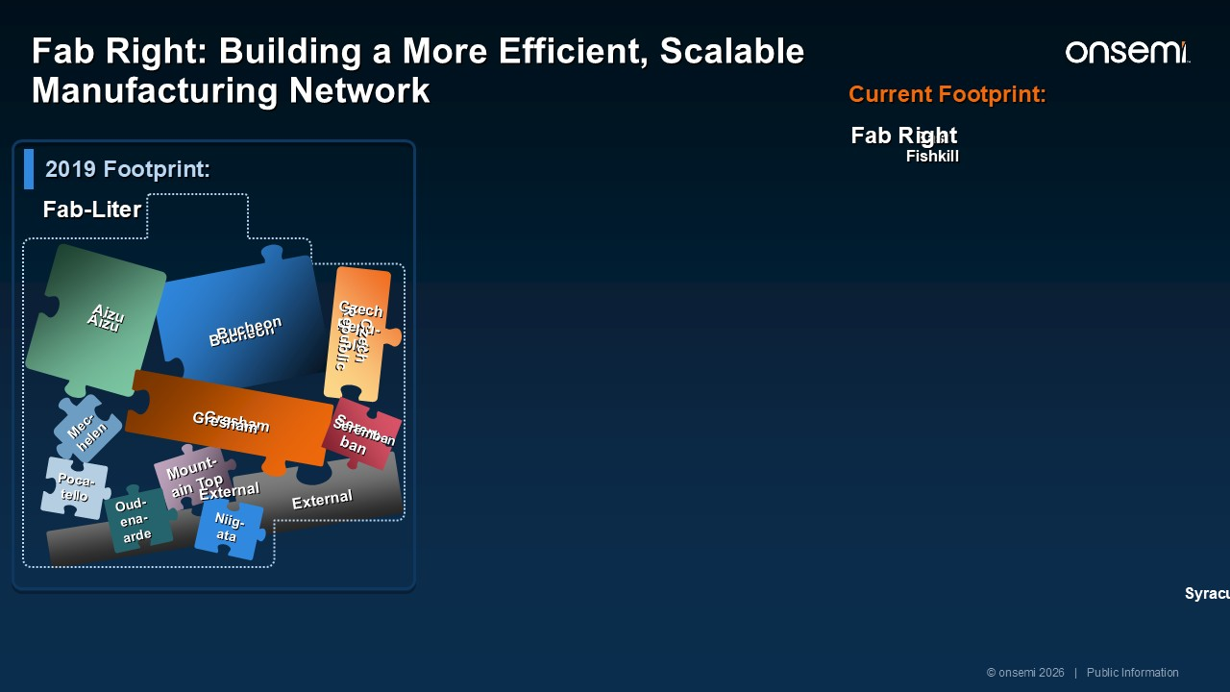
East Fishkill External 2019 Footprint: Mount-ain Top Mec-helen Bucheon Poca-tello Oud-ena-arde Niig-ata Czech Repu-blic Aizu Gresham Serem-ban Aizu Gresham Bucheon Czech Republic Seremban External Fab-Liter Current Footprint: Fab Right Syracuse © onsemi 2026 | Public Information Fab Right: Building a More Efficient, Scalable Manufacturing Network

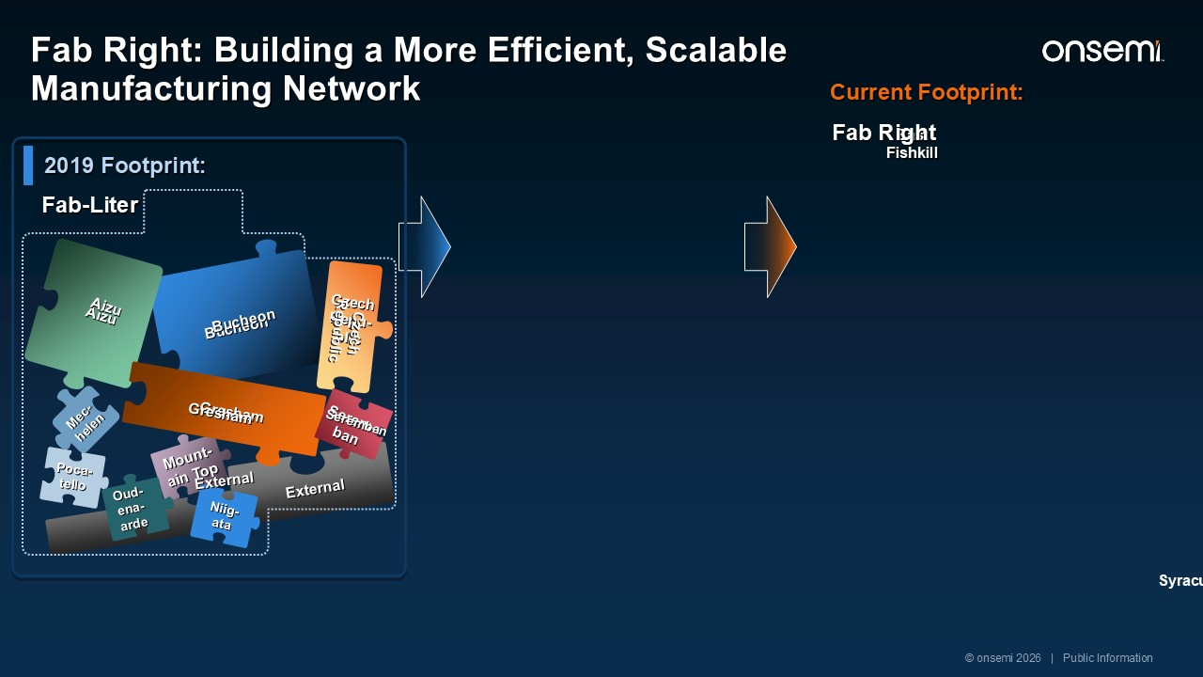
East Fishkill External 2019 Footprint: Mount-ain Top Mec-helen Bucheon Poca-tello Oud-ena-arde Niig-ata Czech Repu-blic Aizu Gresham Serem-ban Aizu Gresham Bucheon Czech Republic Seremban External Fab-Liter Current Footprint: Fab Right Syracuse © onsemi 2026 | Public Information Fab Right: Building a More Efficient, Scalable Manufacturing Network

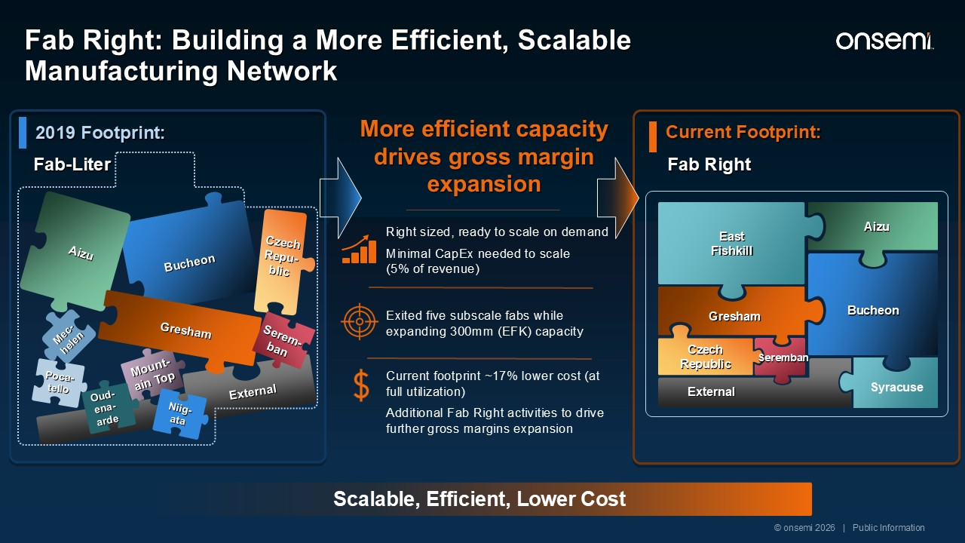
External Scalable, Efficient, Lower Cost Right sized, ready to scale on demand Minimal CapEx needed to scale (5% of revenue) More efficient capacity drives gross margin expansion Exited five subscale fabs while expanding 300mm (EFK) capacity Current footprint ~17% lower cost (at full utilization) Additional Fab Right activities to drive further gross margins expansion 2019 Footprint: Mount-ain Top Mec-helen Bucheon Poca-tello Oud-ena-arde Niig-ata Czech Repu-blic Aizu Gresham Serem-ban East Fishkill Aizu Gresham Bucheon Czech Republic Seremban External Fab-Liter Current Footprint: Fab Right Syracuse © onsemi 2026 | Public Information Fab Right: Building a More Efficient, Scalable Manufacturing Network

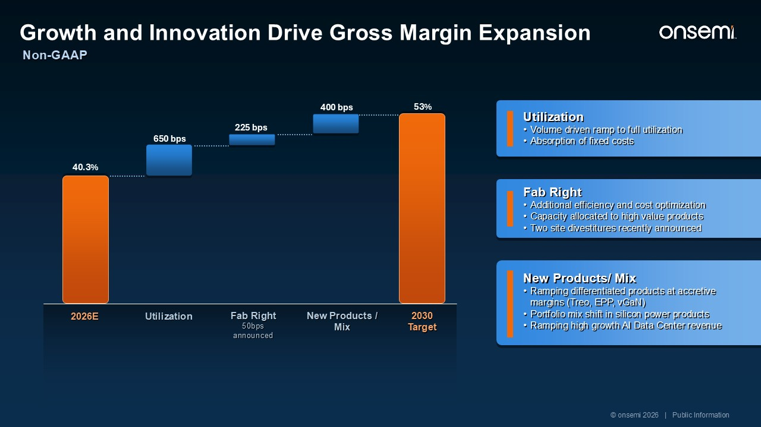
Utilization Volume driven ramp to full utilization Absorption of fixed costs Fab Right Additional efficiency and cost optimization Capacity allocated to high value products Two site divestitures recently announced New Products/ Mix Ramping differentiated products at accretive margins (Treo, EPP, vGaN) Portfolio mix shift in silicon power products Ramping high growth AI Data Center revenue 40.3% 2026E Utilization Fab Right 50bps announced New Products / Mix 53% 2030 Target 400 bps 225 bps 650 bps © onsemi 2026 | Public Information Non-GAAP Growth and Innovation Drive Gross Margin Expansion

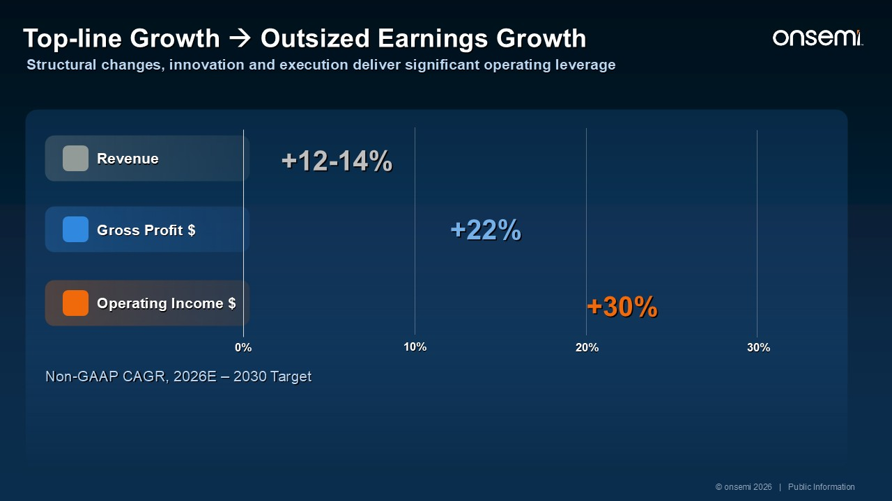
Non-GAAP CAGR, 2026E – 2030 Target Operating Income $ Gross Profit $ Revenue 20% 30% 10% 0% +12-14% +22% +30% Gross profit grows 1.6x faster than revenue; operating income more than 2x faster. © onsemi 2026 | Public Information Top-line Growth → Outsized Earnings Growth Structural changes, innovation and execution deliver significant operating leverage

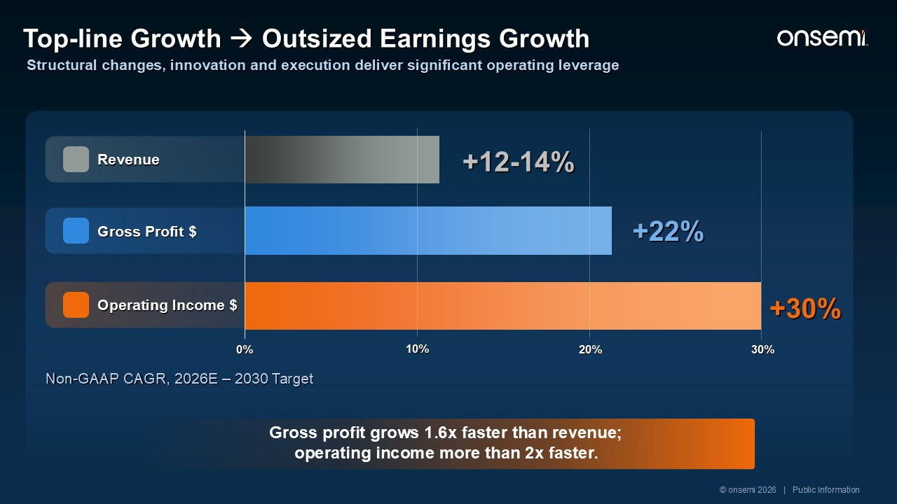
Operating Income $ Gross Profit $ Revenue +12-14% +22% +30% 20% 30% 10% 0% Gross profit grows 1.6x faster than revenue; operating income more than 2x faster. Non-GAAP CAGR, 2026E – 2030 Target © onsemi 2026 | Public Information Top-line Growth → Outsized Earnings Growth Structural changes, innovation and execution deliver significant operating leverage

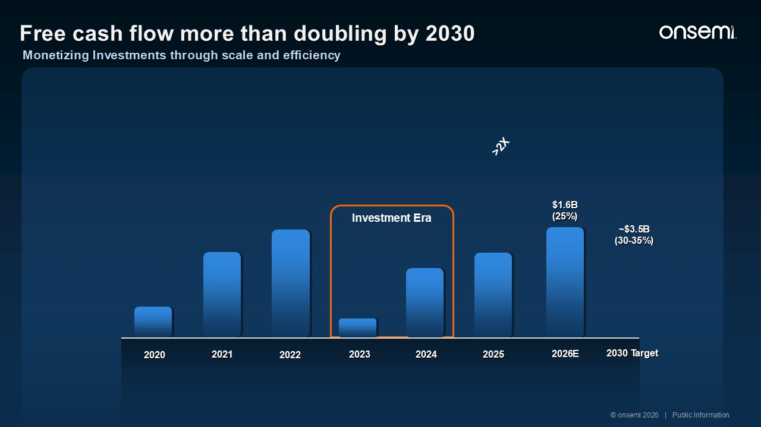
Investment Era 2020 2022 2024 2025 2026E 2021 2023 2030 Target $1.6B (25%) ~$3.5B (30-35%) Buyback $4.2B / 92% FCF 2023-2026E = 12% reduction in shares outstanding >2X © onsemi 2026 | Public Information Free cash flow more than doubling by 2030 Monetizing Investments through scale and efficiency

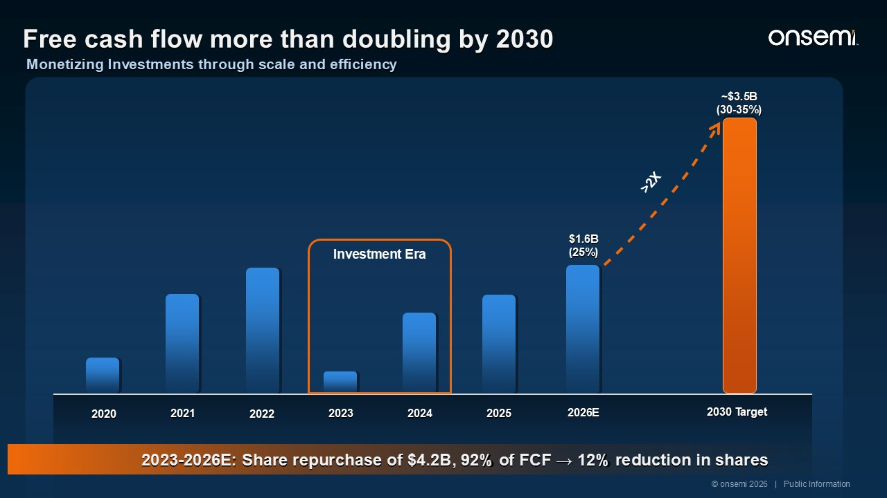
2020 2022 2024 2025 2026E 2021 2023 2030 Target $1.6B (25%) ~$3.5B (30-35%) >2X Investment Era 2023-2026E: Share repurchase of $4.2B, 92% of FCF → 12% reduction in shares Free cash flow more than doubling by 2030 Monetizing Investments through scale and efficiency © onsemi 2026 | Public Information

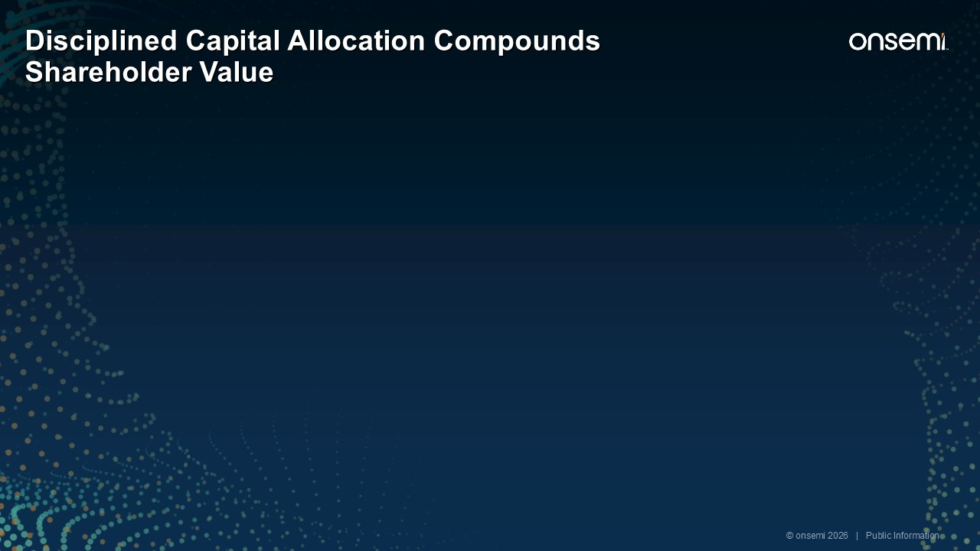
REINVEST Fund the highest-return growth Differentiated products, R&D and capacity investments that strengthen competitive advantage. © onsemi 2026 | Public Information Disciplined Capital Allocation Compounds Shareholder Value

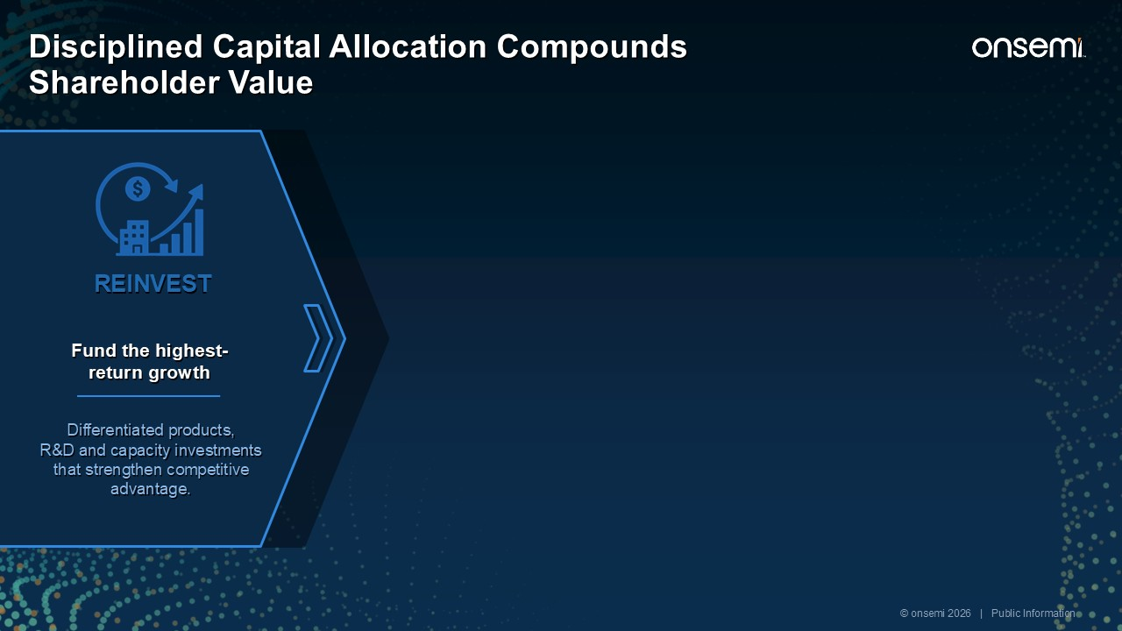
STRATEGIC M&A Expand the portfolio selectively Add capabilities to expand TAM and accelerate time to market. Clear strategic and financial merit enhancing the financial model. REINVEST Fund the highest-return growth Differentiated products, R&D and capacity investments that strengthen competitive advantage. © onsemi 2026 | Public Information Disciplined Capital Allocation Compounds Shareholder Value

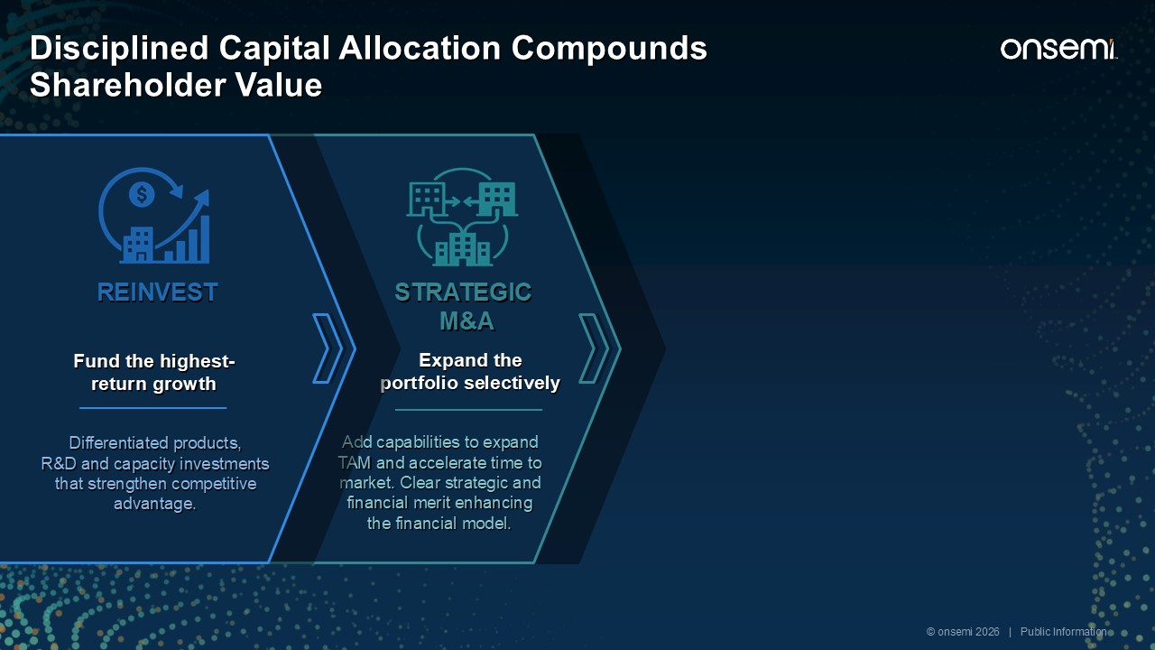
BALANCESHEET Preserve resilience and flexibility Maintain strong liquidity and leverage profile. STRATEGIC M&A Expand the portfolio selectively Add capabilities to expand TAM and accelerate time to market. Clear strategic and financial merit enhancing the financial model. REINVEST Fund the highest-return growth Differentiated products, R&D and capacity investments that strengthen competitive advantage. © onsemi 2026 | Public Information Disciplined Capital Allocation Compounds Shareholder Value

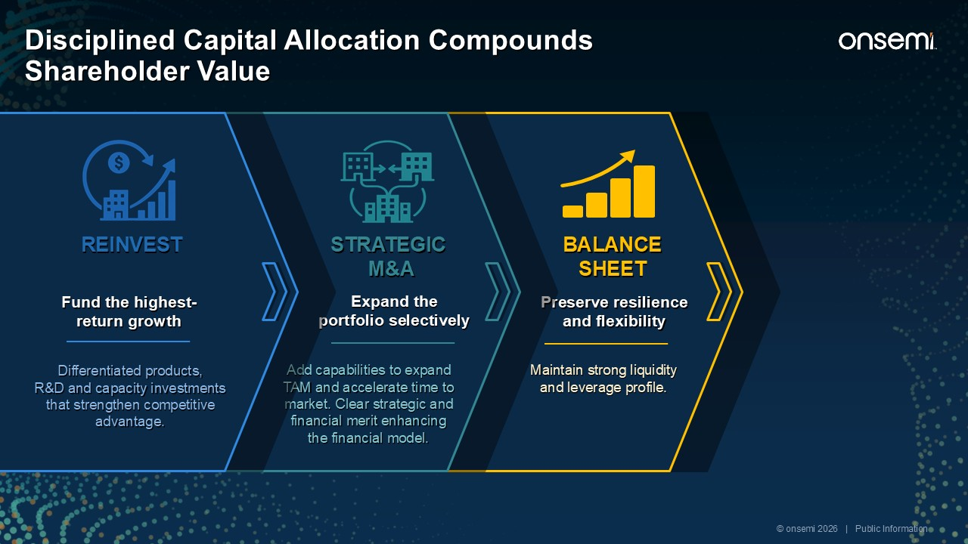
RETURN CASH Repurchase shares consistently Return 100% of free cash flow through share repurchases. $5.3B remaining under the existing authorization. BALANCESHEET Preserve resilience and flexibility Maintain strong liquidity and leverage profile. STRATEGIC M&A Expand the portfolio selectively Add capabilities to expand TAM and accelerate time to market. Clear strategic and financial merit enhancing the financial model. REINVEST Fund the highest-return growth Differentiated products, R&D and capacity investments that strengthen competitive advantage. © onsemi 2026 | Public Information Disciplined Capital Allocation Compounds Shareholder Value

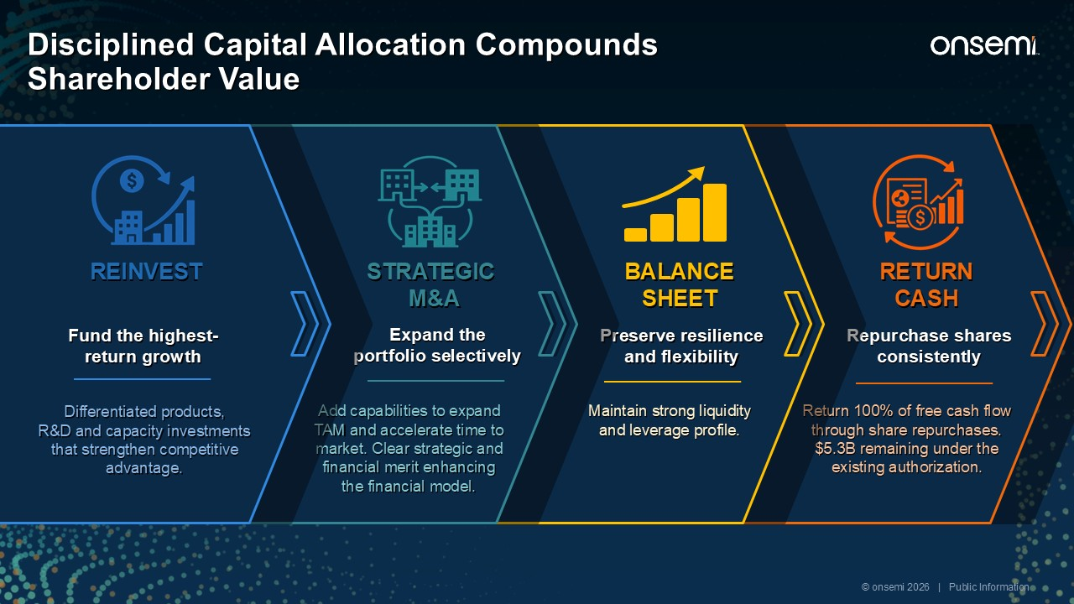
RETURN CASH Repurchase shares consistently Return 100% of free cash flow through share repurchases. $5.3B remaining under the existing authorization. BALANCESHEET Preserve resilience and flexibility Maintain strong liquidity and leverage profile. STRATEGIC M&A Expand the portfolio selectively Add capabilities to expand TAM and accelerate time to market. Clear strategic and financial merit enhancing the financial model. REINVEST Fund the highest-return growth Differentiated products, R&D and capacity investments that strengthen competitive advantage. © onsemi 2026 | Public Information Disciplined Capital Allocation Compounds Shareholder Value

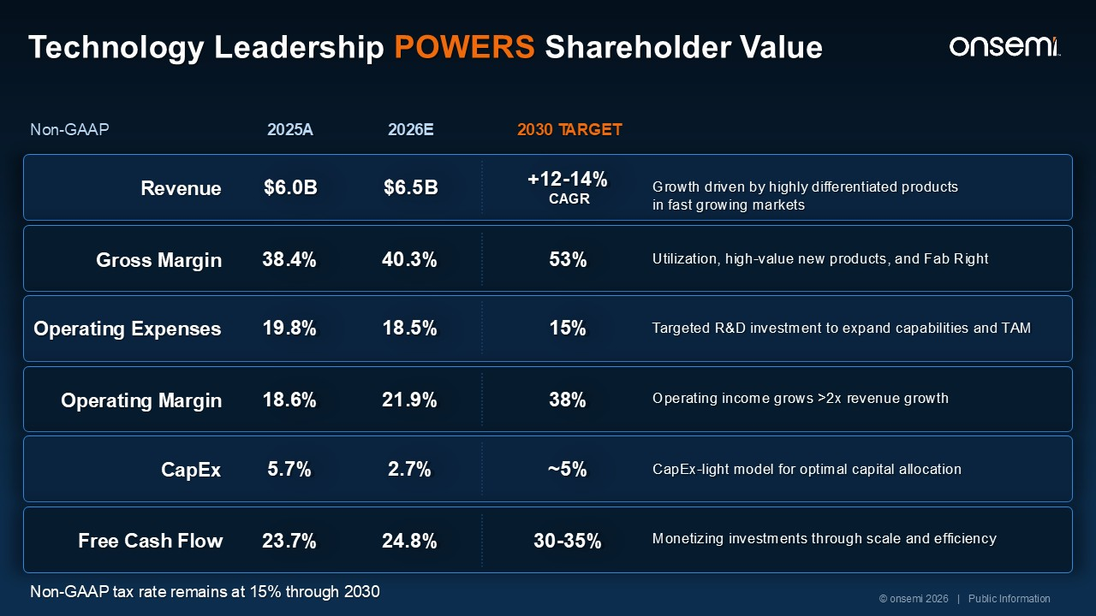
Non-GAAP 2025A 2030 TARGET Revenue Gross Margin $6.0B 38.4% +12-14% CAGR 53% Growth driven by highly differentiated products in fast growing markets Utilization, high-value new products, and Fab Right Operating Expenses Operating Margin 19.8% 18.6% 15% 38% Targeted R&D investment to expand capabilities and TAM Operating income grows >2x revenue growth CapEx Free Cash Flow 5.7% 23.7% ~5% 30-35% CapEx-light model for optimal capital allocation Monetizing investments through scale and efficiency 2026E $6.5B 40.3% 18.5% 21.9% 2.7% 24.8% Non-GAAP tax rate remains at 15% through 2030 © onsemi 2026 | Public Information Technology Leadership POWERS Shareholder Value Synaptics standalone Post-Synergies Accelerates Financial model

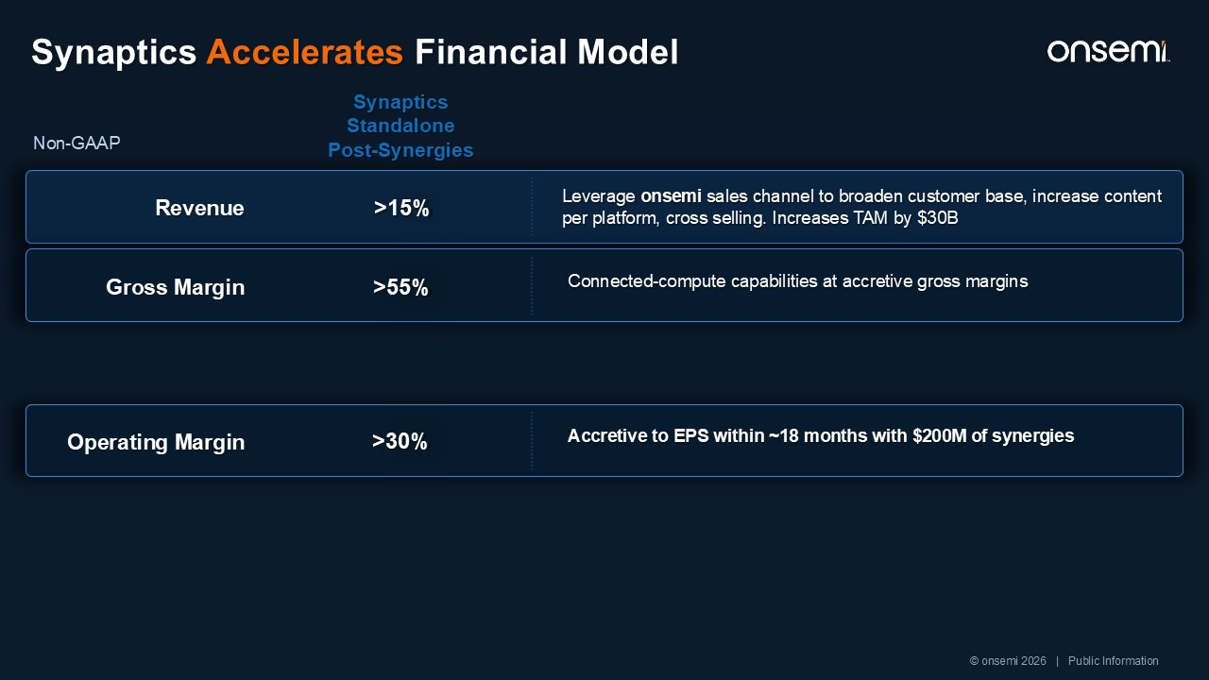
Non-GAAP Synaptics Accelerates Financial Model Revenue Gross Margin $6.0B 38.4% +12-14% CAGR 53% Growth driven by highly differentiated products in fast growing markets Utilization, High-Value New Products, and Fab-Right Operating Margin 18.7% 38% Operating income grows >2x revenue growth $6.5B 40.3% 21.9% Revenue Gross Margin Leverage onsemi sales channel to broaden customer base, increase content per platform, cross selling. Increases TAM by $30B Connected-compute capabilities at accretive gross margins Operating Margin Accretive to EPS within ~18 months with $200M of synergies >15% Synaptics Standalone Post-Synergies >55% >30% © onsemi 2026 | Public Information Non-GAAP

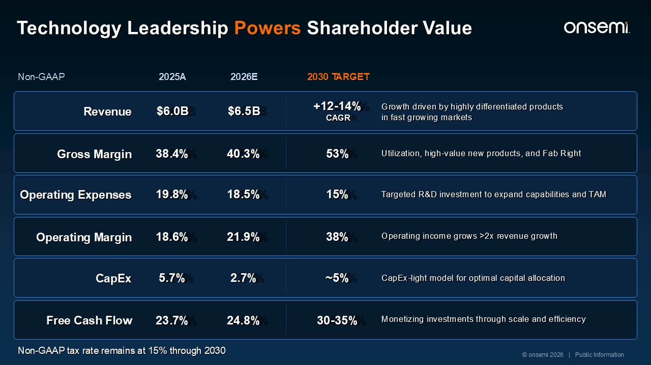
Operating Expenses Operating Margin 19.8% 18.6% 15% 38% Targeted R&D investment to expand capabilities and TAM Operating income grows >2x revenue growth CapEx Free Cash Flow 5.7% 23.7% ~5% 30-35% CapEx-light model for optimal capital allocation Monetizing investments through scale and efficiency 18.5% 21.9% 2.7% 24.8% Revenue Gross Margin $6.0B 38.4% +12-14% CAGR 53% Growth driven by highly differentiated products in fast growing markets Utilization, high-value new products, and Fab Right $6.5B 40.3% Non-GAAP 2025A 2030 TARGET 2026E Non-GAAP tax rate remains at 15% through 2030 © onsemi 2026 | Public Information Technology Leadership Powers Shareholder Value Synaptics standalone Post-Synergies Accelerates Financial model

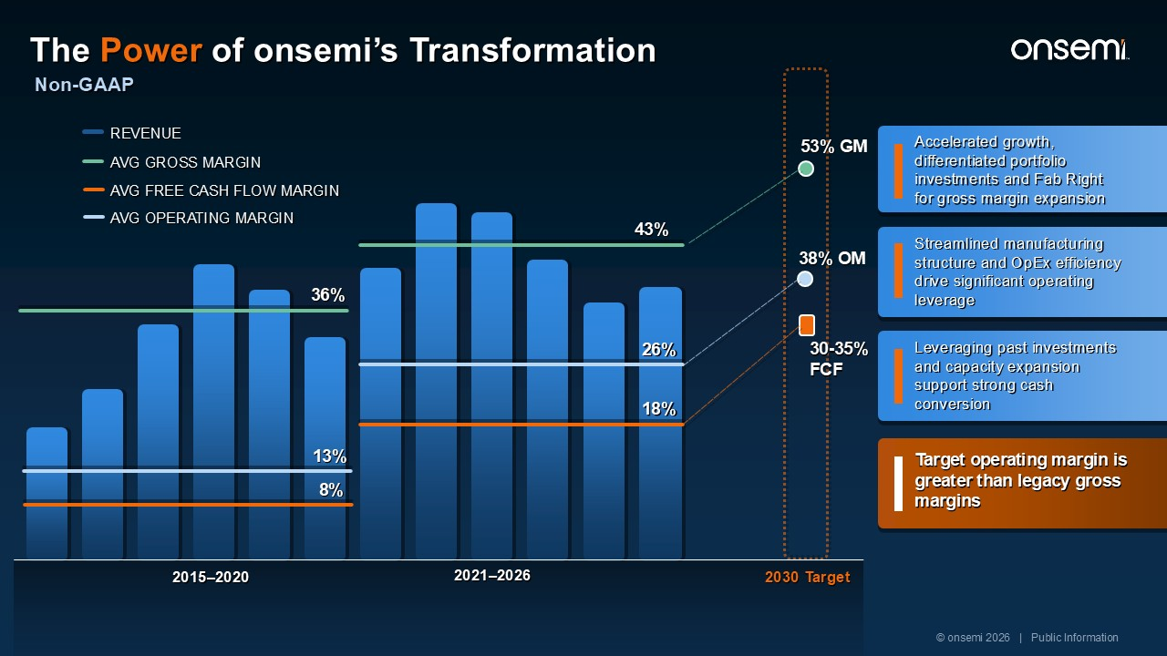
2015–2020 2021–2026 8% 36% AVG GROSS MARGIN 43% REVENUE AVG FREE CASH FLOW MARGIN 18% 2030 Target 13% AVG OPERATING MARGIN 26% 53% GM 38% OM Accelerated growth, differentiated portfolio investments and Fab Right for gross margin expansion Leveraging past investments and capacity expansion support strong cash conversion Streamlined manufacturing structure and OpEx efficiency drive significant operating leverage Target operating margin is greater than legacy gross margins 30-35% FCF © onsemi 2026 | Public Information Non-GAAP The Power of onsemi’s Transformation

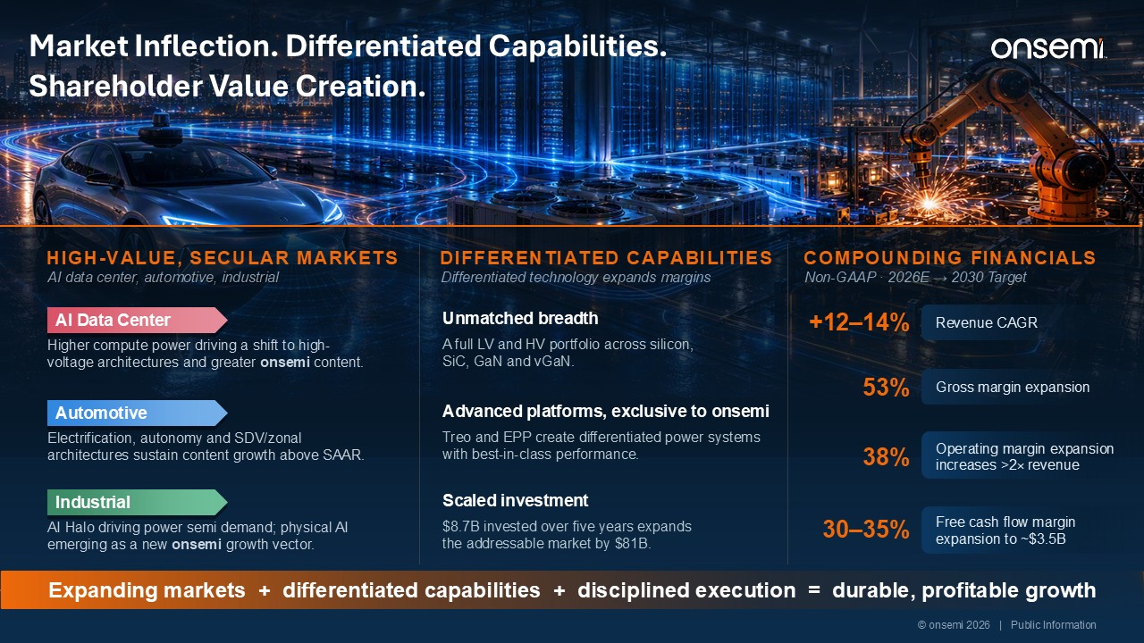
AI data center, automotive, industrial Higher compute power driving a shift to high-voltage architectures and greater onsemi content. Electrification, autonomy and SDV/zonal architectures sustain content growth above SAAR. AI Halo driving power semi demand; physical AI emerging as a new onsemi growth vector. +12–14% Revenue CAGR 53% 38% 30–35% Unmatched breadth A full LV and HV portfolio across silicon, SiC, GaN and vGaN. Advanced platforms, exclusive to onsemi Treo and EPP create differentiated power systems with best-in-class performance. Scaled investment $8.7B invested over five years expands the addressable market by $81B. Expanding markets + differentiated capabilities + disciplined execution = durable, profitable growth © onsemi 2026 | Public Information Market Inflection. Differentiated Capabilities. Shareholder Value Creation. HIGH-VALUE, SECULAR MARKETS​ AI Data Center Automotive Industrial Differentiated technology expands margins​ DIFFERENTIATED CAPABILITIES Non-GAAP · 2026E → 2030 Target COMPOUNDING FINANCIALS Gross margin expansion Operating margin expansion increases >2× revenue Free cash flow margin expansion to ~$3.5B



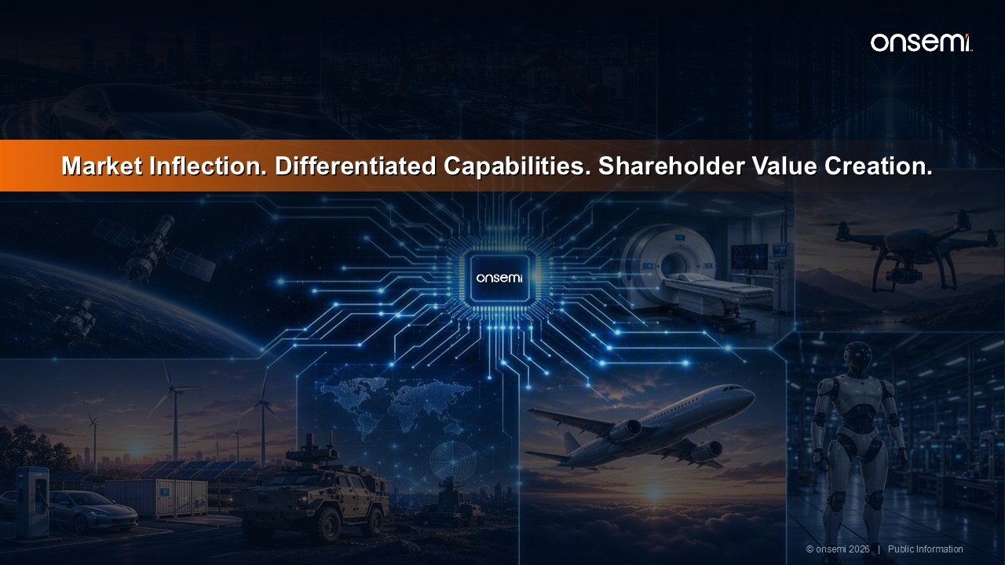
Market Inflection. Differentiated Capabilities. Shareholder Value Creation. © onsemi 2026 | Public Information

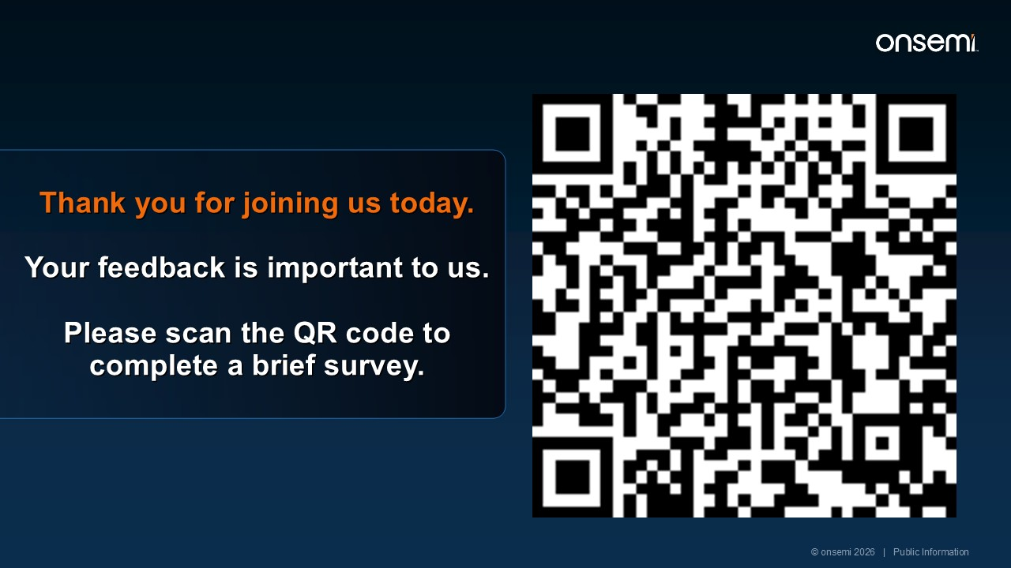
Thank you for joining us today. Your feedback is important to us. Please scan the QR code to complete a brief survey. © onsemi 2026 | Public Information

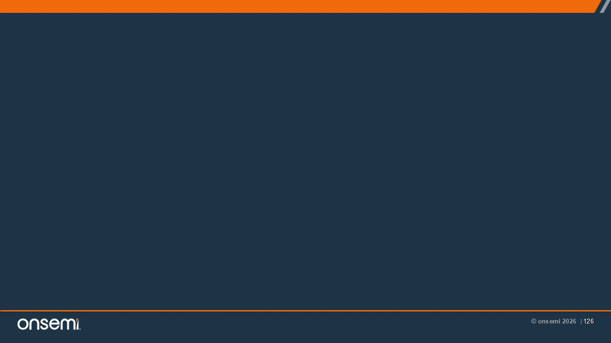

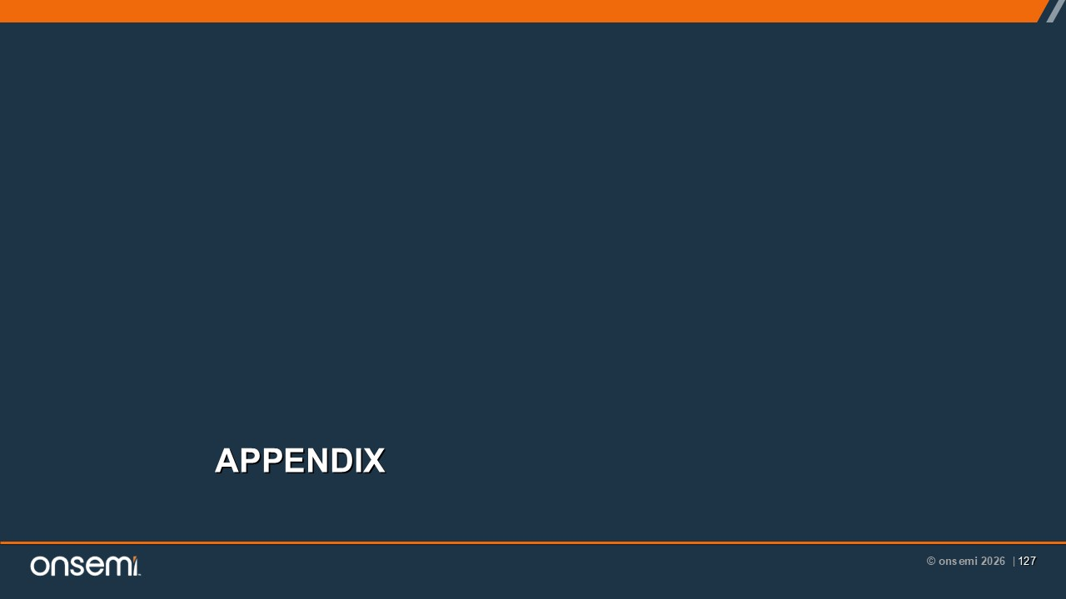
APPENDIX

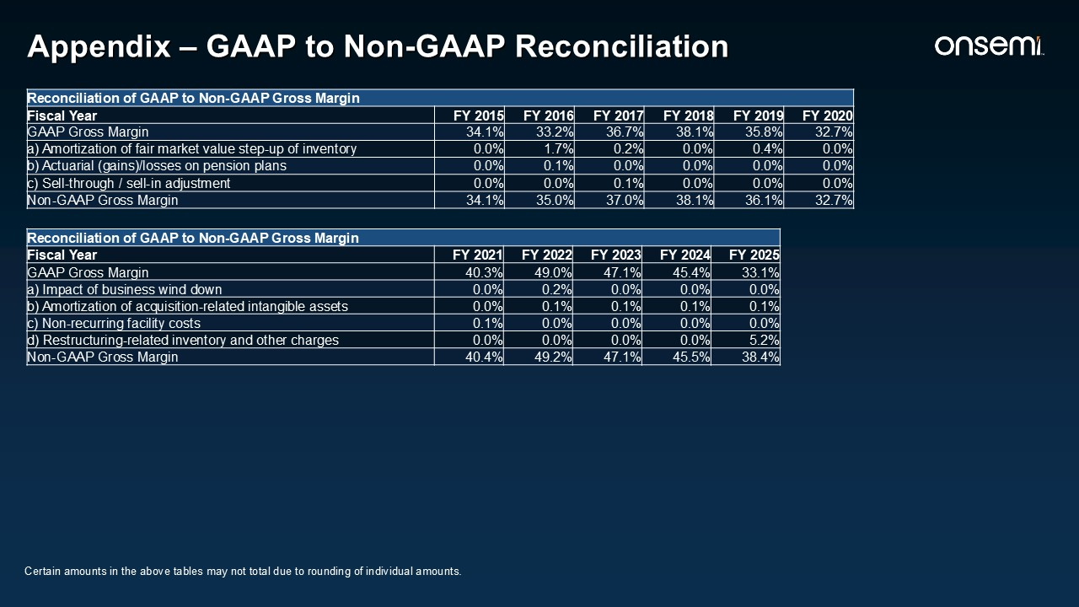
Reconciliation of GAAP to Non-GAAP Gross Margin Fiscal Year FY 2021 FY 2022 FY 2023 FY 2024 FY 2025 GAAP Gross Margin 40.3% 49.0% 47.1% 45.4% 33.1% a) Impact of business wind down 0.0% 0.2% 0.0% 0.0% 0.0% b) Amortization of acquisition-related intangible assets 0.0% 0.1% 0.1% 0.1% 0.1% c) Non-recurring facility costs 0.1% 0.0% 0.0% 0.0% 0.0% d) Restructuring-related inventory and other charges 0.0% 0.0% 0.0% 0.0% 5.2% Non-GAAP Gross Margin 40.4% 49.2% 47.1% 45.5% 38.4% Appendix – GAAP to Non-GAAP Reconciliation Reconciliation of GAAP to Non-GAAP Gross Margin Fiscal Year FY 2015 FY 2016 FY 2017 FY 2018 FY 2019 FY 2020 GAAP Gross Margin 34.1% 33.2% 36.7% 38.1% 35.8% 32.7% a) Amortization of fair market value step-up of inventory 0.0% 1.7% 0.2% 0.0% 0.4% 0.0% b) Actuarial (gains)/losses on pension plans 0.0% 0.1% 0.0% 0.0% 0.0% 0.0% c) Sell-through / sell-in adjustment 0.0% 0.0% 0.1% 0.0% 0.0% 0.0% Non-GAAP Gross Margin 34.1% 35.0% 37.0% 38.1% 36.1% 32.7% Certain amounts in the above tables may not total due to rounding of individual amounts.

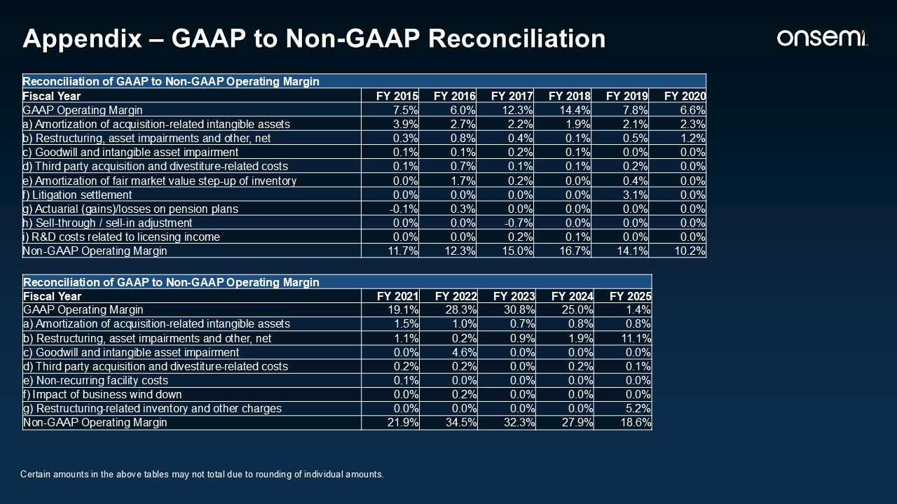
Appendix – GAAP to Non-GAAP Reconciliation Reconciliation of GAAP to Non-GAAP Operating Margin Fiscal Year FY 2021 FY 2022 FY 2023 FY 2024 FY 2025 GAAP Operating Margin 19.1% 28.3% 30.8% 25.0% 1.4% a) Amortization of acquisition-related intangible assets 1.5% 1.0% 0.7% 0.8% 0.8% b) Restructuring, asset impairments and other, net 1.1% 0.2% 0.9% 1.9% 11.1% c) Goodwill and intangible asset impairment 0.0% 4.6% 0.0% 0.0% 0.0% d) Third party acquisition and divestiture-related costs 0.2% 0.2% 0.0% 0.2% 0.1% e) Non-recurring facility costs 0.1% 0.0% 0.0% 0.0% 0.0% f) Impact of business wind down 0.0% 0.2% 0.0% 0.0% 0.0% g) Restructuring-related inventory and other charges 0.0% 0.0% 0.0% 0.0% 5.2% Non-GAAP Operating Margin 21.9% 34.5% 32.3% 27.9% 18.6% Reconciliation of GAAP to Non-GAAP Operating Margin Fiscal Year FY 2015 FY 2016 FY 2017 FY 2018 FY 2019 FY 2020 GAAP Operating Margin 7.5% 6.0% 12.3% 14.4% 7.8% 6.6% a) Amortization of acquisition-related intangible assets 3.9% 2.7% 2.2% 1.9% 2.1% 2.3% b) Restructuring, asset impairments and other, net 0.3% 0.8% 0.4% 0.1% 0.5% 1.2% c) Goodwill and intangible asset impairment 0.1% 0.1% 0.2% 0.1% 0.0% 0.0% d) Third party acquisition and divestiture-related costs 0.1% 0.7% 0.1% 0.1% 0.2% 0.0% e) Amortization of fair market value step-up of inventory 0.0% 1.7% 0.2% 0.0% 0.4% 0.0% f) Litigation settlement 0.0% 0.0% 0.0% 0.0% 3.1% 0.0% g) Actuarial (gains)/losses on pension plans -0.1% 0.3% 0.0% 0.0% 0.0% 0.0% h) Sell-through / sell-in adjustment 0.0% 0.0% -0.7% 0.0% 0.0% 0.0% i) R&D costs related to licensing income 0.0% 0.0% 0.2% 0.1% 0.0% 0.0% Non-GAAP Operating Margin 11.7% 12.3% 15.0% 16.7% 14.1% 10.2% Certain amounts in the above tables may not total due to rounding of individual amounts.

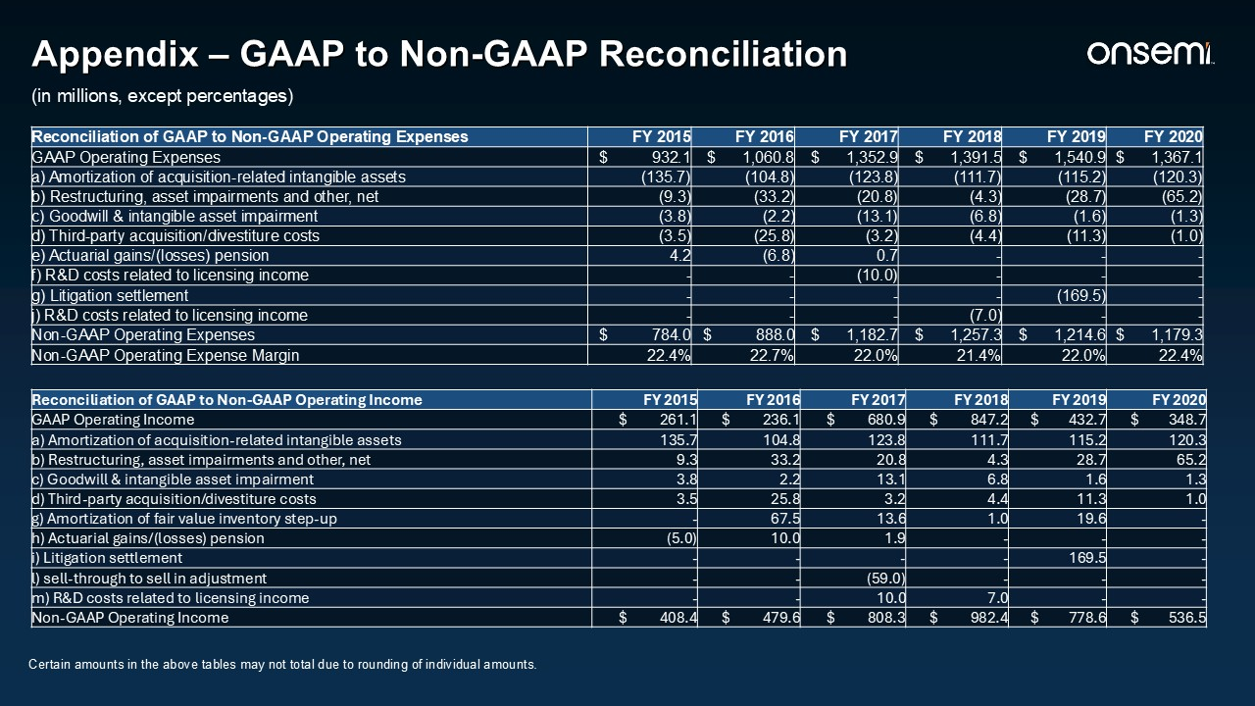
Appendix – GAAP to Non-GAAP Reconciliation Reconciliation of GAAP to Non-GAAP Operating Expenses FY 2015 FY 2016 FY 2017 FY 2018 FY 2019 FY 2020 GAAP Operating Expenses $ 932.1 $ 1,060.8 $ 1,352.9 $ 1,391.5 $ 1,540.9 $ 1,367.1 a) Amortization of acquisition-related intangible assets (135.7) (104.8) (123.8) (111.7) (115.2) (120.3) b) Restructuring, asset impairments and other, net (9.3) (33.2) (20.8) (4.3) (28.7) (65.2) c) Goodwill & intangible asset impairment (3.8) (2.2) (13.1) (6.8) (1.6) (1.3) d) Third-party acquisition/divestiture costs (3.5) (25.8) (3.2) (4.4) (11.3) (1.0) e) Actuarial gains/(losses) pension 4.2 (6.8) 0.7 - - - f) R&D costs related to licensing income - - (10.0) - - - g) Litigation settlement - - - - (169.5) - j) R&D costs related to licensing income - - - (7.0) - - Non-GAAP Operating Expenses $ 784.0 $ 888.0 $ 1,182.7 $ 1,257.3 $ 1,214.6 $ 1,179.3 Non-GAAP Operating Expense Margin 22.4% 22.7% 22.0% 21.4% 22.0% 22.4% Reconciliation of GAAP to Non-GAAP Operating Income FY 2015 FY 2016 FY 2017 FY 2018 FY 2019 FY 2020 GAAP Operating Income $ 261.1 $ 236.1 $ 680.9 $ 847.2 $ 432.7 $ 348.7 a) Amortization of acquisition-related intangible assets 135.7 104.8 123.8 111.7 115.2 120.3 b) Restructuring, asset impairments and other, net 9.3 33.2 20.8 4.3 28.7 65.2 c) Goodwill & intangible asset impairment 3.8 2.2 13.1 6.8 1.6 1.3 d) Third-party acquisition/divestiture costs 3.5 25.8 3.2 4.4 11.3 1.0 g) Amortization of fair value inventory step-up - 67.5 13.6 1.0 19.6 - h) Actuarial gains/(losses) pension (5.0) 10.0 1.9 - - - i) Litigation settlement - - - - 169.5 - l) sell-through to sell in adjustment - - (59.0) - - - m) R&D costs related to licensing income - - 10.0 7.0 - - Non-GAAP Operating Income $ 408.4 $ 479.6 $ 808.3 $ 982.4 $ 778.6 $ 536.5 (in millions, except percentages) Certain amounts in the above tables may not total due to rounding of individual amounts.

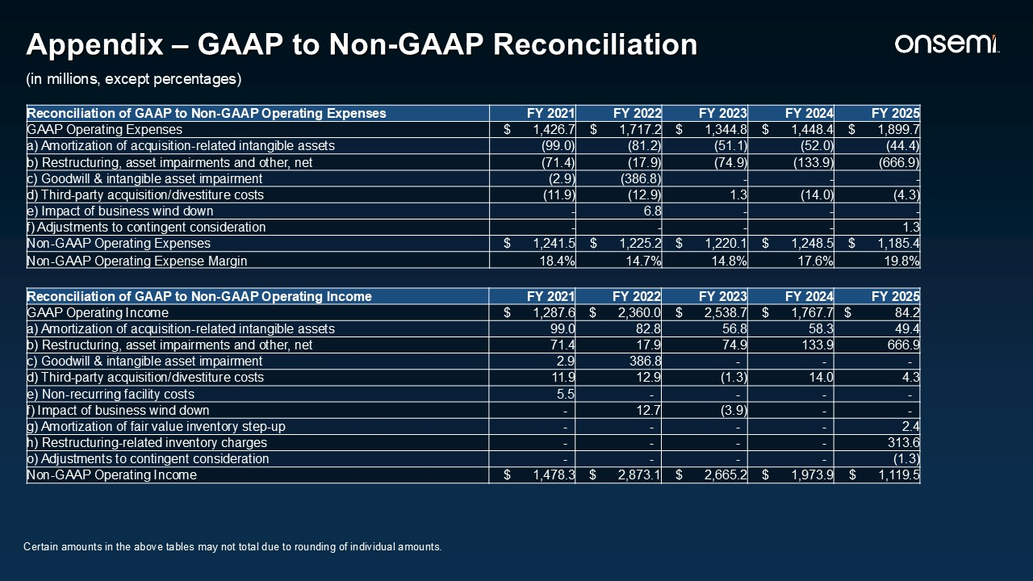
Appendix – GAAP to Non-GAAP Reconciliation (in millions, except percentages) Reconciliation of GAAP to Non-GAAP Operating Expenses FY 2021 FY 2022 FY 2023 FY 2024 FY 2025 GAAP Operating Expenses $ 1,426.7 $ 1,717.2 $ 1,344.8 $ 1,448.4 $ 1,899.7 a) Amortization of acquisition-related intangible assets (99.0) (81.2) (51.1) (52.0) (44.4) b) Restructuring, asset impairments and other, net (71.4) (17.9) (74.9) (133.9) (666.9) c) Goodwill & intangible asset impairment (2.9) (386.8) - - - d) Third-party acquisition/divestiture costs (11.9) (12.9) 1.3 (14.0) (4.3) e) Impact of business wind down - 6.8 - - - f) Adjustments to contingent consideration - - - - 1.3 Non-GAAP Operating Expenses $ 1,241.5 $ 1,225.2 $ 1,220.1 $ 1,248.5 $ 1,185.4 Non-GAAP Operating Expense Margin 18.4% 14.7% 14.8% 17.6% 19.8% Reconciliation of GAAP to Non-GAAP Operating Income FY 2021 FY 2022 FY 2023 FY 2024 FY 2025 GAAP Operating Income $ 1,287.6 $ 2,360.0 $ 2,538.7 $ 1,767.7 $ 84.2 a) Amortization of acquisition-related intangible assets 99.0 82.8 56.8 58.3 49.4 b) Restructuring, asset impairments and other, net 71.4 17.9 74.9 133.9 666.9 c) Goodwill & intangible asset impairment 2.9 386.8 - - - d) Third-party acquisition/divestiture costs 11.9 12.9 (1.3) 14.0 4.3 e) Non-recurring facility costs 5.5 - - - - f) Impact of business wind down - 12.7 (3.9) - - g) Amortization of fair value inventory step-up - - - - 2.4 h) Restructuring-related inventory charges - - - - 313.6 o) Adjustments to contingent consideration - - - - (1.3) Non-GAAP Operating Income $ 1,478.3 $ 2,873.1 $ 2,665.2 $ 1,973.9 $ 1,119.5 Certain amounts in the above tables may not total due to rounding of individual amounts.

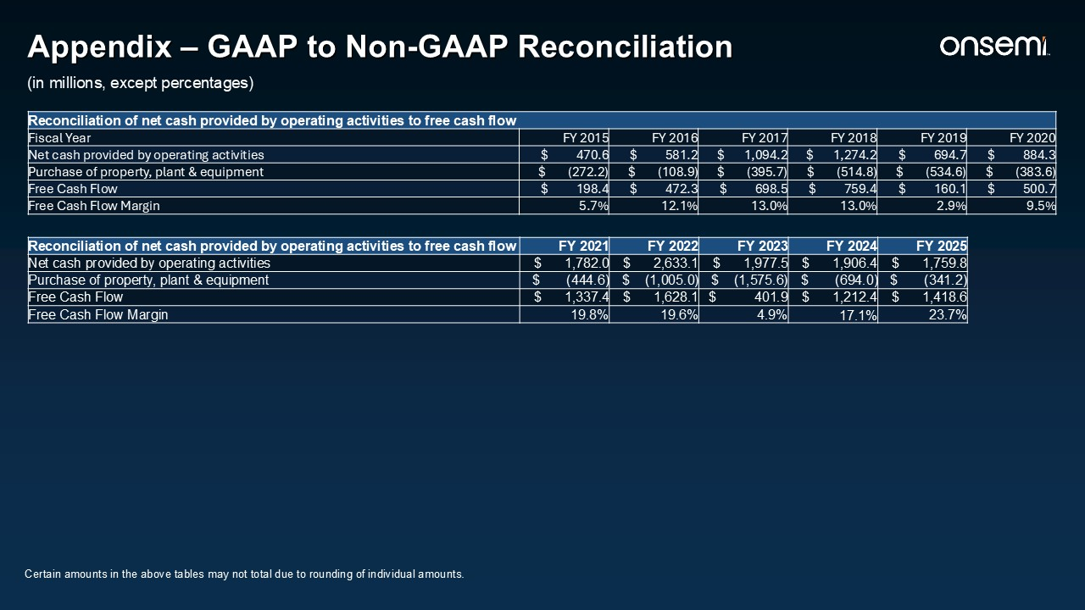
Reconciliation of net cash provided by operating activities to free cash flow FY 2021 FY 2022 FY 2023 FY 2024 FY 2025 Net cash provided by operating activities $ 1,782.0 $ 2,633.1 $ 1,977.5 $ 1,906.4 $ 1,759.8 Purchase of property, plant & equipment $ (444.6) $ (1,005.0) $ (1,575.6) $ (694.0) $ (341.2) Free Cash Flow $ 1,337.4 $ 1,628.1 $ 401.9 $ 1,212.4 $ 1,418.6 Free Cash Flow Margin 19.8% 19.6% 4.9% 17.1% 23.7% Reconciliation of net cash provided by operating activities to free cash flow Fiscal Year FY 2015 FY 2016 FY 2017 FY 2018 FY 2019 FY 2020 Net cash provided by operating activities $ 470.6 $ 581.2 $ 1,094.2 $ 1,274.2 $ 694.7 $ 884.3 Purchase of property, plant & equipment $ (272.2) $ (108.9) $ (395.7) $ (514.8) $ (534.6) $ (383.6) Free Cash Flow $ 198.4 $ 472.3 $ 698.5 $ 759.4 $ 160.1 $ 500.7 Free Cash Flow Margin 5.7% 12.1% 13.0% 13.0% 2.9% 9.5% Appendix – GAAP to Non-GAAP Reconciliation (in millions, except percentages) Certain amounts in the above tables may not total due to rounding of individual amounts.

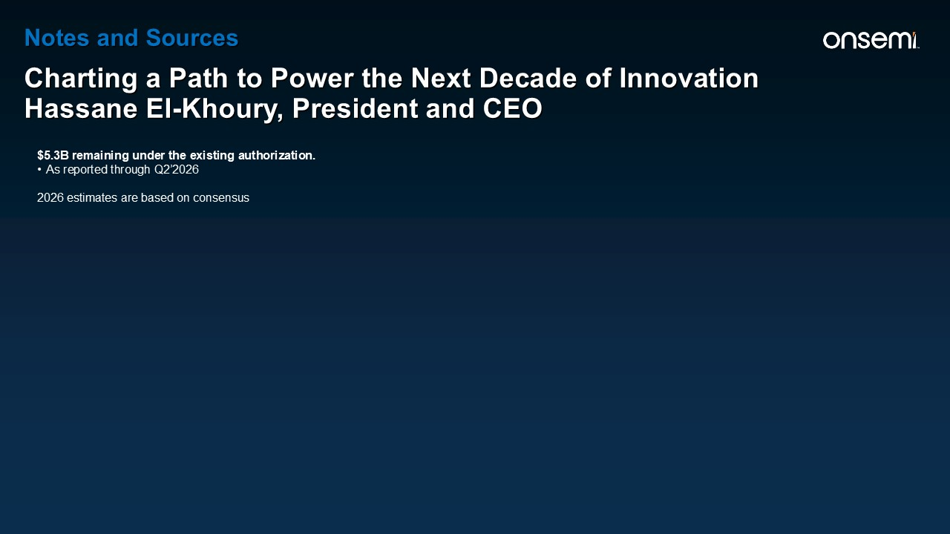
Notes and Sources Charting a Path to Power the Next Decade of Innovation Hassane El-Khoury, President and CEO $5.3B remaining under the existing authorization. As reported through Q2’2026 2026 estimates are based on consensus

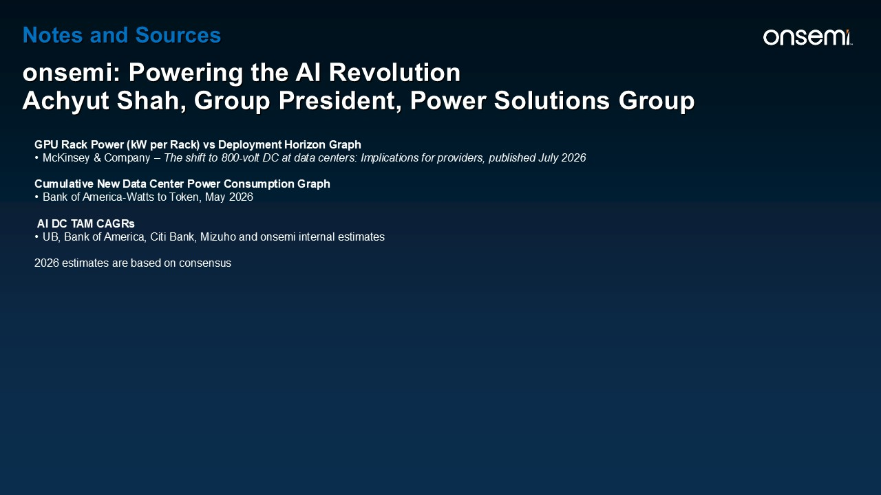
GPU Rack Power (kW per Rack) vs Deployment Horizon Graph McKinsey & Company – The shift to 800-volt DC at data centers: Implications for providers, published July 2026 Cumulative New Data Center Power Consumption Graph Bank of America-Watts to Token, May 2026 AI DC TAM CAGRs UB, Bank of America, Citi Bank, Mizuho and onsemi internal estimates 2026 estimates are based on consensus Notes and Sources onsemi: Powering the AI Revolution Achyut Shah, Group President, Power Solutions Group

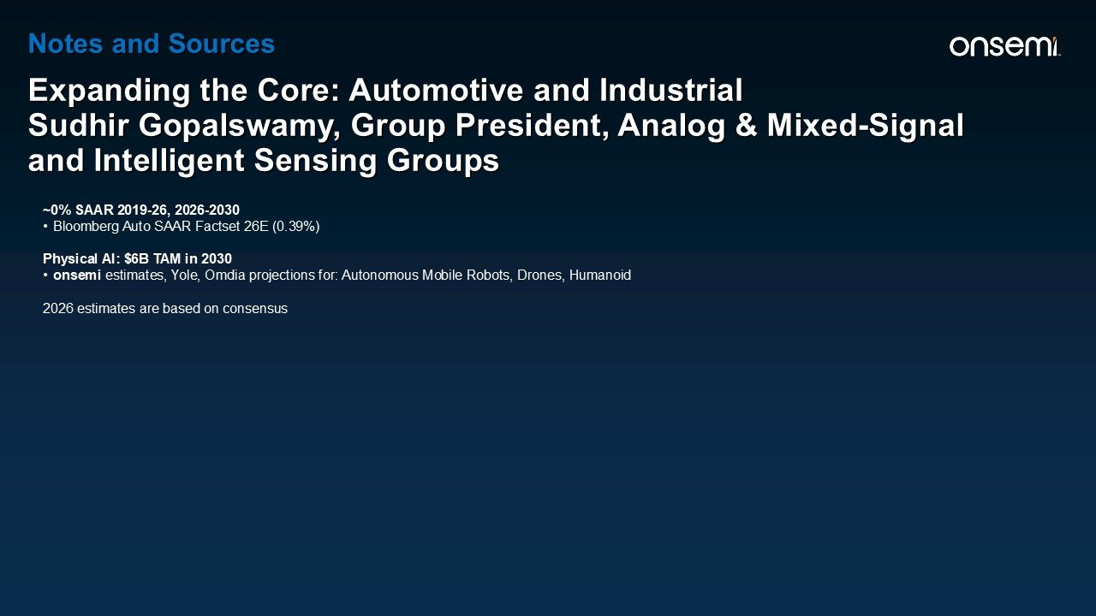
Notes and Sources Expanding the Core: Automotive and Industrial Sudhir Gopalswamy, Group President, Analog & Mixed-Signal and Intelligent Sensing Groups ~0% SAAR 2019-26, 2026-2030 Bloomberg Auto SAAR Factset 26E (0.39%) Physical AI: $6B TAM in 2030 onsemi estimates, Yole, Omdia projections for: Autonomous Mobile Robots, Drones, Humanoid 2026 estimates are based on consensus

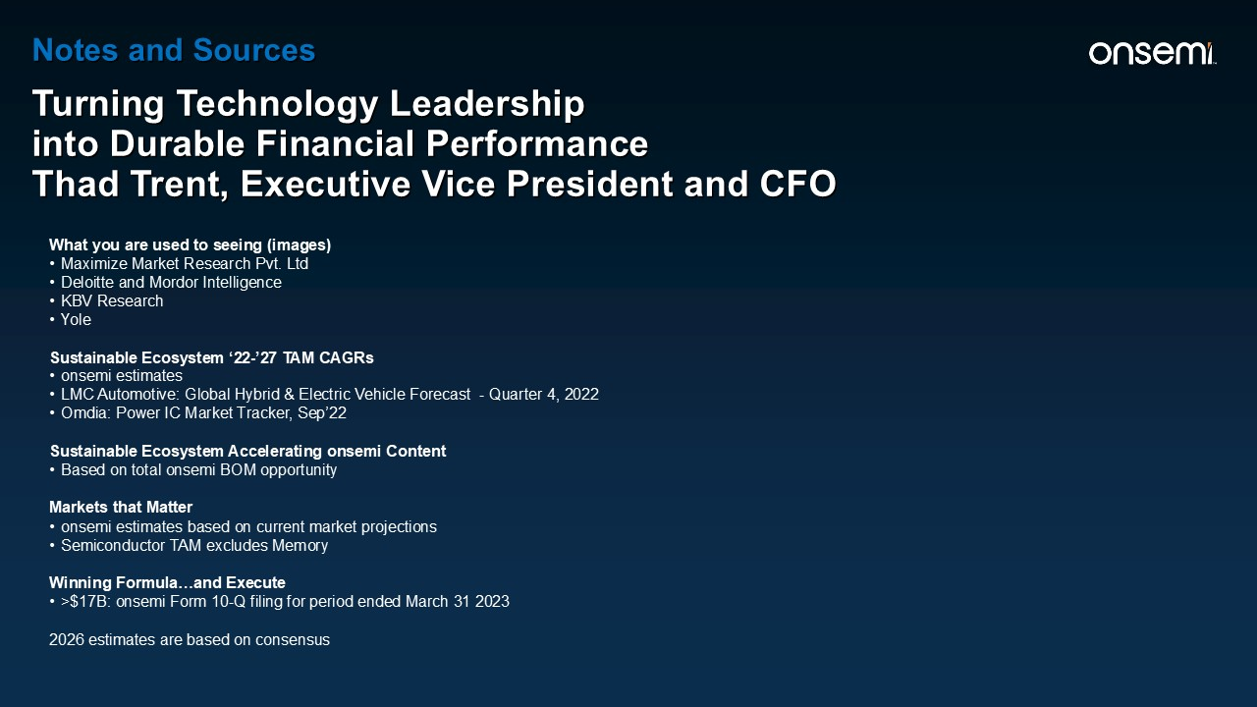
What you are used to seeing (images) Maximize Market Research Pvt. Ltd Deloitte and Mordor Intelligence KBV Research Yole Sustainable Ecosystem ‘22-’27 TAM CAGRs onsemi estimates LMC Automotive: Global Hybrid & Electric Vehicle Forecast - Quarter 4, 2022 Omdia: Power IC Market Tracker, Sep’22 Sustainable Ecosystem Accelerating onsemi Content Based on total onsemi BOM opportunity Markets that Matter onsemi estimates based on current market projections Semiconductor TAM excludes Memory Winning Formula…and Execute >$17B: onsemi Form 10-Q filing for period ended March 31 2023 2026 estimates are based on consensus Notes and Sources Turning Technology Leadership into Durable Financial Performance Thad Trent, Executive Vice President and CFO

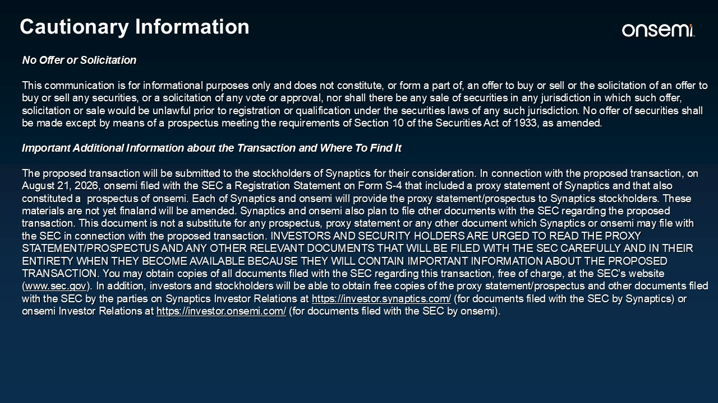
Cautionary Information No Offer or Solicitation This communication is for informational purposes only and does not constitute, or form a part of, an offer to buy or sell or the solicitation of an offer to buy or sell any securities, or a solicitation of any vote or approval, nor shall there be any sale of securities in any jurisdiction in which such offer, solicitation or sale would be unlawful prior to registration or qualification under the securities laws of any such jurisdiction. No offer of securities shall be made except by means of a prospectus meeting the requirements of Section 10 of the Securities Act of 1933, as amended. Important Additional Information about the Transaction and Where To Find It The proposed transaction will be submitted to the stockholders of Synaptics for their consideration. In connection with the proposed transaction, on August 21, 2026, onsemi filed with the SEC a Registration Statement on Form S-4 that included a proxy statement of Synaptics and that also constituted a prospectus of onsemi. Each of Synaptics and onsemi will provide the proxy statement/prospectus to Synaptics stockholders. These materials are not yet finaland will be amended. Synaptics and onsemi also plan to file other documents with the SEC regarding the proposed transaction. This document is not a substitute for any prospectus, proxy statement or any other document which Synaptics or onsemi may file with the SEC in connection with the proposed transaction. INVESTORS AND SECURITY HOLDERS ARE URGED TO READ THE PROXY STATEMENT/PROSPECTUS AND ANY OTHER RELEVANT DOCUMENTS THAT WILL BE FILED WITH THE SEC CAREFULLY AND IN THEIR ENTIRETY WHEN THEY BECOME AVAILABLE BECAUSE THEY WILL CONTAIN IMPORTANT INFORMATION ABOUT THE PROPOSED TRANSACTION. You may obtain copies of all documents filed with the SEC regarding this transaction, free of charge, at the SEC’s website (www.sec.gov). In addition, investors and stockholders will be able to obtain free copies of the proxy statement/prospectus and other documents filed with the SEC by the parties on Synaptics Investor Relations at https://investor.synaptics.com/ (for documents filed with the SEC by Synaptics) or onsemi Investor Relations at https://investor.onsemi.com/ (for documents filed with the SEC by onsemi).

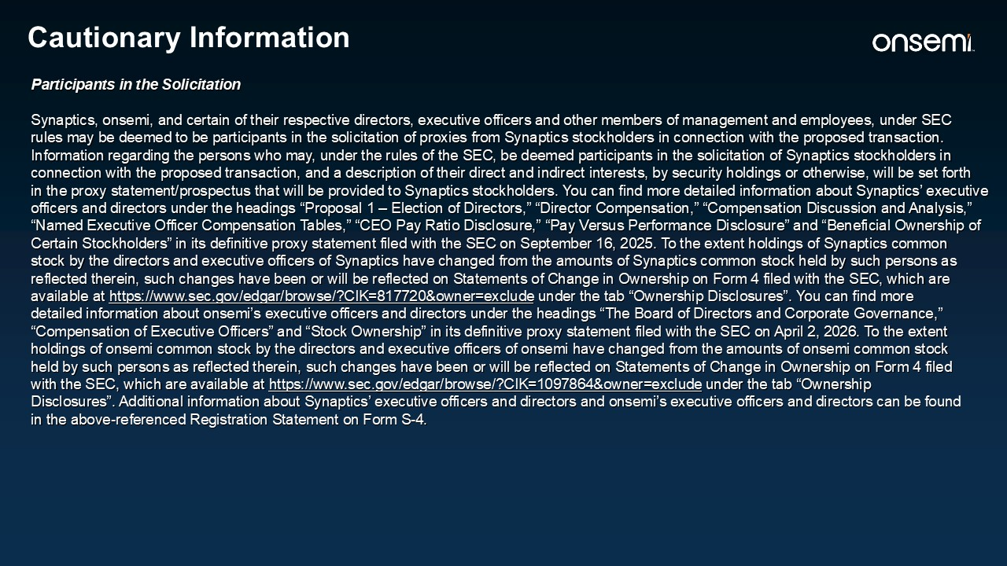
Cautionary Information Participants in the Solicitation Synaptics, onsemi, and certain of their respective directors, executive officers and other members of management and employees, under SEC rules may be deemed to be participants in the solicitation of proxies from Synaptics stockholders in connection with the proposed transaction. Information regarding the persons who may, under the rules of the SEC, be deemed participants in the solicitation of Synaptics stockholders in connection with the proposed transaction, and a description of their direct and indirect interests, by security holdings or otherwise, will be set forth in the proxy statement/prospectus that will be provided to Synaptics stockholders. You can find more detailed information about Synaptics’ executive officers and directors under the headings “Proposal 1 – Election of Directors,” “Director Compensation,” “Compensation Discussion and Analysis,” “Named Executive Officer Compensation Tables,” “CEO Pay Ratio Disclosure,” “Pay Versus Performance Disclosure” and “Beneficial Ownership of Certain Stockholders” in its definitive proxy statement filed with the SEC on September 16, 2025. To the extent holdings of Synaptics common stock by the directors and executive officers of Synaptics have changed from the amounts of Synaptics common stock held by such persons as reflected therein, such changes have been or will be reflected on Statements of Change in Ownership on Form 4 filed with the SEC, which are available at https://www.sec.gov/edgar/browse/?CIK=817720&owner=exclude under the tab “Ownership Disclosures”. You can find more detailed information about onsemi’s executive officers and directors under the headings “The Board of Directors and Corporate Governance,” “Compensation of Executive Officers” and “Stock Ownership” in its definitive proxy statement filed with the SEC on April 2, 2026. To the extent holdings of onsemi common stock by the directors and executive officers of onsemi have changed from the amounts of onsemi common stock held by such persons as reflected therein, such changes have been or will be reflected on Statements of Change in Ownership on Form 4 filed with the SEC, which are available at https://www.sec.gov/edgar/browse/?CIK=1097864&owner=exclude under the tab “Ownership Disclosures”. Additional information about Synaptics’ executive officers and directors and onsemi’s executive officers and directors can be found in the above-referenced Registration Statement on Form S-4.

